APPENDIX 13



LONDON BOROUGH OF HILLINGDON

PROCUREMENT PURCHASE CARDS

REGULATIONS AND USER GUIDANCE

Schools Finance Team (v8.0 September 2017)

PURCHASE CARDS

REGULATIONS AND USER GUIDANCE

CONTENTS

Page

Introduction………………………………………………………………. 2

Governing Body approvals required………………………………… 2

Application Procedures………………………………………………... 3

How the facility will operate…………………………………………… 3

Cardholder Procedures..................................................................... 4

Role of the Purchase Card Operator……………………………........ 4

Role of the Purchase Card Authorisers……………………………... 4

ANNEX 1 – Cardholder Specifics……………………………….... 5

ANNEX 2 – Cardholder Rules and Employee Agreement.…... 6

ANNEX 3 – Transaction Record ………..…………………..... 10

ANNEX 4 – Purchase card Lost / Stolen Notification……….... 11

ANNEX 5 – Ten top tips to foil the fraudsters………………….. 12

ANNEX 6 – Purchase Card Permission to Spend Form………. 13

ANNEX 7 – Guidance on processing Purchase Card
Payments on FMS6…………………………………… 14

INTRODUCTION

Procurement Purchase cards (“p-cards" or GPC cards) are cards that can be used to purchase goods or services. They are used to make purchases on behalf of the school and the school pays the card statements.

Purchase / Charge cards are available from most high street banks. All expenditure must be paid off each month from schools own bank accounts by direct debit and restrictions can be placed limiting their use to certain commodities or suppliers.

The following information identifies the rules and regulations that schools must adhere to if they choose to adopt the purchase card system.

The Scheme for Financing Schools bars schools from credit arrangements. Therefore the balance on purchase card accounts MUST be cleared at the end of each month by direct debit and before any interest becomes due. The school is responsible / liable for all expenditure on the card and for paying off the monthly statement.

The basic objective of using the purchase card is to reduce paperwork and administration time, particularly for low value goods and services and to enable schools to access online discounts.

It is for the governing body of the school, guided by the Headteacher, to determine whether it is appropriate for the school to operate a purchase card facility. Schools considering operating a purchase card should read the whole of this guidance before making a final decision so that they are as well informed as possible prior to making that decision.

GOVERNING BODY APPROVALS REQUIRED

The Governing Body must agree the use of a purchase card system within their school. This should be minuted together with the Governing Body’s approval of the following:

- Who is to act on the school’s behalf as the Purchase Card Operator

- Who the cardholders are to be. LB Hillingdon recommends that this should be a maximum of 2 cardholders for Nursery, Primary and Special Schools and 3 cardholders for Secondary Schools.

- Who acts as the school’s Purchase Card Authoriser.

Please note that Authorisers can not be cardholders and likewise the Operator can not be the Authoriser.

- The credit limit i.e. the total amount that can be outstanding on the school purchase card account i.e. the total limit to cover all the school cards. LB Hillingdon stipulates that this limit should be no higher than £6,000 per month.
- The individual card credit limit and transactions limits i.e. the total amount that can be outstanding on each Purchase card at any time and the maximum amount to be spent on any one transaction. These limits should be set by the Governing Body and must not exceed the total credit limit applicable to your school.
- The School Financial Management Policy must be reviewed to include the Purchase card procedures and limitations. The wording recommended is as follows “Use of the Government Procurement Card is permitted subject to the London Borough of Hillingdon’s ‘Regulations and User Guidance’ which has been adopted.” If agreement has been made to put in place an individual card and transaction limit , then this should be stated in the Policy as a local decision.
Cardholders are responsible for ensuring that they do not exceed these limits at any time. Cardholders must also ensure that any expenditure will be within limits of individual budget areas and that appropriate approvals to spend are obtained.

Transactions may be undertaken over the telephone, by fax, in shops and over the Internet. The card must ONLY be used for School purchases and under no account may it be used for personal purchases.

APPLICATION PROCEDURES

Schools should contact the Schools Finance Team in the first instance. An application will need to be completed by two signatories, in line with the signatories on your current bank mandate.

HOW THE FACILITY WILL OPERATE

The purchase card will operate by having a monthly direct debit set up to the school’s local bank account to recover the full balance on the account. This will ensure that there are no outstanding amounts on the card(s) at the end of the month.

Due to the direct debit being in operation there will be no charges as there will not be any late payments.

Schools need to take responsibility of their own cash flow management to ensure they have sufficient funds available to pay off the balance monthly in addition to the normal costs of the school.

If a member of staff leaves the schools employment the card needs to be cut up and returned to the bank. A new additional application will need to be submitted if it is deemed necessary to issue a card to an alternative member of staff.

Internal Audit may carry out short notice audits of p-cards at any time.

CARDHOLDER PROCEDURES

The School’s Purchase Card Operator must ensure they have a record of each Cardholder’s Specifics (see Annex 1) and issue cardholder’s with the Cardholder Rules and Employee Agreement (Annex 2).

The card is issued in the cardholder’s name and it will be assumed that the cardholder has incurred all the expenditure on that card. An acknowledgement of responsibilities (Annex 2) must be signed by the cardholder prior to their acceptance of the card and kept by the School’s Purchase Card Operator.

Before using the purchase card a school Purchase Order should be processed to create a commitment on the schools accounting system. Alternatively a “permission to spend” form can be completed and authorised (to be the equivalent of a purchase order). A Permission to Spend form is on Annex 6. Before authorisation a check should be made that expenditure will be within budget limits.

When using the card, cardholders must record each transaction (a transaction record form is provided in Annex 3). This must be passed to the School’s Purchase Card Operator every month, so that the expenditure incurred can be checked and passed for authorisation. Delivery notes, invoices, VAT invoices and payment slips should be attached to the transaction record.

Any cardholder not adhering to these procedures will have their card withdrawn and be liable to disciplinary procedures/prosecution.

ROLE OF THE PURCHASE CARD OPERATOR

The Operator must:

- Keep records of all cardholders and issue rules of use
- Review cardholder card statement, transaction record and receipts to ensure that expenditure is appropriate and that budgetary control reports accurately reflect purchasing card transactions.
- The Operator must keep a record of all transactions for audit purposes
- Only the monthly direct debit needs to be recorded on the school system. Instructions for schools using SIMS FMS6 are in Annex 7.
- Where VAT has been charged, a suitable invoice should be available or where appropriate electronic data held.
- The Operator must add any assets purchased costing over £250 to the school inventory.

ROLE OF THE PURCHASE CARD AUTHORISER

Each month the Authoriser must approve, sign and date the transaction records and purchase card statements as reconciled.

ANNEX 1

CARDHOLDER SPECIFICS

School Name:

Cardholder Name:

Post Held in School:

Authorising Officer:

Transaction Limit: | £
Monthly Card Limit: | £

Contact | Name | Telephone Number
Card Operator

Lost / Stolen Cards

ANNEX 2

CARDHOLDER RULES and EMPLOYEE AGREEMENT

…………………………………………….…….School issues a Purchase card to

Ms/Mr/Mrs……….……………………………..…………………. as a cardholder.

CARDHOLDER SECURITY

- The cardholder agrees to use the card only for appropriate London Borough of Hillingdon ……………….School business purchases, to use good judgement and act responsibility when using the card.
- The cardholder must sign the card as soon as it is received.
- Only the cardholder named on the card may use the card, it must not be lent to anyone else. It will be assumed that activity has been incurred solely by the named cardholder.
- The card pin number must not be written down, kept with the card or communicated to anyone else. Once the pin number has been memorised the notification should be destroyed.
- The card number should be known only to the cardholder and Card Operator and should not be written down or communicated to anyone else except in the course of a purchasing transaction. The Card Operator must maintain a secure record of card numbers and respective cardholders.
- The cardholder is responsible for the safekeeping of the card. Dependent upon the school’s insurance policy the card is likely to only be insured if locked away or carried by the cardholder in their purse/wallet.

- The cardholder must report any discrepancies/errors to the Card Operator.

- The cardholder must retain all receipts and delivery documentation to attach to the transaction record until passed to the Card Operator.

- Fraudulent or misuse of the card may result in either revocation of user privileges or any other disciplinary actions, up to and including the possibility of termination of employment/prosecution.
- The card is to be returned immediately on request or upon changing jobs or on giving notice to terminate employment. The card should be cut in half across the magnetic strip and returned to the school officer appointed to administrate Purchase Cards.

- Random audits may be conducted for both card activity and retention of receipts and invoices. Suspension of the card or Disciplinary Procedures/prosecution could be invoked for improper use of the card.

If the card is lost or stolen, the cardholder must advise …………………….Bank immediately by telephone. Telephone ………………………………. and also notify the School’s Card Operator as soon as possible (at least by the following day if outside working hours).

Transactions

Before buying goods or services with the card, the cardholder must:
- Ensure that the goods or service that they propose to buy are not available from suppliers with whom the School already has a contract.
- Before using the purchase card a school order should be processed and authorised. Alternatively a “permission to spend” form can be completed and authorised (to be the equivalent of a purchase order). This is to ensure that expenditure will be within budget limits.
- Check that the value of the purchase is within their transaction limit.
- Check that the value of the purchase will not, when added to the existing balance on the card account, exceed the credit limit.
- Ensure that the supplier is able to accept payment by the card.

The following must not be purchased using the card:
- Personal or private goods or services
- Cash
- Goods or services from statutory bodies (e.g., electricity, gas, water)
- Payments to individuals including supply or permanent staff.

Placing an Order

The cardholder must place the order themselves, but only after authorisation of the expenditure is confirmed. The order is then placed in one of five ways:

- By telephone, quoting the card number. Telephone orders must be delivered to the School’s address.

- By mail, where an application form can be completed with details for card payment.

- By fax, providing the necessary card and delivery details.

- Over the Internet (the golden rules are included as Annex 5)

- Over the counter in a shop or premises where a VAT invoice can be provided. The following is a guide to the details which are required on a VAT invoice:

Details required | Invoices less than £250
Suppliers name and address | YES
Suppliers VAT registration number | YES
Date of supply | YES
Description of goods or services | YES
Overall cost of invoice | YES
Cost of goods and services, identifying the VAT rate and amount separately for each item | YES (for each VAT rate but not item)
The School’s full name and address | NO

In all instances you must inform the supplier of: -

- The full card number and date of expiry.
- The full name of the cardholder (as shown on the card).
- School’s name.
- The full delivery address.
- A clear description of the goods required.

The cardholder should ask the supplier for the total transaction amount and a customer reference (they may not provide this but the cardholder should ask – this will help in case the cardholder needs to query it in the future).

For some suppliers, details from the reverse of the card may be asked for or details of the billing address. This is for security reasons to help prevent fraud.
However once the order is placed, do not leave paperwork containing your card number on view and keep it secure.

Card Declined

If your transaction is declined contact the school’s card Operator. Potential causes are exceeding the monthly card limit or exceeding the individual transaction limit.

Rejection of Goods/Goods Incorrect

If you reject the goods, ensure that you tell the supplier directly, as it is they who will arrange a credit to your purchase card account. The credit will appear on the monthly account statement and, therefore, must be entered on your transaction record. If you cannot come to mutual agreement with the supplier, you should inform the school’s card Operator.

Transaction Record

Your transaction record must be kept up to date. Details of goods/services received must also be recorded on the record. All receipts and delivery notes should be kept safe and reconciled to your transaction record. Where the supplier or shop provides receipts these documents must be retained as evidence of the transaction.

Where VAT has been incurred on a transaction, the amount of VAT should be clearly identified on the transaction log. VAT can only be reclaimed by the school where a VAT invoice or receipt is held by the school.

Authorisation

Each month you must sign your transaction record and passed to the School’s Card Operator for reconciliation with the card account statement and entry onto the school’s accounting system. It will also be subject to review/authorisation by the Head Teacher or other designated authorised signatory.

I confirm receipt of a school Purchase card, that I have read and understood the Cardholder Rules above and “Regulations and User Guidance” and agree to comply with them.

Employee’s Signature  Head Teacher’s Signature  Card Operator’s Signature | ………………………………………………..  ………………………………………………..  ……………………………………………….. | Date  Date  Date | …………………….  …………………….  …………………….

ANNEX 3
Transaction Record

Name ................................Department ........................... Date – log start .............. log finish ...............

Transact Date / Ref | Supplier Name | Description of Goods / Services | Cost Centre  code | Date Goods Rec’d | Total Value  £* | VAT  £ | Net Value  £ | Attachments  Del Note (1)  VAT Invoice if required (2)
 |  |  |  | Monthly total

*Record in the Total Value field the gross amount of the purchase (includes VAT)
Cardholder’s Name………………………………………………. | Cardholder’s Signature .............…………………………….................……………Date…………….
I certify that the transactions summarised above have been incurred as part of the School’s business and are chargeable to the cost centre codes shown.
Authorising Person’s Name ...................……………………….... Signature......…….…………………………...... Date ...…….......

ANNEX 4

Purchase Card – Lost /Stolen Notification

Cardholder Name

Department / Contact Number

Card Number

Date Lost/Stolen

Location Lost/Stolen

Brief Report of Circumstances Lost/Stolen

Date Reported to Bank

Name of Contact at Bank

Date Reported to card Operator

Give this form to the Card Operator as confirmation of your telephone call to the Bank and retain a copy for yourself.
ANNEX 5

TEN TOP TIPS TO FOIL THE FRAUDSTERS

The following guide to using the card over the Internet has been devised; using information provided by Financial Fraud Action UK and is recognized as good practice.

- Don’t let your cards or your card details out of your sight when making a transaction.

- Destroy, preferably shred, any documents or receipts that contain personal financial information when you dispose of them.

- Do not keep your passwords, login details and PINs written down.

- Do not disclose PINs, login details or passwords in response to unsolicited emails claiming to be from your bank or the police.

- When entering your PIN in a shop or a cash machine use your spare hand to shield the number from prying eyes or hidden cameras.

- Only divulge your card details in a telephone transaction when you have instigated the call and are familiar with the company.

- Make sure your computer has up-to-date anti-virus software and a firewall installed.

- If you have registered your card for online protection via Verified by Visa and MasterCard SecureCode ensure your password is kept safe and secure.

- Access internet banking or shopping sites by typing the address into your web browser. Never go to a website from a link in an email and then enter personal details.

- Shop at secure websites by ensuring that the security icon (locked padlock or unbroken key symbol) is showing in the bottom of your browser window.

Further guidance can be obtained from

www.financialfraudaction.org.uk

ANNEX 6
PURCHASE CARD

PERMISSION TO SPEND FORM

This form is required to be authorised before any expenditure on behalf of the school is undertaken by a member of staff.

STAFF NAME……………………………………………………………….…

REASON FOR EXPENDITURE……………………………………………..

…………………………………………………………………………………..

…………………………………………………………………………………..

…………………………………………………………………………………...

ESTIMATED COST £……………………………………...

If at the point of purchase the actual cost is more than 5% of the estimated price then the purchase will not be made. A new Permission to Spend should be completed with a more accurate spend.

AUTHORISED…………………………….HEADTEACHER

DATE……………………………

ANNEX 7

GUIDANCE ON PROCESSING CHARGE CARD PAYMENTS

ON SIMS FMS6

It is now possible to set up a new ledger code for the charge card(s) held by the school with details of each card being recorded. When the Charge Account Statement is received, an invoice is processed for each charge/supplier using the payment date as per the statement. A new Pay From Option can be selected for Charge Account and this will allow the invoice to be paid using Direct Payment Processing.

When the Bank Statement is received the items paid using the Charge Card must be reconciled using the Charge Account Reconciliation feature. A Cashbook Journal is then created to reconcile with the Bank.

For each statement a payment must be paid monthly in full by Direct Debit. Payment processing must allocate costs to the appropriate cost centres, taking into account any VAT payable (the usual VAT rules apply for these purchases).

The original invoices will need to be clipped to the transaction log and statement. These invoices will show the amount of VAT to be processed for each transaction. Follow the authorisation procedures as detailed in “the Role of the Purchase Card Authoriser” and your Schools Finance Policy / LB Hillingdon’s Guidance to Schools on Financial Management.

There is now a Charge Account Transaction Report available providing detailed transactions for a selected year, both paid and unpaid invoices/credit notes.

Adding a Charge Account Ledger Code

- Tools > General Ledger Setup > Tab5: Ledger Codes
- Click on 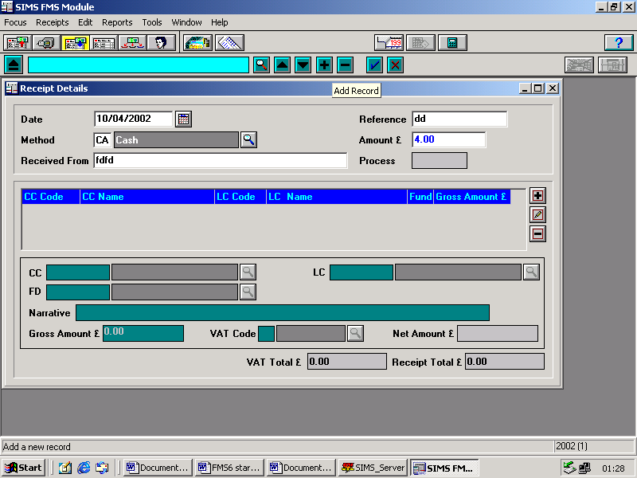
- Select the type of ledger code as Charge Liability from the drop-down list
- Click Next
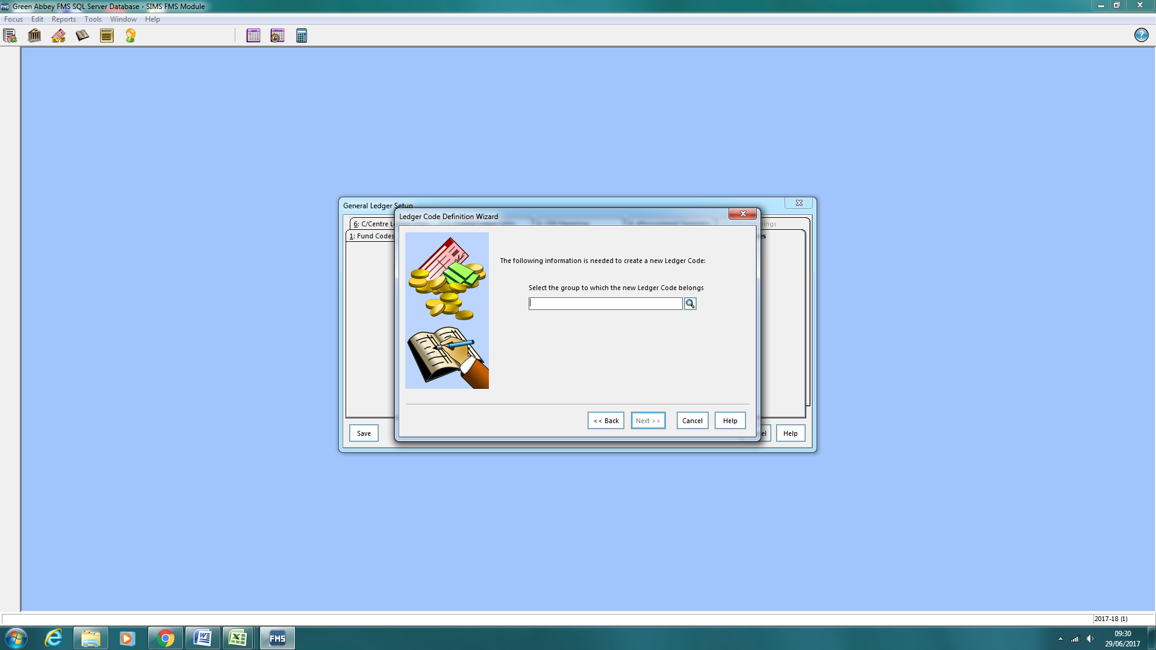
- Select the Ledger Group e.g. Liabilities by clicking on the browser
- Click Next and enter a new code e.g. CL together with a description such as Lloyds Charge Account

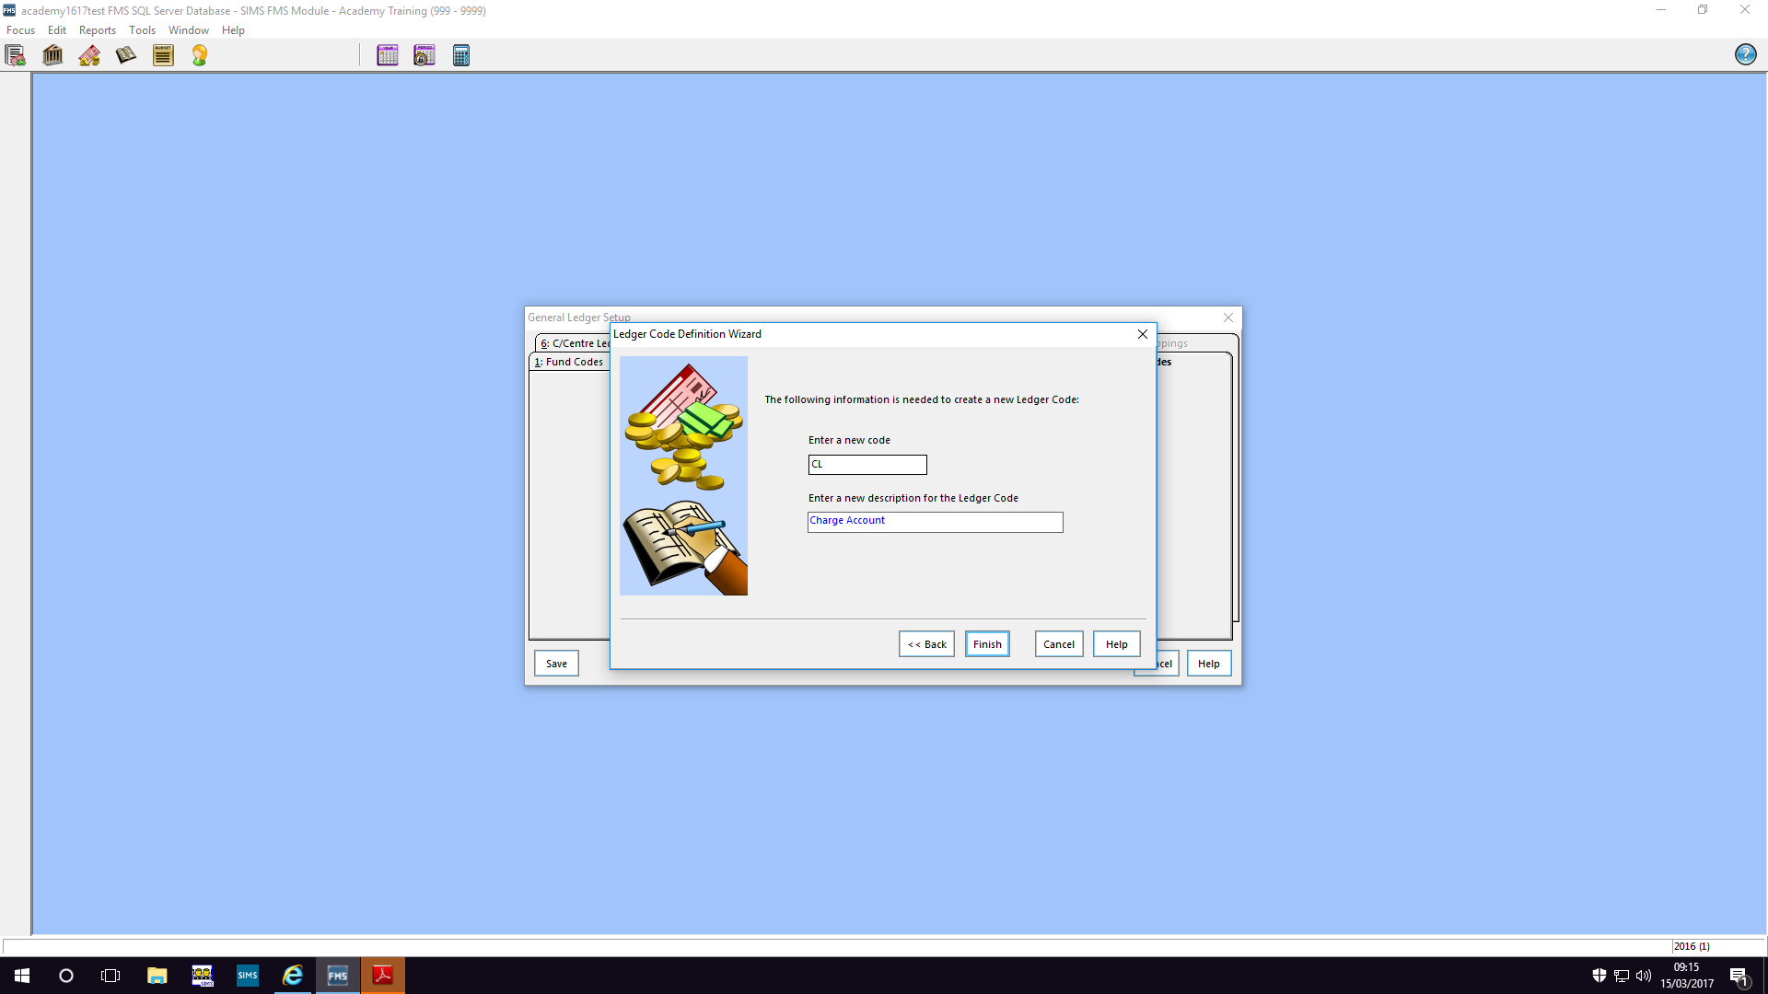

- Finish
- Within Ledger Code Definition add bank details as required and then click on
next to Charge Card Details
- In the Charge Card Maintenance menu enter the last four digits of the Charge Card Number
- Enter the name of the Charge Card Holder
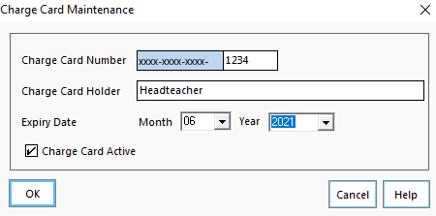

- Select the month and Year of expiry
- Additional cards can be added as required

Charge Account Statement received

- An invoice needs to be processed for each charge / supplier
- Select Order Invoice assuming a Purchase Order has already been raised
- Select the Pay From browser and choose Charge Account
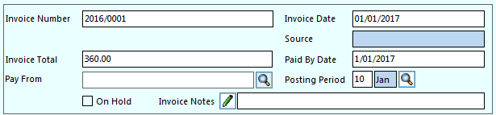

- Complete details in the usual way, Save and Authorise
- Pay invoice by using Direct Payment Processing
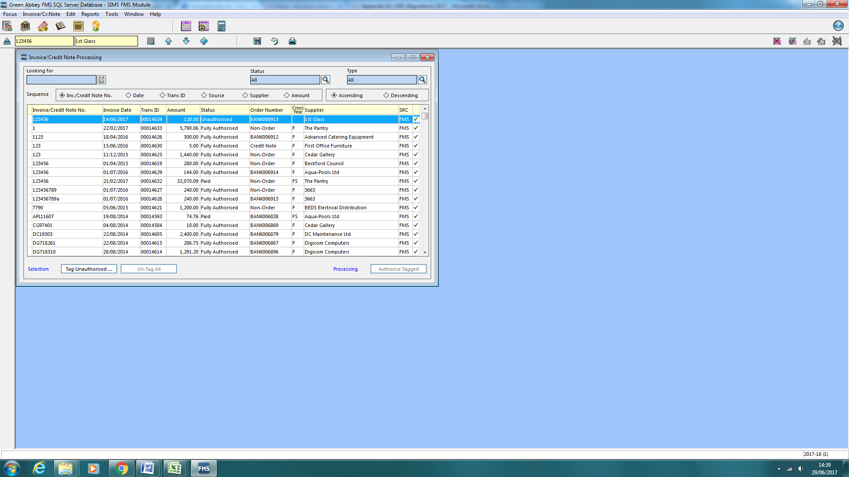
- Highlight or double click to view the relevant Invoice, click on Direct Payment Processing

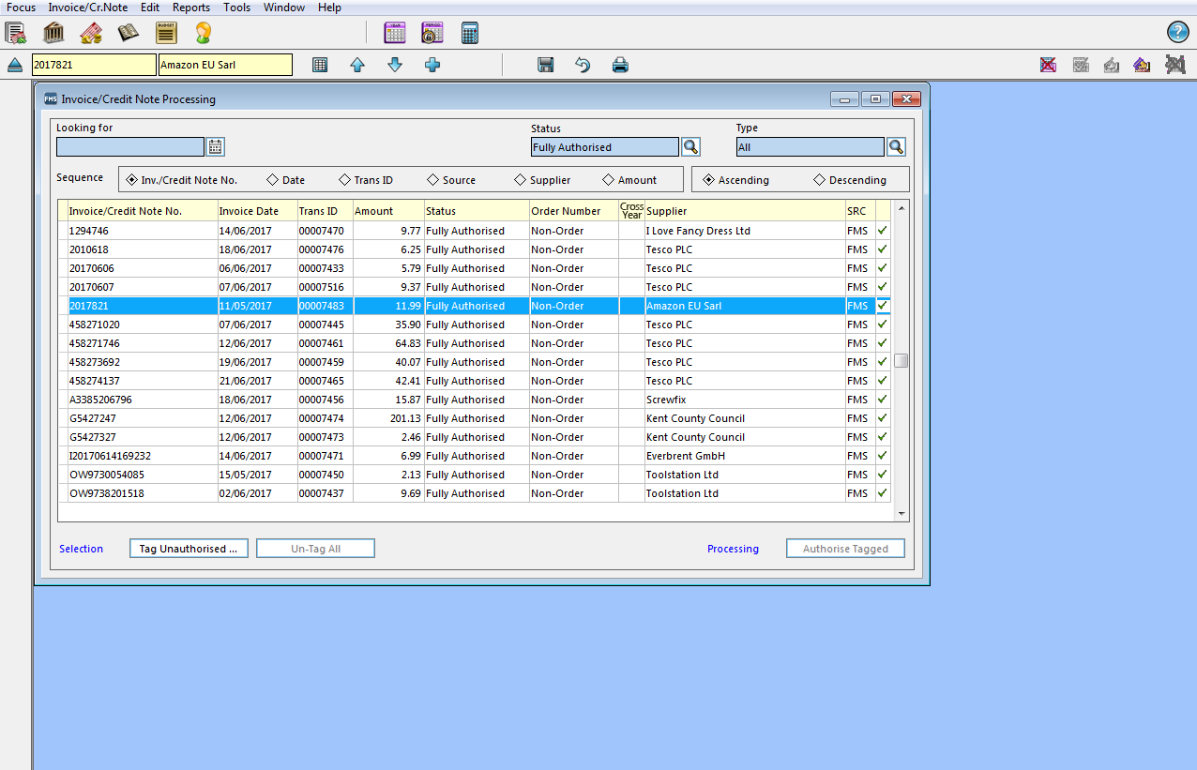

- If the Paid From Card No is blank choose the correct number from the browser
- Click on Pay and select correct card if more than one held.

Once the Bank Statement has arrived or a Bank reconciliation is being completed, items that have been paid using the Charge Card must be reconciled

- Focus > General Ledger > Charge Account Reconciliation
- Click on to add a Charge Account statement

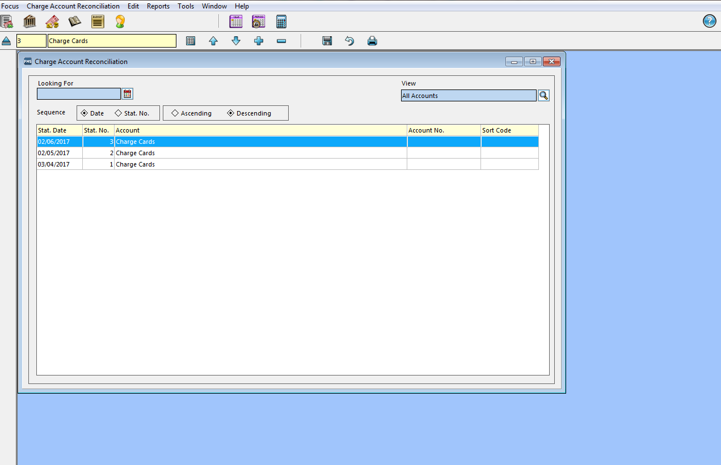

- Enter the statement number and date details
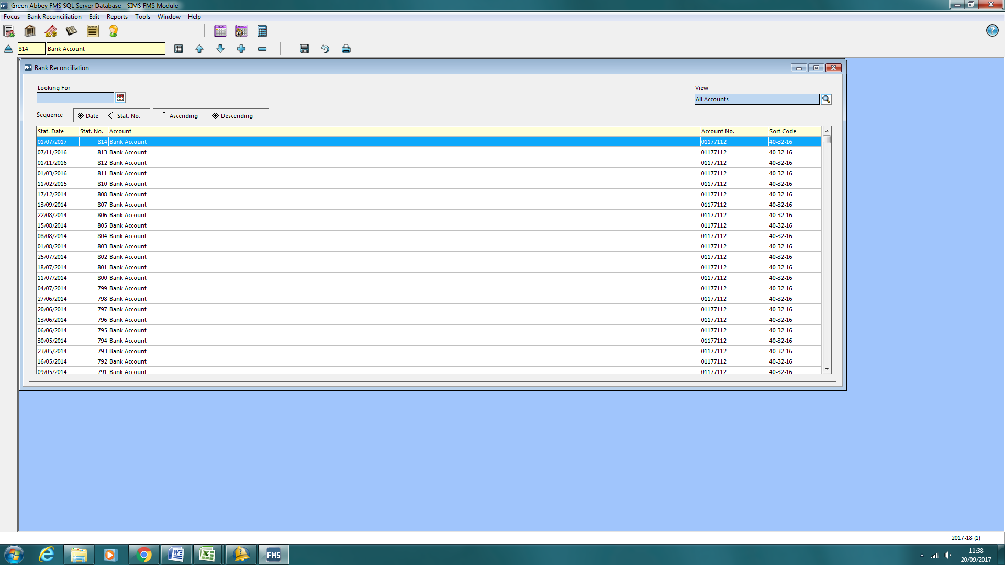
- Check that the Opening Balance is zero. If there is a balance, check and reconcile the previous statement before proceeding. Click on the down arrow at the top of the screen and click No to Save changes

- Click on the browser

- Statement Contents Chooser is now displayed

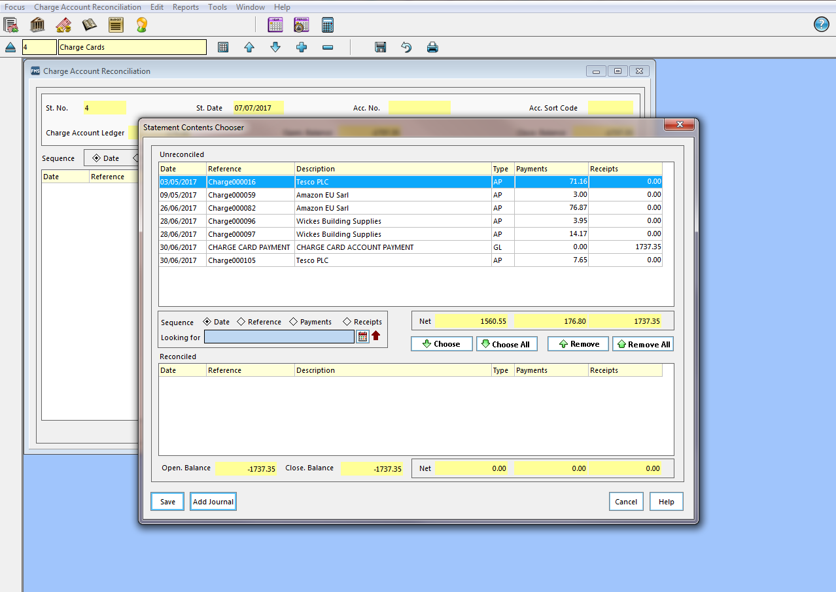

- Individual items can now be chosen to reconcile to the Charge Account statement in the same way as a bank account statement is reconciled
- Select Save
- Click on Add Journal at the bottom
- Select Cashbook Journal, Continue, complete the narrative and select Bank Ledger Code as required

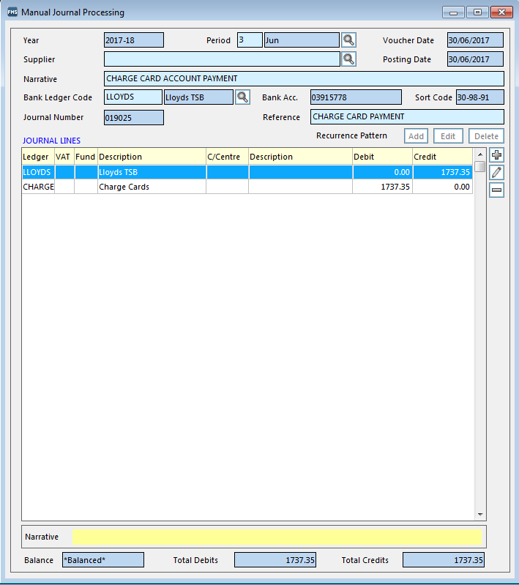

- Complete save and post the journal
- Select Save to save the reconciled items on the statement
- Check that the closing balance is zero
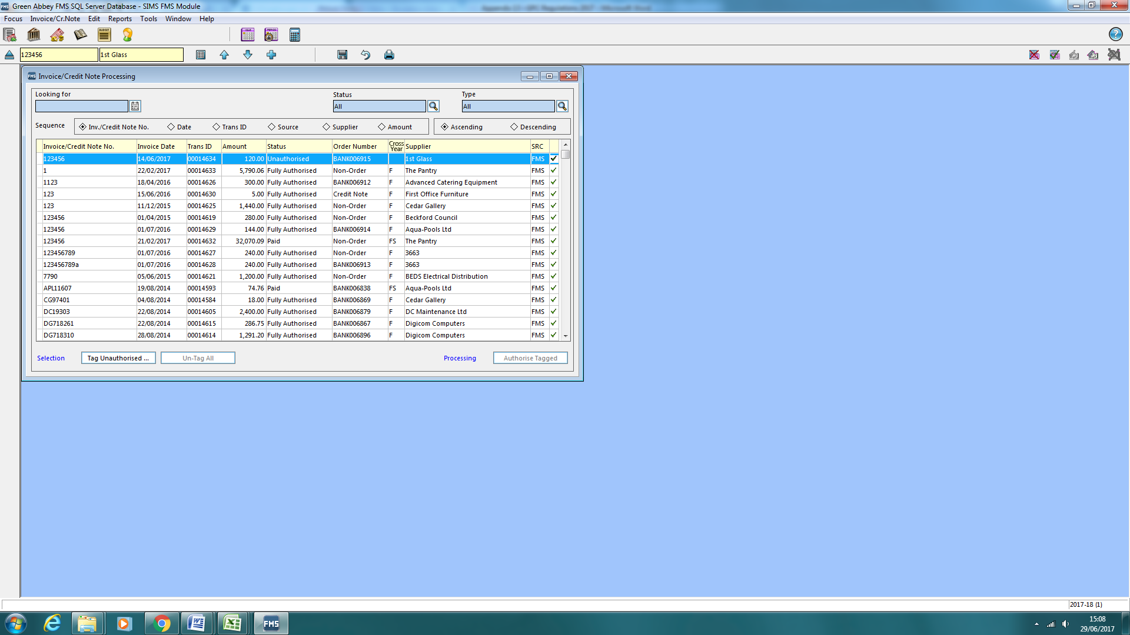
- Select the Save icon to save the statement

Transactions Report

- Details of transactions can obtained as follows
- Reports > Accounts Payable > Payments > Charge Account Transactions Report
- Complete criteria as required

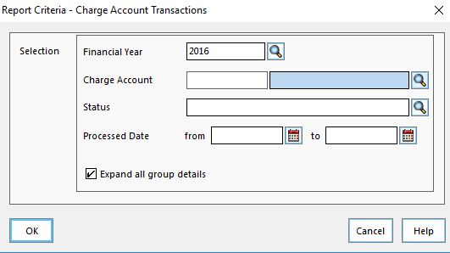

- Click on browser to select correct card
- Click on Status browser and choose from list
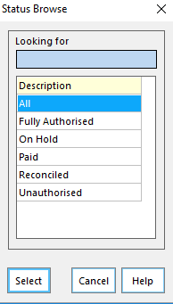

- Group details are selected by default, this can be changed as required
- Click on OK and export to Excel, PDF, Word etc.

Charge Account Processing in FMS
 | New Ledger Code created
 |  | CL
 | Authorised Purchase Requisition
 | Purchase Order created
 | Charge Account Statement |  |  |  |  |  | Process Order Invoice for
 | received |  |  |  |  |  | each charge and supplier
 |  |  |  |  |  |  | New Pay From option,
 |  |  |  |  |  |  | 'Charge Account'
 |  |  |  |  |  |  | Authorise invoice
 |  |  |  |  |  |  | Direct Payment Processing
 |  |  |  |  |  |  | Update for each invoice
 | Bank Statement |  |  |  |  |  | Charge Account Reconciliation
 |  |  |  |  |  |  | Reconcile items on Charge Account
 |  |  |  |  |  |  | Statement
 |  |  |  |  |  |  | Process Charge Account
 |  |  |  |  |  |  | Cashbook Journal
 | Charge Account Transaction Report |  |  |  |  |  | Useful for viewing invoice amounts

