GUIDANCE ON COMPLETION OF QUARTERLY CAPITAL

RETURNS (QTRS 1, 2 & 3 only)

Each quarter schools are requested to complete a capital return; this guidance is for quarters 1, 2 & 3 (the final return of the year quarter 4 differs as it has a section on accruals). There are three sections that require completion.

SECTION 1 – Actual Expenditure to date

The first part of the return will look like this:

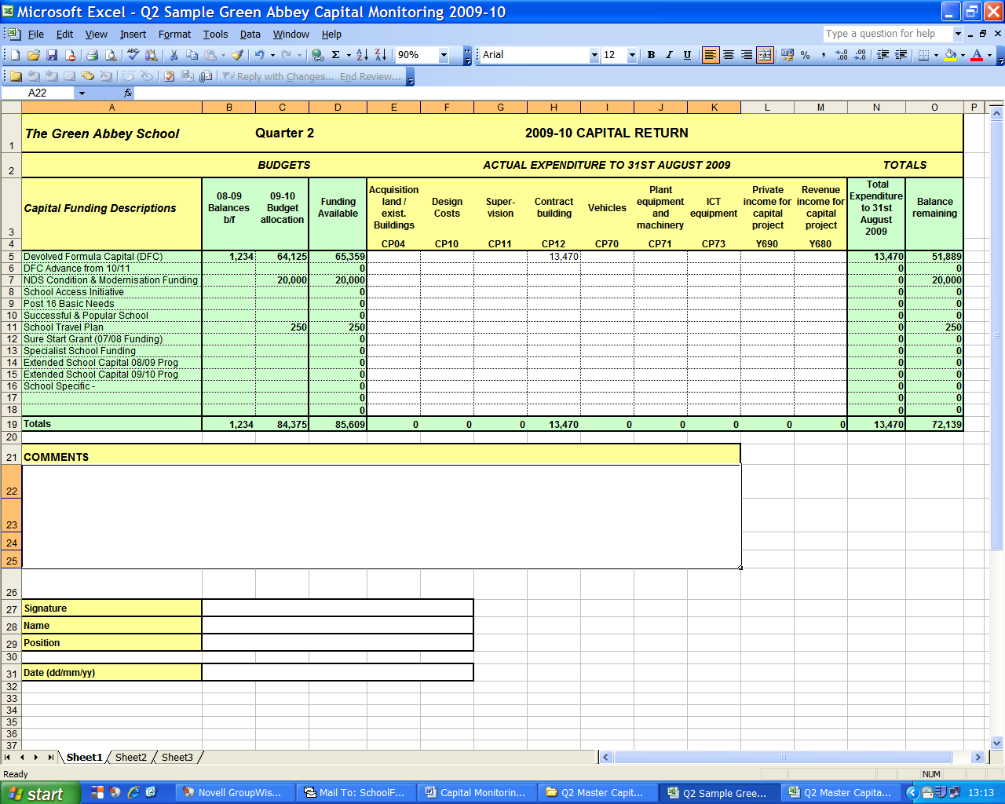

In order to fill this part, you will need to print out a ‘Cumulative Expense Analysis’ Report for your capital cost centres in FMS6 as follows:-

- Click on Reports / General Ledger / Analysis / Cumulative Expense Analysis.

- Please Select Cost Centre button (need to click in the circle)

- Click on Cost Centre Group (magnifying glass)
- Double click ‘All Cost Centres’ Folder

- Select ‘Capital’ Folder

- Leave the ‘Fund ‘ and ‘Ledger Group’ fields blank

- Un-tick ‘Show Movement up to Period’

- Leave 'Expand all Group details' ticked

- Click on ‘OK’

This is what the report looks like. Please ensure that the report is in Cost Centre order and not in Ledger Code order.

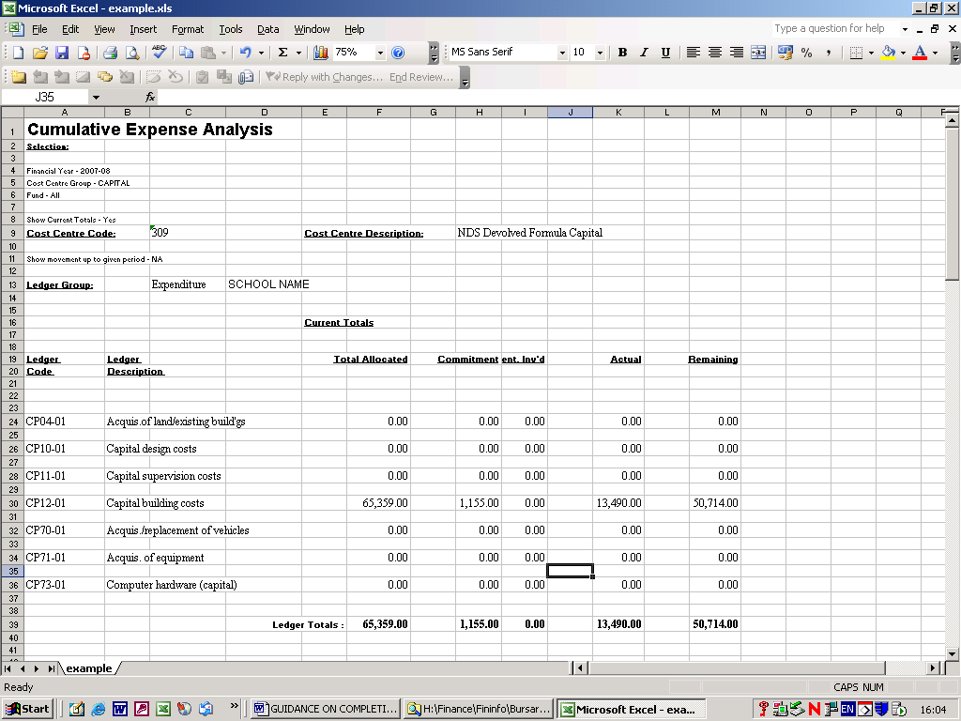

Input actual expenditure figures according to this report, which splits actual expenditure into separate Ledger Codes, e.g., CP04, CP10, etc as shown below:-

Ensure you only key actual expenditure. Do not include budgeted or committed values.

Remember Income ledger code amounts should be entered as negative figures. These figures must also be the ‘actual’ amounts.

Input name, position and date

To save the ‘Cumulative Expense Analysis’ Report, while on the FMS6 System:-

- Click on PDF icon on the top left hand corner of the screen

- Save in an appropriate folder, ready to email as an attachment.

SECTION 2 – Forecasting expenditure

Scroll to the right of the Return and the next section will appear: (columns Q to Y)

- This is where you input your expected expenditure for the following two years, this is particularly important in Q3.
.

SECTION 3 - Procurement of Assets over £20,000
(Columns AA to AH)

 |  |  | Quarter 3 |  | 2017 - 18 Capital Return
Details of Assets procured (Over £20,000) this quarter
Description | Location | Project completion or Purchase date | Total cost of project | If a project: Invoiced to date | If a project: balance outstanding | New or replacement asset (Select from drop-down) | Expected life of asset (select from drop-down)

- Capital Expenditure for individual assets valued over £20K should recorded here. Individual assets should be extended to encompass projects, i.e. ICT Suites, estate wide ICT infrastructure, building and refurbishment projects.

- If a project is ongoing and / or payments are being made in instalments it is acceptable to estimate the total cost and balance outstanding at point of submission.

- It is recognised that 'Expected life of asset' is subjective. Select the nearest reasonable option from the drop-down list. If no reasonable option exists, please leave blank and notify your link officer at point of submission.

Please email your completed return, together with your Cumulative Expense Analysis to schoolfinancereturns@hillingdon.gov.uk

Should you have any queries regarding the above please do not hesitate to contact your schools finance link officer (Nina Yasin 01895 277665, Greg Watson 01895 250451 or Davinder Devgon 01895 250458).

Schools Finance Team
August 2022

