Developing Futures  The JGA Group - Apprenticeship, Training and Career Management (jga-group.com)  The JGA Group is a well-established and fast growing apprenticeship, training and career management organisation. We are learner-centred, flexible and inclusive. We have excellent success and satisfaction rates, Ofsted “Good” and ESFA approval.  We were delighted to receive the 2021 Queen’s Award for Enterprise: Promoting Opportunity (the presentation is pictured above) and beat stiff competition to be named West London Business Best Education & Training Provider 2021 and official BAME Apprenticeship Awards Provider of the Year 2020. |  | Exciting Apprenticeships @ The restaurant group!!  Opportunities at chains like Wagamama, Frankie and Benny’s, Brunning and Price, Chiquito, Coast to Coast and Fire Jacks.  Investment 2020 – FREE of charge!  An Industry for Everyone - Investment20/20 (investment2020.org.uk)  The Investment20/20 trainee programme offers jobs across the investment industry depending on where your interests and skills are. |  | - www.centraltraininggroup  Central Training  Designed to help to prepare young people aged 16 –18 years (or up to 24 years with an EHCP), for the world of work, further education and training and, if needed, how to live independently.  Our courses run from Entry Level 1 up to a Level 2 and you can work towards your chosen career path by adding one of the following units to your qualification……  Business Administration, Catering,Child Care  Construction,Health and Social Care, Independent Living Skills  There is a link on the website showing our outreach project at Balmer's and all of the qualifications we offer at the Aylesbury Centre, as well as the apprenticeships and other qualifications that can be done online
Our Apprenticeship programmes offer a wide range of opportunities to people who are looking to start a career in the construction industry.
Our trainees and apprentices have worked on iconic projects, including the London 2012 Olympic Park, The Shard, Battersea Power Station, Tottenham Hotspur Football Stadium and Manchester Business School.
As well as the opportunity to work on some of the UK’s most exciting projects, all of our apprentices and trainees receive financial and practical support with part-time study towards an industry recognised qualification.
School leaver and Apprenticeship programmes | Mace (macegroup.com)
Multiverse Apprenticeships
Multiverse | Apprenticeships | Start your career
Shape an exciting future
Our programs open up a huge range of opportunities with top employers. From world-leading financial institutions to tech firms solving the biggest challenges – these are the companies who are building the future.

In fact 95% of apprentices who completed our programmes landed a job in their field within 90 days.

Shape an exciting future
Our programmes open up a huge range of opportunities with top employers. From world-leading financial institutions to tech firms solving the biggest challenges – these are the companies who are building the future.
In fact 95% of apprentices who completed our programmes landed a job in their field within 90 days.

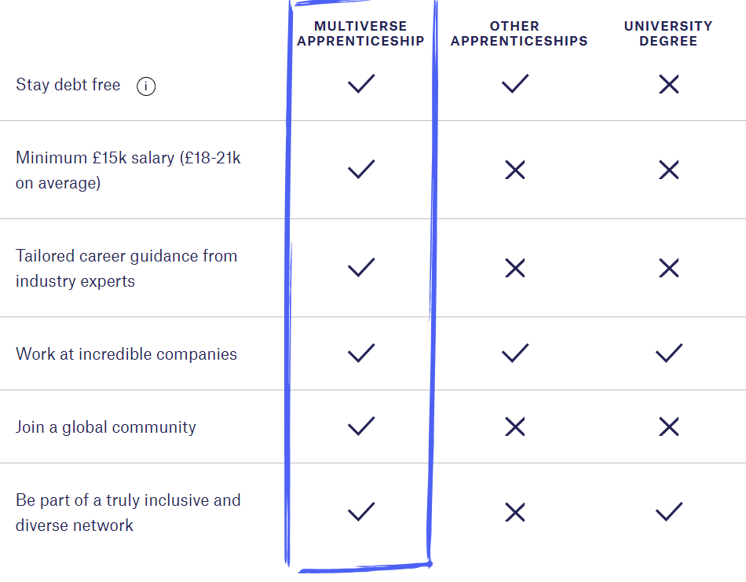

Career oppurtunities with tui!

Options
Our apprenticeship, placement and graduate programmes are essential in ensuring we develop a pipeline of early talent for our UK & Ireland business.

Flexibility
We offer opportunities across a number of business areas, ensuring you experience an exciting mix of day-to-day business activities.

progression
Bubble for visual interest bullet
You’ll gain a unique insight into our exciting and dynamic industry, with exposure to many other business areas and senior colleagues.
Apprenticeships and Dual study programmes • TUI Careers (tuigroup.com)

