SBS BUDGETING SOFTWARE FLOWCHART WHAT DO I DO NEXT?
ACTIVATE ACCOUNT (new users only)
User name and password provided by SBS
User Guidance Pages 2-7

DASHBOARD

Check User Details & Updates
 |  |  |  |  |  | SETTINGS CHECKS
Service Terms
Settings > Budgets > Edit > Staff Contract Settings
 |  | Teacher Payscales  Staffing > Salary Scales |  |  |  |  |  | Staffing Inflation & Pension Rates  Staffing > Inflation & Superannuation
UPDATE STAFF MEMBERS
Staffing > Staff Members > select Contract Name

Pupil Numbers  As previous Oct census and future forecasts | PLANNING  )  Funding Predictor  Check against LA funding figures |  |  | Income Calculator  Examples EYSFF, Teacher Pay Grant |  |  |  | Budget Entries  Planning > Budget Entries  (for Income & Expenditure,  Revenue & Capital)
KEY CHECKS
Reports > General Reports > Budget Overview

PRODUCE REPORTS
Reporting >
CFR Summary for LA
FIX BUDGET
Settings > Budgets > Select Budget > Cog icon > Fix
PUBLISH BUDGET
Settings > Budgets > Select Budget > Cog icon > Publish

? Help icon on each page and at bottom left hand corner.
OR

Connect to SBS Assist by icon or the assist on the top of each page.

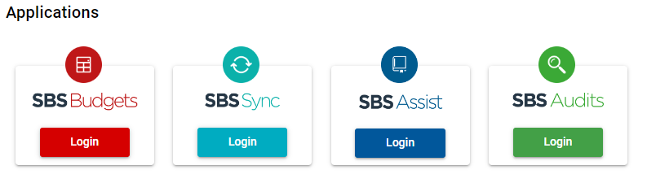
- For Finance assistance contact your link officer

- For technical assistance contact SBS Budgets 0345 222 1551 Option 8

Schools Finance Team
February 2023

