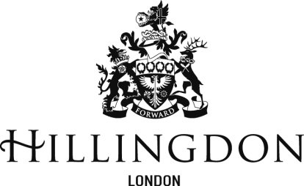

Consultation Response – October 2023

Schools Funding Formula 2024/25

Deadline for response: 17th November 2023

Please respond on the sheet below and return a copy to schoolfinancereturns@hillingdon.gov.uk

Question

Do you agree with the recommendations of schools forum to proceed with the principles set out in the schools funding formula 2024/25 consultation paper?

If you do not agree please feel free to provide reasons below

