Consultation Paper – October 2023

Notional SEN Budget for Mainstream Schools 2024/25

Deadline for response: 21 November 2023

- Introduction

1.1 This paper provides mainstream schools with information on the requirement for local authorities to identify a notional SEN budget for their mainstream schools, to help them comply with their duty to meet the special educational needs of their pupils.

1.2 This paper also provides background information to help you respond to the consultation on the consultation response document which accompanies this paper.

- Background

2.1 On 23 August 2023 the ESFA issued updated guidance to local authorities on the notional SEN budget for mainstream schools. This guidance is primarily for local authorities, to help them comply with the requirement to identify for each mainstream school in their area a notional amount to guide schools in their spending to meet the costs of additional support for the school’s pupils with special educational needs (SEN). Although this is an indicative amount, it is important that it is sufficient for the reasonable additional costs that may be incurred by schools.
2.2 The notional SEN budget is not a budget that is separate from a school’s overall budget. It is an identified amount within a maintained school’s delegated budget share or an academy’s general annual grant. It is intended as a guide for a school’s spending decisions, and is neither a target nor a constraint on a school’s duty to use its ‘best endeavours’ to secure special provision for its pupils with SEN.
2.3 Mainstream maintained schools and academies (“schools”) will be notified each year of a clearly identified but notional budget, within their overall school block budget allocation, towards the costs of fulfilling their duty to use their ‘best endeavours’ to secure the special educational provision for their pupils with SEN.
- Calculating the notional SEN budget
3.1 Using funds from the schools block of the dedicated schools grant (DSG), local authorities are responsible for calculating the amount of SEN notional budget using their local mainstream schools funding formula factors. Funding for notional SEN is not a separate formula factor.
3.2 ESFA expect the calculation of the notional SEN budget to include:
- a small part of the basic entitlement funding;
- a larger part of deprivation funding, reflecting the higher prevalence of lower-level SEN amongst disadvantaged pupils,
- the majority or whole of the low prior attainment factor funding, as this is the best proxy we currently have for pupils with low-cost, high-incidence SEN

- The 2023/24 notional SEN budget calculation
4.1 The SEN notional funding calculation for Hillingdon Schools has not been reviewed for several years and the factors and percentages used for the 2023/24 budget bear no resemblance to the ESFA expectations listed above.
4.2 The Hillingdon 2023/24 calculation is based on just one factor i.e. 100% of the “low prior attainment” factor funding. This resulted in a total 2023/24 SEN notional funding figure for Hillingdon of £16,103,762.

- The 2024/25 notional SEN budget calculation
5.1 The ESFA guidance on notional SEN Budgets includes examples which base the proportionate contribution of the various formula factors broadly on existing local authority practice and these factors are summarised in the table below:
Table 1: DFE worked example of funding allocated to notional SEN
Factor | Primary | Secondary
Basic Entitlement (AWPU) | 3.6% | 2.3%
Deprivation (FSM6 and IDACI) | 45.0% | 34.0%
Prior attainment | 94.0% | 81.0%
Mobility | 18.0% | 15.0%
Lump sum | 3.7% | 1.6%

5.2 ESFA have also published a chart which shows comparisons with other local authorities’ calculations, and this has been included as Figure 1 below. The chart shows how, at overall local authority level, the notional SEN budget in 2022 to 2023 varies as a percentage of the total schools block formula allocation. The average notional SEN allocation is 10.8%.
Figure 1: percentage of funding allocated to notional SEN
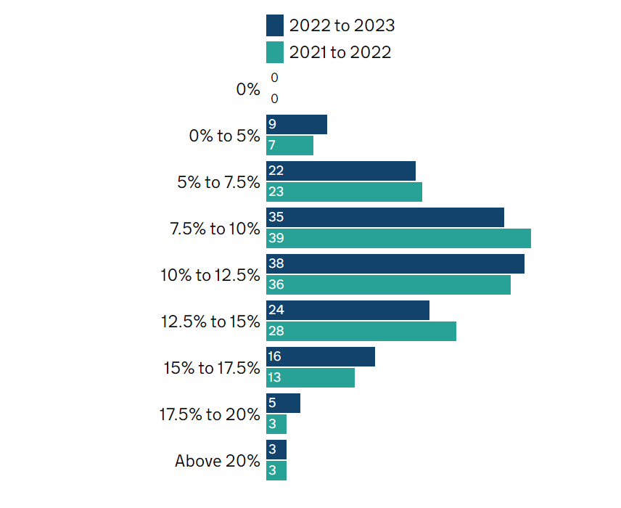

5.3 The Council has calculated that if the ESFA example factors in Table 1 had been used for the 2023/24 SEN notional budget (rather than the single “low prior attainment” factor that was actually used) the total SEN notional funding for 2023/24 would have been £28.6m (10.8% of the total schools block formula allocation, which is the same percentage as the national average).
5.4 The Council is therefore proposing to adopt the factors and percentages in Table 1 in order to set the 2024/25 SEN notional budget, as this aligns with ESFA expectations and with the national average of the percentage of total schools block formula allocation that is allocated to notional SEN.

- Consultation on the proposed 2024/25 notional SEN budget calculation
6.1 The Hillingdon Schools Forum Meeting on the 18th of October 2023 recommended that the Council carry out a consultation with all Hillingdon mainstream schools on 2 options for the proposed calculation of SEN notional funding contained within their mainstream schools budgets for 2024/25.
6.2 The consultation response paper (circulated alongside this paper) seek views on 2 options:
- Option 1: The Council’s adopts the factors and percentages in Table 1 when setting the 2024/25 SEN notional budget.
- Option 2: The Council uses factors for setting the 2024/25 SEN notional budget that bring the total SEN notional calculation 50% closer to the calculation under Option 1, and the Council fully adopts the factors and percentages in Table 1 when setting the 2025/26 SEN notional budget.
6.3 Table 2 below gives an indication of the difference in the levels of SEN notional budget calculated under each of the two options. It should be noted that the numbers in Table 2 are based on 2023/24 schools block funding (as the funding for 2024/25 will not be know until mid to late December) and are therefore for illustrative purposes only.
Table 2: Illustrative figures for options 1 and 2
 | Total SEN notional funding (£m) | % of schools block funding
existing method | 16.1 | 6.1%
option 2 | 22.4 | 8.4%
option 1 | 28.6 | 10.8%

- New APT validation checks

7.1 The Council will decide on the which factors to use for the 2024/25 SEN notional budgets, after taking into account feedback from schools forum and this consultation. However, it should be noted that there are new validation checks within the ESFA schools budget setting template (the APT) and these may limit how low the total SEN notional funding can be set. The impact of this cannot be confirmed until the 2024/25 final APT template and schools 2024/25 DSG allocations are published by EFSA (probably in mid to late December). As a result, the Council will only be able to confirm final allocations and factors used to set the 2024/25 SEN notional budgets in January 2024.

