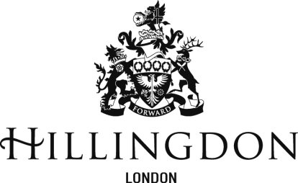

Consultation Response – October 2023

Notional SEN Budget for Mainstream Schools 2024/25

Deadline for response: 21 November 2023

Formal responses should be returned to schoolfinancereturns@hillingdon.gov.uk

The Hillingdon Schools Forum Meeting on the 18th of October 2023 recommended that the Council carry out a consultation with all Hillingdon mainstream schools on 2 options for the proposed calculation of the Notional SEN Budget contained within mainstream schools budgets for 2024/25.

This consultation therefore asks mainstream schools to select their preferred option:

Option 1
The Council adopts the factors and percentages in Table 1 (section 5) of the Paper accompanying this consultation response document, when setting the 2024/25 SEN notional budget. Is this your preferred option? YES/NO - if NO please feel free to provide reasons why.

Option 2
The Council uses factors for setting the 2024/25 SEN notional budget that brings the total SEN notional calculation 50% closer to the option 1 calculation; please see Table 2 (paragraph 6.3) of the Paper accompanying this document.
Is this your preferred option? YES/NO - if YES please feel free to provide reasons why.

Please Note: the notional SEN budget calculation has no impact on the amount of funding schools receive through their schools block funding certificate.

