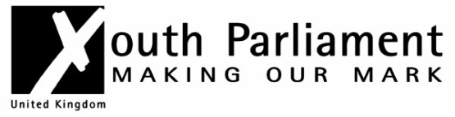

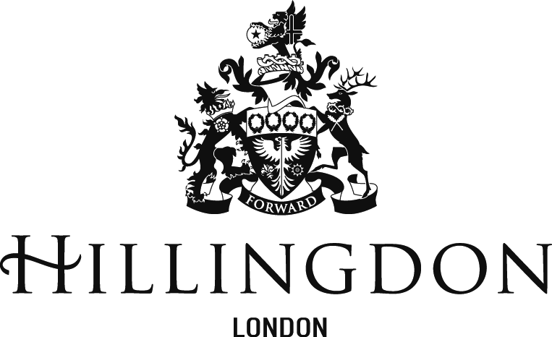

UK Youth Parliament Elections
Term of Office 2023 - 2025

Introduction
The UK Youth Parliament (UKYP) enables young people to use their energy and passion to change the world for the better. Run by young people for young people, UKYP provides opportunities for young people to use their voice in creative ways to bring about social change. The UK Youth Parliament is managed by the British Youth Council, as part of the Youth Voice programme including the Young Mayors Network and Local Youth Council Network.
The UK Youth Parliament has over 300 elected representatives, Members of Youth Parliament (MYPs). MYPs are elected in youth elections throughout the UK. Once elected, MYPs organise events and projects, run campaigns and influence decision-makers on the issues which matter most to young people. All MYPs have the opportunity to meet twice a year at the UK Youth Parliament Annual Sitting and House of Commons events.

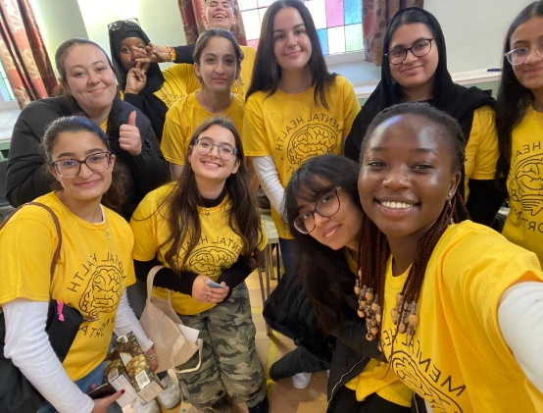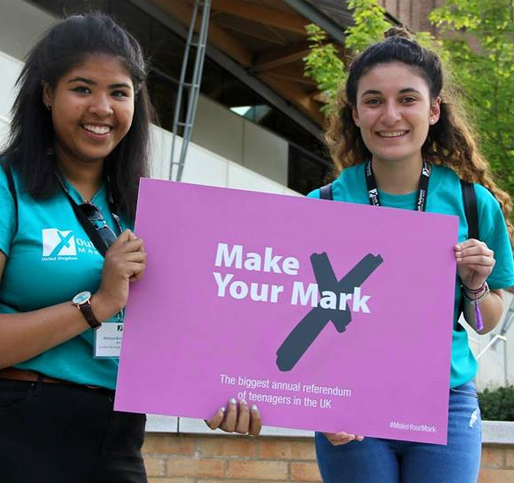
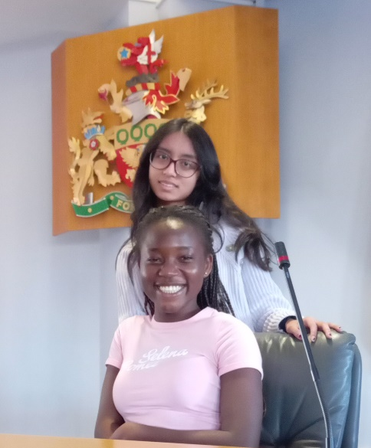
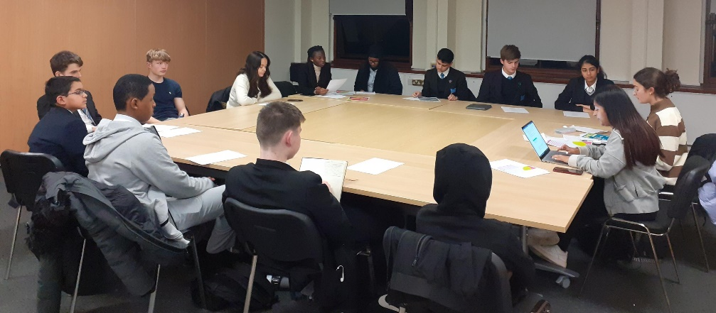
What does it mean to be a Member of Youth Parliament?
Being an MYP is a very exciting opportunity. Throughout your term of office you will have the chance to get involved in a range of activities. For example, MYPs meet with MPs and local councillors, organise events, run campaigns, make speeches, hold debates, and ensure the views of young people are listened to by decision makers. But the most important aspect of any MYPs job is to make sure they represent the views of young people in their constituency.
MYPs are expected to attend BYC Conventions, the Annual Sitting and House of Commons. UKYP time commitment is an estimated 7 hours a month. Attendance at weekly Hillingdon Youth Council sessions, estimated 6 hours per month.
MYPs are elected by their constituency for a period of 1 year; this will run from March 2024 to February 2025. To run for election in Hillingdon you must be aged 11 on the date of the election and up to 18 when your term of office finishes. To be eligible to stand you must live, work or volunteer for a minimum of 14 hours per week or be in education for more than the equivalent of three school days a week, in the London Borough of Hillingdon.
MYPs are politically neutral.

How do I become an MYP?
There are lots of ways for young people everywhere to get involved with the UK Youth Parliament, from supporting campaigns to debating in online forums, utilising social media and filling in online ballot papers.
Each year Hillingdon elects two new MYPs to represent the young people in Hillingdon, if you would like to stand for election, please complete the application form at the end of this document.
The first stage in the process is to complete the attached application form outlining your key manifesto points, the issues you would address if you were elected. All candidates will then be expected to attend an information session and campaign meeting before going on to campaign across the Borough.
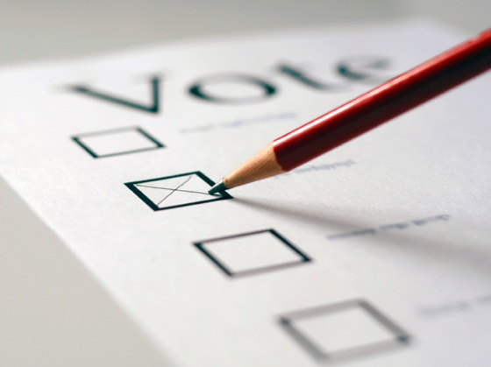
The election for MYPs will take place in February 2024, with young people across the Borough voting via their schools/youth projects.

Election Process Timeline

Submit your Application
DEADLINE: Friday 15th December 2023

Attend Information Session
Thursday 21st December 2023
rr
Attend Campaign Meeting
Thursday 18th January 2024

2024

Submit manifestos
Friday 12th January
2024

Attend Youth Conference & Hustings
Thursday 25th January 2024

Campaign Results!
1st March 2024

Election
12th -23rd February 2024

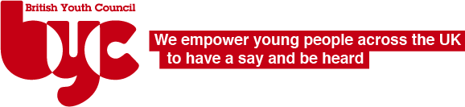
MYP Role Description

The role of an MYP is to:
- Support youth voice and actively engage with young people in their constituency.
- Promote the positive work of the UK Youth Parliament.
- Attend and participate in all BYC Conventions or regional/national meetings; Annual Sitting and the UK Youth Parliament House of Commons Sitting.
- To vote on and feed into UK Youth Parliament policy.
- Meet regularly with other youth councils and forums in their area.
- Speak on behalf of their constituents.
- Take the views of their constituents to BYC Conventions, the Annual Sitting and the House of Commons Sitting and report on local campaigns.
- Ensure that the work of the UK Youth Parliament is not affiliated with any political party.
- Carry out other tasks as relevant in their constituency.
- Take part in Make Your Mark and support young people in their areas to take part too; and
- To vote for, campaign on and promote the UK Youth Parliament campaign priorities.
- Communicate to the media as appropriate and under BYC media guidelines.

Key Tasks:
- Participate in meetings.
- Speak on behalf of their constituents.
- Take part in votes.
- Take part in the national campaign consultation and support young people in their areas to take part.
- Take news of UKYPs work back to their constituency.
Skills:
- Approachable
- Inclusive of everyone
- Experience – none needed, just a desire to get young people’s voices heard.

Staff Support:

If you are interested in becoming an MYP for Hillingdon we will provide a local authority worker to support you in your role, accompany you to meetings where appropriate, help develop your own manifesto and assist with establishing meetings with local councillors / officers of the Council.
Additionally, the UK Youth Parliament allocates representatives and Youth Democracy Coordinator to provide support.

Application to run for Member of Youth Parliament for London Borough of Hillingdon
Name:
Date of Birth:
Address:

Contact Number:
Email:
Parent / Guardian Name:
Contact Number:
Manifesto (to be no longer than 150 words):

Please complete and return to:
Maggie Ditchburn, Specialist & Accredited Programme Coordinator – Universal Youth Services at mditchburn@hillingdon.gov.uk by 15th December 2024

