2023-24

Financial Year End Guidance
For

Hillingdon Schools

Capital

Produced by the Schools Finance Team
November 2023
V1.0

The Quarter 4 Capital Returns will be made available to schools by the 9th February 2024. The completed Returns together with Cumulative Expenditure Analysis (Capital) reports must be submitted to Schools Finance Team by Friday 15th March 2024. Nil returns are also required. It is appreciated meeting this deadline will once again present a challenge, so please consider carefully what is required and plan ahead. Please contact your link officer if you require any assistance in completing the return and/or producing the analysis report.

Please note that your March 2024 Cash Advance will be received after you have submitted your final Capital Return, remember to include any anticipated capital movements in the March Cash Advance on your Final Return. If you are expecting any other Capital income that has not been received by 15th March 2024, then an accrual will need to be recorded and processed at year end.

Capital invoices for works and capital purchases (ICT) related to 2023-24 should be promptly paid;

- On or before 15th March and charged to 2023-24

- No journals passed, cheques cancelled, or adjustments be processed to Capital Ledger Codes after 15th March

- Any outstanding capital payments after 15th March should be processed in the system after 1st April in the new financial year 2024-25

- Any expenditure incurred in 2023-24 for which payment has not been processed by 15th March should be recorded as an accrual and the accruals form (Appendix A (1)) should be submitted to the Schools Finance Team by 15th March. Please see section on ‘Processing Accruals’ on the Main Year End Guidance and follow the process. The minimum limit for capital accruals remains at £10,000 and supporting documentation will be required prior to any journals passed.

- Do not implement capital accrual journals on your accounting system until after you have completed the final March bank reconciliation and are completing your early close (Please refer to the Main Year End Guidance for further process).

If you need to make an urgent capital payment which is not accrued on your capital return of 15th March, please contact the Schools Finance Team. Ordinarily capital transactions should NOT be processed once your capital return has been submitted. Where an accrual has been processed and urgent payment is required, please contact the Schools Finance Team for further advice. All capital income expected for the financial year 2023-24, especially for VA Schools from the Diocese must be received prior to the return being submitted.

Revenue Contribution to Capital

Schools are NOT permitted to close with a year-end capital (primarily the Devolved Formula Capital Budget) overspend. Where costs (including any capital accruals) exceed capital income plus capital balances brought forward, a journal transfer from revenue (debit ledger code A200) to Capital Income (credit ledger code Y680) must be processed. This journal must be actioned as a Manual ‘normal’ journal (and not as a Reversing Journal). Schools are NOT permitted to transfer capital funds to revenue, nor can revenue funds be transferred to capital in advance of capital costs being incurred. Please contact your link officer if you require further assistance in completing these journals.

GUIDANCE ON COMPLETION OF FINAL QUARTERLY CAPITAL RETURNS

Each quarter schools are requested to complete a capital return, the final return of the year differs as it has a section on accruals. There are three sections that require completion.

SECTION 1 – Expenditure to date

The first part of the return will look like this:

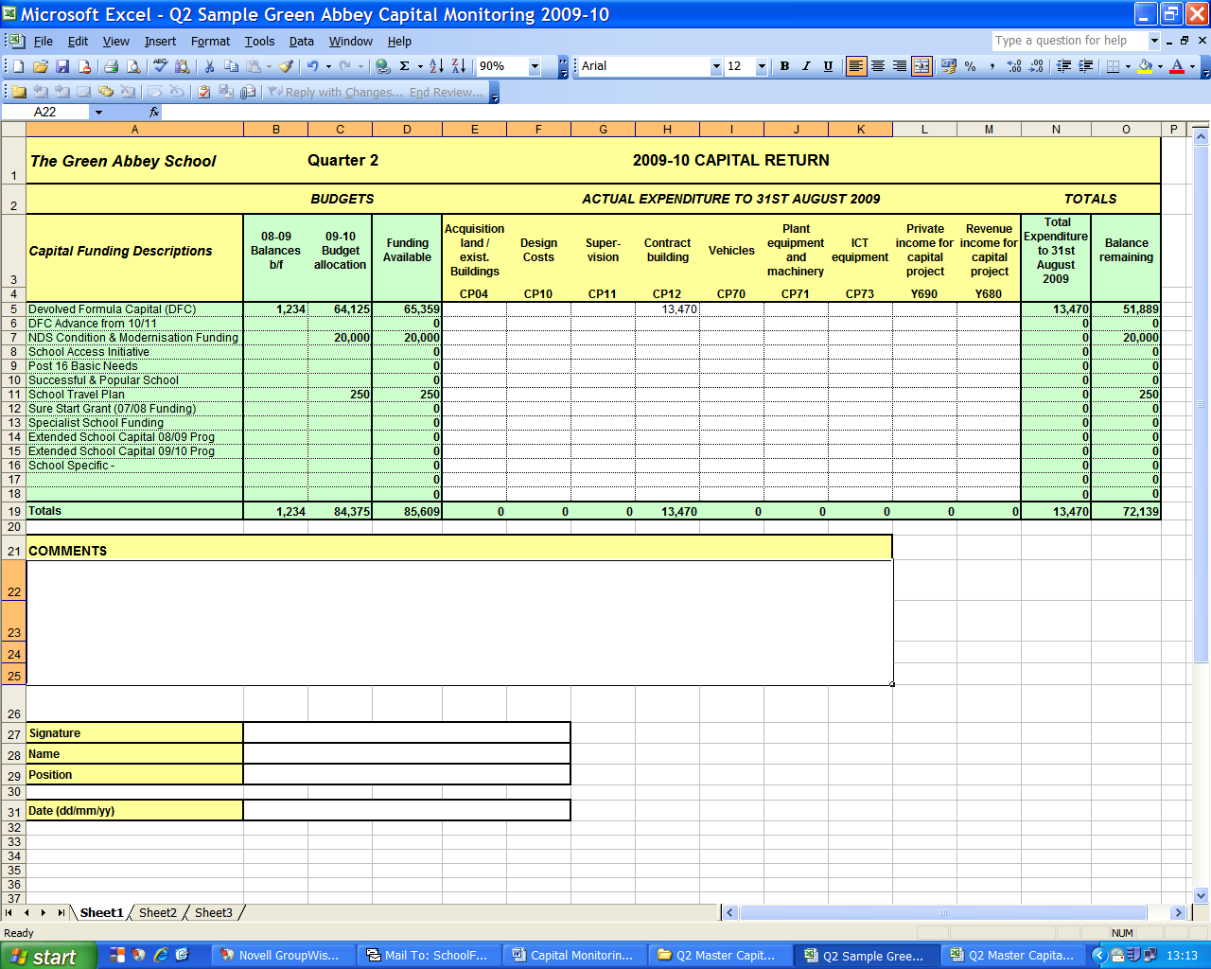

In order to fill this part, you will need to print out a ‘Cumulative Expense Analysis’ Report for your capital cost centres in FMS6 as follows:-

- Click on Reports / General Ledger / Analysis / Cumulative Expense Analysis.

- Please Select Cost Centre button (need to click in the circle)

- Click on Cost Centre Group (magnifying glass)
- Double click ‘All Cost Centres’ Folder

- Select ‘Capital’ Folder

- Leave the ‘Fund ‘and ‘Ledger Group’ fields blank

- Un-tick ‘Show Movement up to Period’

- Leave 'Expand all Group details' ticked

- Click on ‘OK’
This is what the report looks like. Please ensure that the report is in Cost Centre order and not in Ledger Code order.

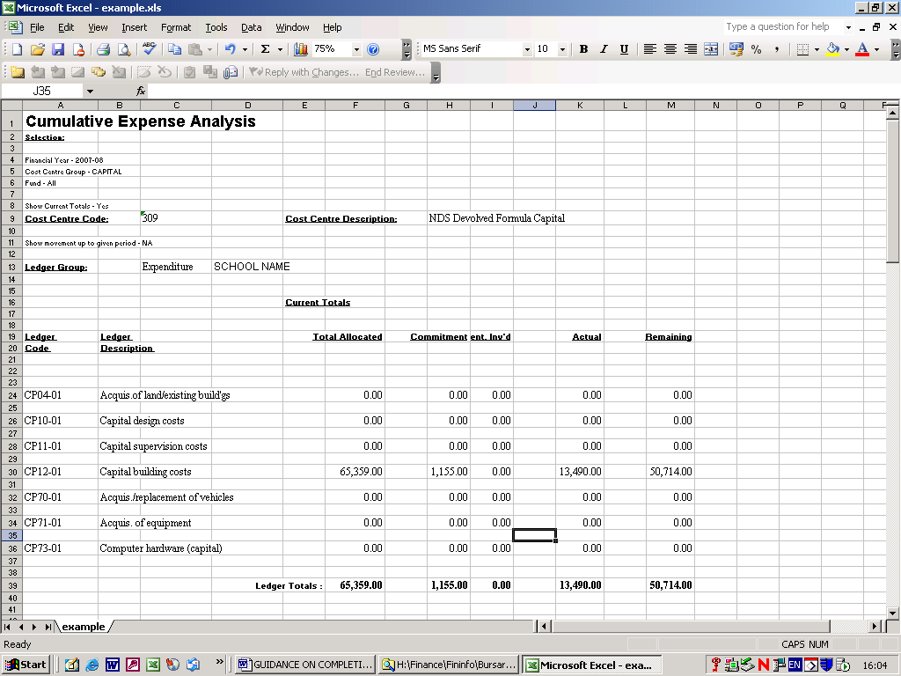

Input actual expenditure figures according to this report, which splits actual expenditure into separate Ledger Codes, e.g., CP04, CP10, etc as shown below:-

Ensure you only key actual expenditure. Do not include budgeted or committed values.

Remember Income ledger code amounts should be entered as negative figures. These figures must also be the ‘actual’ amounts. This can be either - Private Income and/or Revenue Contribution to Capital for Capital Project only.

Sign the form and add in the name, position and date

To save the ‘Cumulative Expense Analysis’ Report, while on the FMS6 System:-

- Click on ‘Export to disk’, middle button on the top right-hand corner of the screen

- Click on Excel…(Format) and ‘OK’

- Alternatively, save as a PDF File

- Save as, in an appropriate folder, ready to email as an attachment.

SECTION 2 – Accruals & Forecasting expenditure

Scroll to the right of the Return and the next section will appear as follows:
(columns Q to Y)

- Accruals should be recorded for any invoices due for works to be completed by 31st March. The de minimus for capital accruals is £10k and these invoices need to be paid in the new financial year. Once the return is submitted no further capital transactions should be processed.

- Any accruals recorded on the Capital Monitoring Return should also be entered on the Year End Statement, Capital Accruals Tab.

- On the two right hand columns input estimated capital expenditure for the next two financial years, if known.

SECTION 3 - Procurement of Assets over £20,000 (Non-VA Schools Only)
(Columns AQ to AX)

 |  |  | Quarter 3 |  | 2017 - 18 Capital Return
Details of Assets procured (Over £20,000) this quarter
Description | Location | Project completion or Purchase date | Total cost of project | If a project: Invoiced to date | If a project: balance outstanding | New or replacement asset (Select from drop-down) | Expected life of asset (select from drop-down)

- Capital Expenditure for individual assets valued over £20k should recorded here. Individual assets should be extended to encompass projects, i.e., ICT Suites, estate wide ICT infrastructure, building and refurbishment projects.

- If a project is ongoing and / or payments are being made in instalments it is acceptable to estimate the total cost and balance outstanding at point of submission.

- It is recognised that 'Expected life of asset' is subjective. Select the nearest reasonable option from the drop-down list. If no reasonable option exists, please leave blank and notify your link officer at point of submission.

RE: DFC Energy Efficiency Project Funding for Schools

If any funding remains unspent, please indicate in the Comments box plans for expenditure in 2024-25.

Please email your Capital Return, together with your Cumulative Expense Analysis to schoolfinancereturns@hillingdon.gov.uk

Should you have any queries regarding the above please do not hesitate to contact your schools finance link officer:

Davinder Devgon 01895 250458
Greg Watson 01895 250451
Steve Denbeigh 01895 556107

Schools Finance Team
November 2023

