2023-24

Financial Year End Guidance
For

Hillingdon Schools

Reports

Produced by the Schools Finance Team
November 2023
V1.0

GUIDANCE ON PRODUCING REPORTS for ELECTRONIC SUBMISSION (including secure transmission)

Appendices A, B and E are separately attached as excel spreadsheets. Appendix F is a word document that simply requires the name of the school entered, signed by the Headteacher, and dated.
Appendix A = Year End Statement, Appendix B=Summary Trial Balance Reconciliation, Appendix E= Staff Remuneration return, which has its own ‘How to complete Guidance’ and Appendix F= IR35 Annual Declaration.

Most FMS reports (as required in Sections 8 and 9 of the Main Year End Guidance) can be saved in electronic format by following the instructions below, we require all reports to be submitted to schoolfinancereturns@hillingdon.gov.uk. Forms that need to be submitted with approval signatures should be scanned and emailed as PDFs.

Income and Expenditure Report – To Period 13 (Ref: Section 9.4 of the Main Year End Guidance)
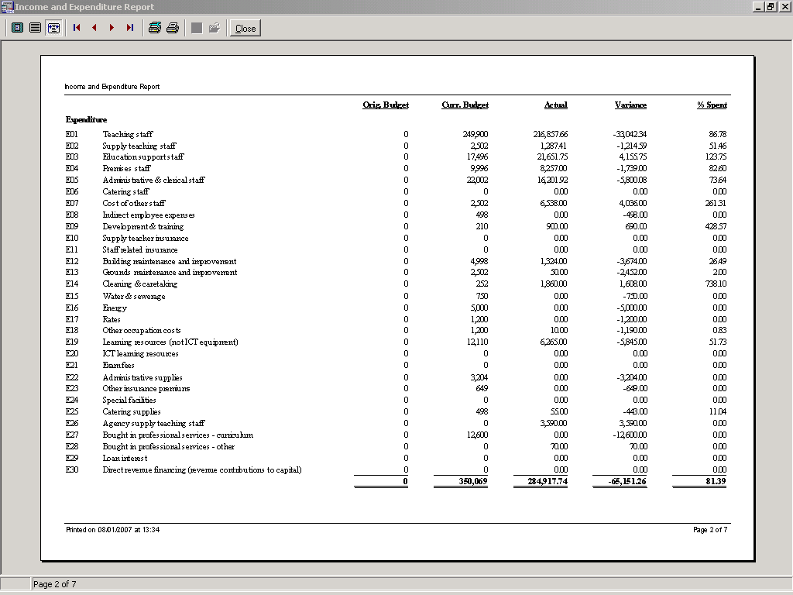

This must be generated immediately following completion of the bank reconciliation.

- Take the route
Reports > CFR > IE Report
- Select ‘Year to Period 13’
- Select Print to produce the report.

The Report can be sent to the LA via email by following the steps below.
When you produce the report at the top of the page,

- Click on the blue Printer Setup icon (please note this is not the Print Button) on the tool bar
- This brings up a Dialog Box, where it says Name, scroll down
- Select Cute PDF Writer (Adobe Pdf)
- Click on OK
- Click on the black Print icon on the tool bar, and then save.
- Depending on the IT setup in the school the above may not be possible so print scan and email as required

Send the saved Document as an attachment to schoolfinancereturns@hillingdon.gov.uk.

Cost Centre Summary (Ref: Section 9.4 of the Main Year End Guidance)

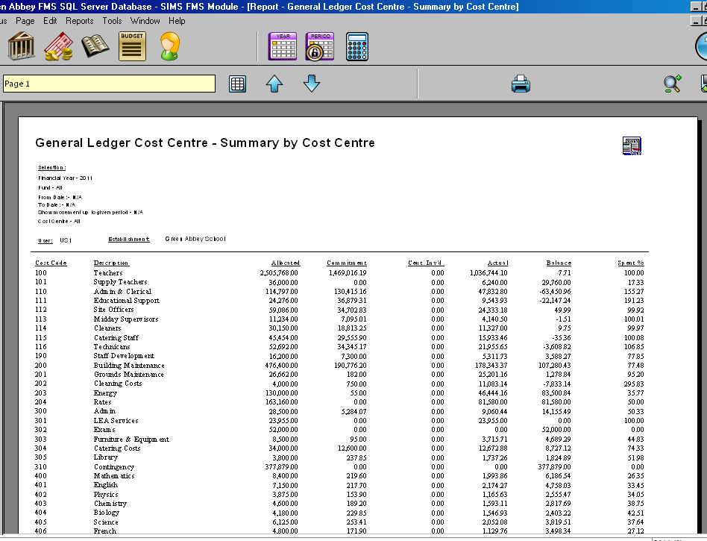

This report can be generated in two ways:
Firstly,
Take the route
- Reports > General Ledger > Transactions > Cost Centre Summary Transactions > Cost Centre Summary by Cost Centre.
- Leave the fund and date range blank and enter Period 13 in the ‘Show Movement up to Period’ box.
- For those schools that have more than one Fund, a Cost Centre Summary for each Fund should be produced separately and one for ‘ALL’.

Secondly,
Take the route
- Focus > General Ledger > Chart of Accounts Review > Click on all Cost Centre Browser (first one) > Click on Preview > Print.
- Brings the report on the Screen > Click on the full Screen icon > You can select the file type to save on the top left-hand side. Please choose either Excel or PDF.

Send the saved Document as an attachment to schoolfinancereturns@hillingdon.gov.uk.

Bank Reconciliation (Ref: Section 8.1 of the Main Year End Guidance)

Please note: The Bank Reconciliation and the Unreconciled Items reports should be run consecutively. It is important that no transactions are processed between producing these two reports.

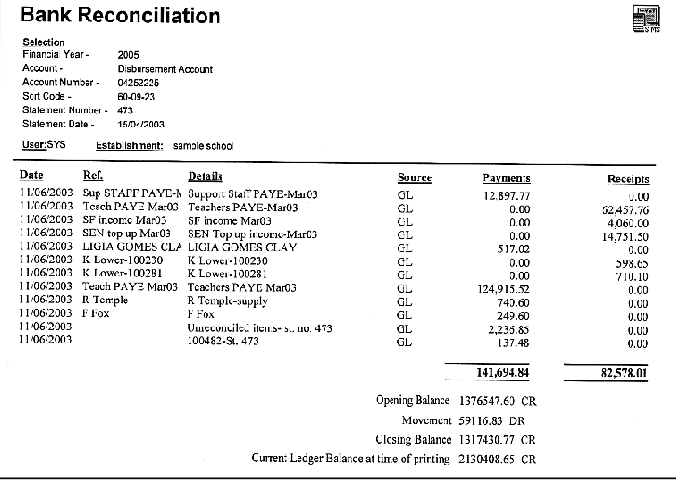

Bank Reconciliation – Un-reconciled Items (Ref: Section 8.1 of the Main Year End Guidance)

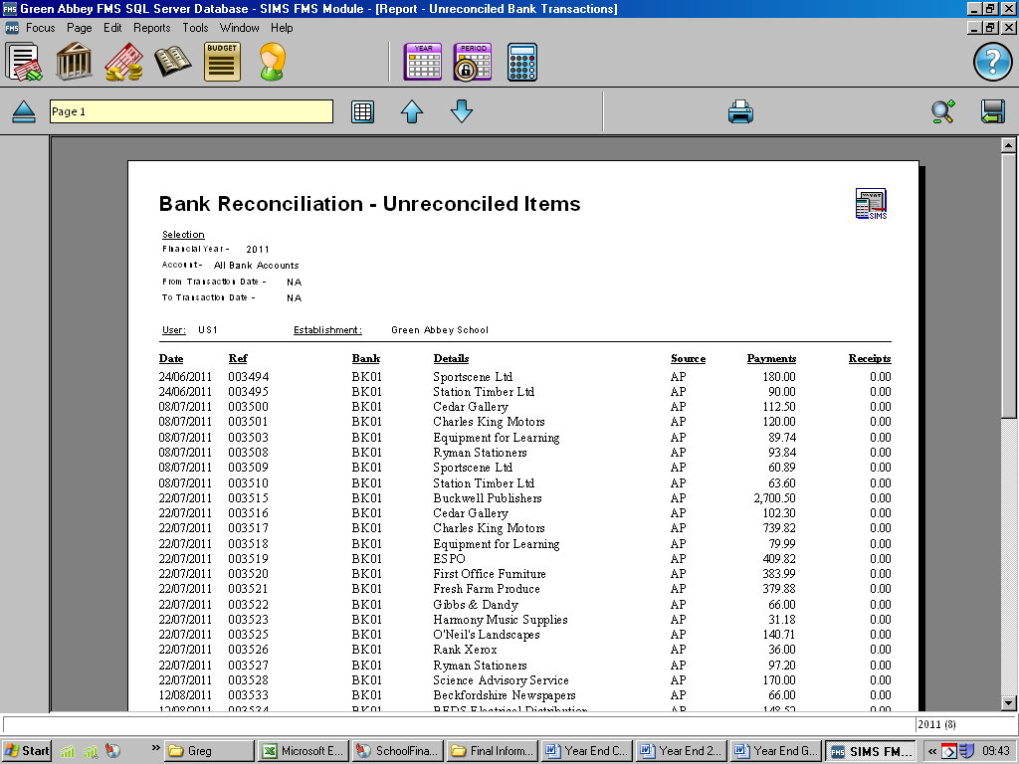

If you wish to e-mail the report to the LA, click on the 'Export to Disk' icon in the top right of the screen and save to disk in Excel 4.0 format or select an Excel icon.

Send the saved document as an attachment to schoolfinancereturns@hillingdon.gov.uk

Summary Trial Balance (Ref: Section 9.4 of the Main Year End Guidance)

- Reports > General Ledger > Trial Balance > Summary Trial Balance > By Ledger Code. Select Period 13, leave Fund blank and untick hide FC/FD

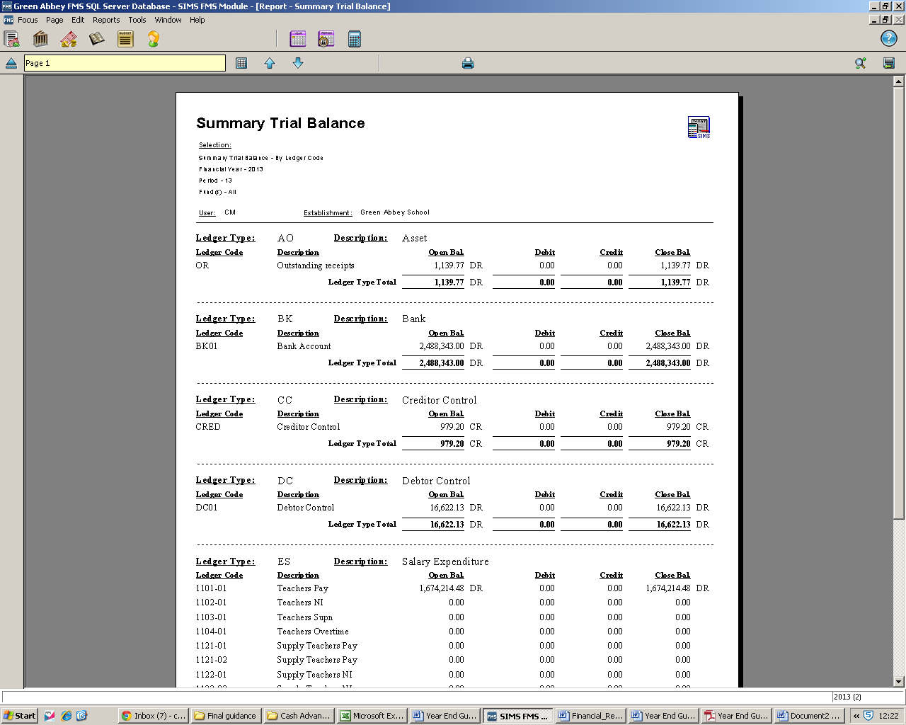

If you wish to e-mail the report to the LA, click on the 'Export to Disk' icon in the top right of the screen and save to disk in Excel 4.0 format or select an Excel icon.

Send the saved document as an attachment to schoolfinancereturns@hillingdon.gov.uk

VAT Submittal Reports (Ref: Section 8.2 of the Main Year End Guidance)

The Q4 VAT Submittal report must be dated to 31st March 2024. Please contact your Link Officer if this is not the case.

There are two VAT Submittal reports required by the School Finance Team, a scanned copy of the printed VAT Submittal (signed by the Headteacher) and an Excel version of the VAT Submittal (MTD).

Firstly, you will need to generate the ‘old printed’ VAT Submittal report so that the VAT period will be closed.

Select:
- Reports
- General Ledger
- VAT
- VAT Reports
- Click on the green + icon

This will take you into the VAT Period for which the report is required. (All reports that have been printed and submitted previously will appear on this screen).

Check carefully that the VAT Period date is 31st March and not the previous quarter if this applies contact your link officer.

The type of report required is chosen on the next screen
Please choose:

- VAT Submittal Report
- Select VAT and Net
- Print

Take care to choose the correct options before clicking the PRINT button.

A request to confirm that the report has been printed will appear.

BEFORE CLICKING YES - Check your printout to ensure it has net expenditure and income totals as these are required to complete our submission to HMRC.

If "NO" is selected then FMS will not record that a VAT submittal was printed and leave that VAT period open, allowing further entries to be made. This will cause complications in the following quarter, leading to different VAT values for reimbursement of VAT Claimed.

To avoid this, make sure that the VAT Submittal report has been printed correctly (see example below) then click YES to confirm print.

The VAT submittal report should show Net Output and Net Input against each VAT code.

The VAT Submittal Report must be signed by the Headteacher, dated, scanned, and emailed to the Schools Finance Team.

Please don’t forget to retain a copy of the signed report for the school’s records.

To confirm that the VAT quarter has been closed take the following steps

Select:
- Reports
- General Ledger
- VAT
- VAT Reports
- Click on the printer icon

You should now find that the option VAT Submittal Report has been greyed out. This confirms the quarter has been has successfully closed.

If for any reason the option is not greyed out, go back to step 1, and generate the VAT Submittal Report once again.

If in doubt, contact your link officer.

VAT Submittal Report (MTD) (Ref: Section 8.2 of the Main Year End Guidance)
Select:
- Reports
- General Ledger
- VAT
- VAT Reports

The FMS systems will show submittal dates for each quarter of the financial year

- Click on the printer icon

This will produce all your quarter’s VAT Reports including the VAT Submittal Report (MTD).

The type of report required is chosen on the next screen

Please choose:

- VAT Submittal Report (MTD)
- VAT and Net
- Preview (Changes from ‘Print’, once VAT Submittal (MTD) selected

Print has now changed
to Preview

Select the Excel or PDF icon and save the file to a suitable location. The total VAT to reclaim figure should be checked against the same total in the VAT Submittal (MTD) report. If they are different for any reason, contact your link officer.

Both reports, a scanned copy of the VAT Submittal and an Excel version of the VAT Submittal (MTD) can now be emailed to the team:

schoolfinancereturns@hillingdon.gov.uk or your Link Officer directly.

VAT Short Summary

(Ref: Section 8.2 of the Main Year End Guidance)

- Reports >General Ledger > VAT >VAT Reports
- Highlight quarter
- Click on the print icon

The type of report required is chosen on the next screen
Please select:

- VAT Short Summary Report
- VAT and Net
- Print

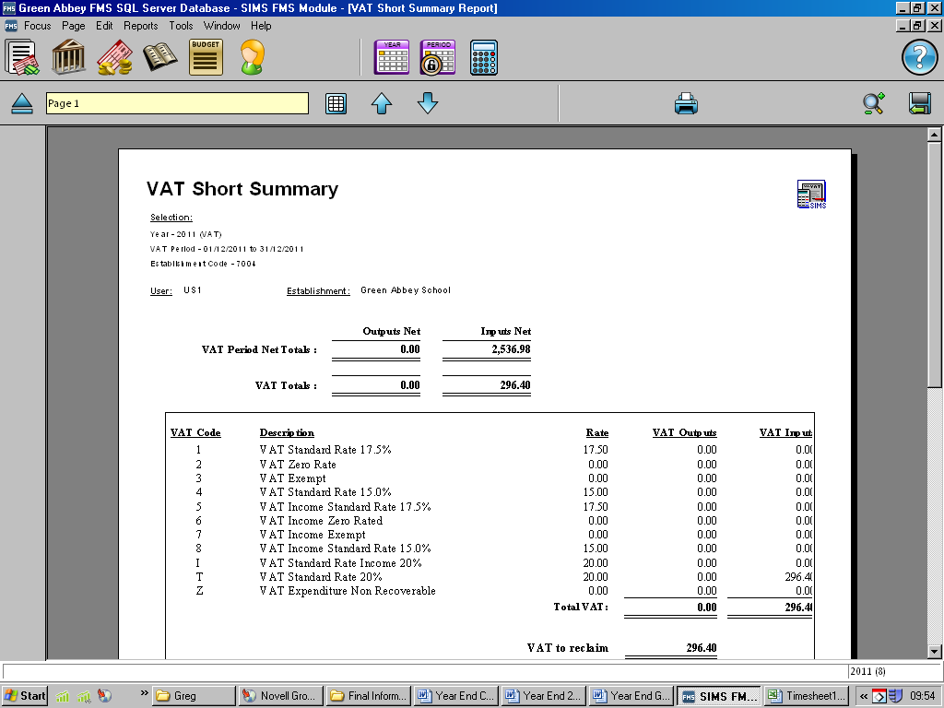

If you wish to e-mail the report to the LA, click on the 'Export to Disk' icon in the top right of the screen and save to disk in Excel 4.0 format or click on an Excel icon.

Send the saved document as an attachment to

schoolfinancereturns@hillingdon.gov.uk

VAT Full Report (MTD) (Ref: Section 8.2 of the Main Year End Guidance)

A Full VAT Report for Q4 is required to facilitate sample invoice checks.

After printing the VAT submittal report for the quarterly return please select:

- Reports > General Ledger > VAT
- VAT Reports
- Highlight last quarter
- Click on the print icon

The type of report required is chosen on the next screen

Please select:

- VAT Full Report (MTD)
- VAT and Net
- Preview

This will then produce the report on the screen.

.

Select the Excel icon and save the file to a suitable location. This can now be emailed to the team, schoolfinancereturns@hillingdon.gov.uk or your Link Officer directly.

Submission of Staff Remuneration Form

Due to the contents of the Staff Remuneration Form (Appendix E) which contains names and salary data of individual staff, it is important that data protection regulations are observed when forwarding the information via e-mail. As Appendix E and the supporting documentation will be regarded as strictly private and confidential, returns must be submitted using a secure method of transfer.

Provided below are two options of sending completed Appendix E to the Schools Finance Team.

Option 1 – Using USO-FX which is a secure transmission facility

or

Option 2 – Password protecting the staff remuneration spreadsheet (Appendix E) in excel before transmitting it to your link finance officer. Please do not provide the password on the same e-mail, it must be sent on a separate e-mail or via telephone to your link finance officer.

How to upload a file securely using USO-FX2

Firstly, go to the main page

https://my.uso.im/usofx/Share.aspx

Log in with your Atomwide password

Login using your existing username and password.

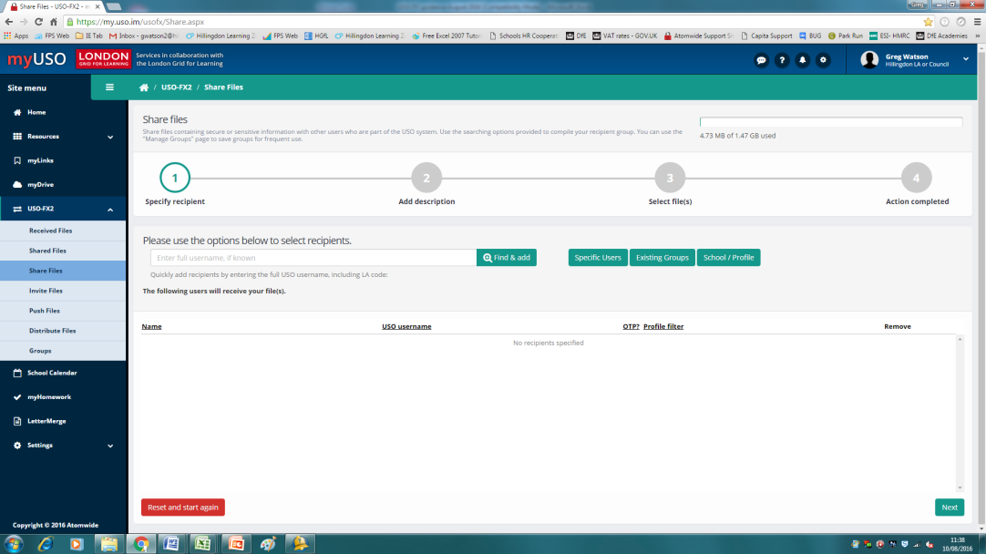
Check 'Share Files' is highlighted

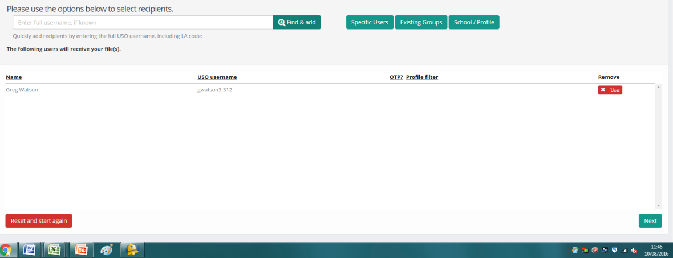
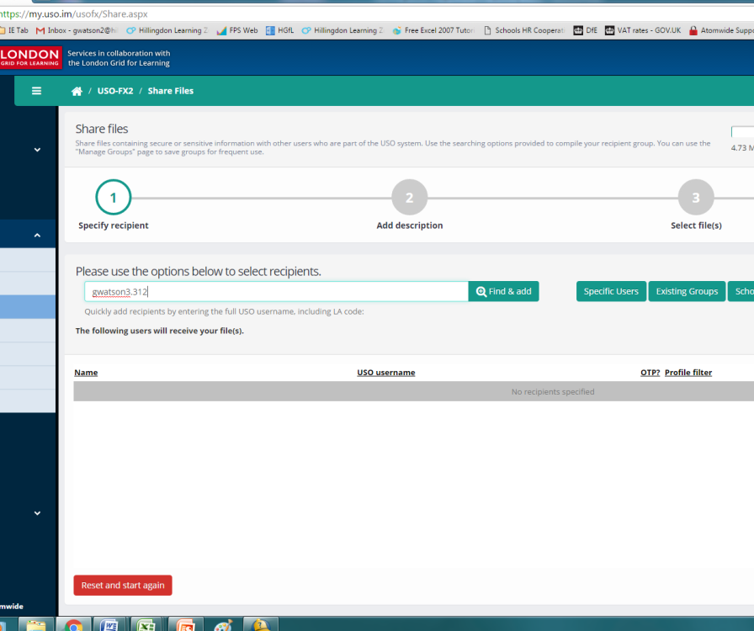
Check name is correct and click on ‘Next’

In the recipient’s box, type the name of the person you are sending the file to e.g., gwatson3.312, ddevgon.312 sdenbeigh.312 etc.
Then 'Find & add'

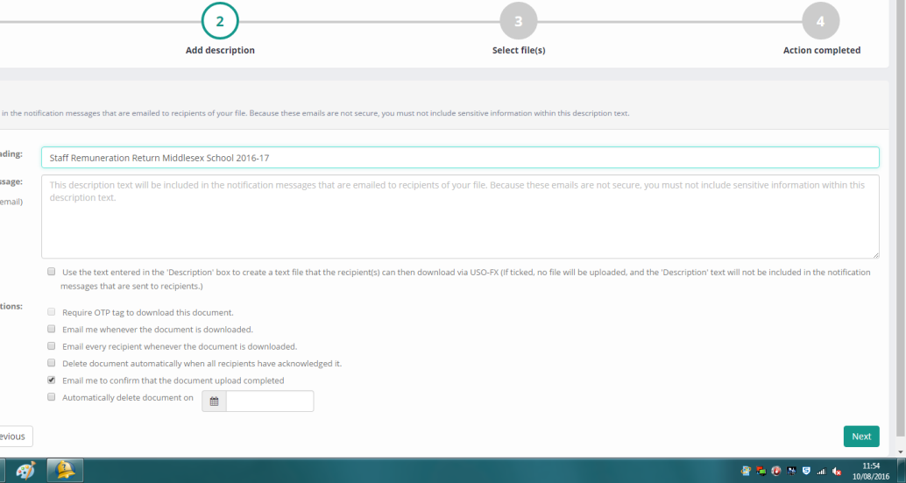
Enter suitable wording such as Staff Remuneration Return 2023-24 from xxx Primary School in the 'Heading' box and then click on 'Next'
You will receive the following message when the file has been uploaded successfully.
Select 'Upload file(s)' and Finish to complete

