Who Can Support Inclusion & Nurture
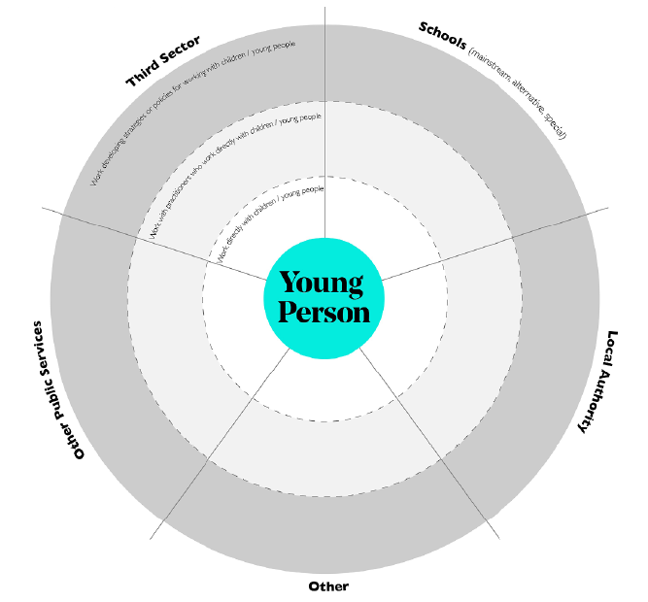

Who are some of the key players in our system?
What is their proximity to the young person?
How are they connected to others? How are they interconnected?
Who do they depend on to be able to do their job, i.e., support pupils, successfully?
Who depends on them?
How well are they working together with others?
Do we work collaboratively?
What could be improved in how players work with one another?

