**Moderation End of KS2**

Building on your initial reading of the child’s first piece, now refer to the teacher assessment (TA) framework.

What evidence does this piece give you towards demonstrating that the pupil is

working at the expected standard?

| **The pupil can:** |
| --- |
| write effectively for a range of purposes and audiences, selecting language that shows good awareness of the reader *(e.g. the use of the first person*  *in a diary; direct address in instructions and persuasive writing), using similar writing as a model (WAGOLL and other texts)* | |
| in narratives, describe settings, characters and atmosphere, using a variety  of techniques to engage the reader and choosing appropriate vocabulary that creates a consistent picture, *e.g. verbs, preposition phrases, fronted adverbials, expanded noun phrases, relative clauses* | |
| integrate dialogue in narratives to convey character and advance the  action, *using correctly punctuated speech* | |
| select vocabulary and grammatical structures that reflect what the writing requires, doing this mostly appropriately (e.g. using contracted forms in dialogues in narrative; using passive verbs to affect how information is  presented; using modal verbs to suggest degrees of possibility) | |
| use a range of devices to build cohesion (e.g. conjunctions, adverbials of  time and place, pronouns, synonyms) within and across paragraphs | |
| use verb tenses consistently and correctly throughout their writing | |
| use the range of punctuation taught at key stage 2 mostly correctly, *e.g. commas after fronted adverbials, apostrophes for plural possession, brackets, dashes and commas to indicate parenthesis, commas for clarity*  *and to avoid ambiguity, hyphen,semi colon and colon to introduce lists* | |
| spell correctly most words from the year 5 / year 6 spelling list,* and use a dictionary to check the spelling of uncommon or more ambitious vocabulary | |
| maintain legibility in joined handwriting when writing at speed.2 | |

**Think about the following questions.**

Which judgements do you need to confirm by looking for further evidence in additional

pieces of writing?

Which other areas or ‘pupil can’ statements do you need to explore when looking at

additional pieces of writing by this pupil?

Write your responses to A and B in the table, then convert these into Questions or

Lines of inquiry for the next steps in this moderation.

If all statements can be found, move to the GDS to see what evidence there is for those statements.

**Line of Inquiry for EXS**

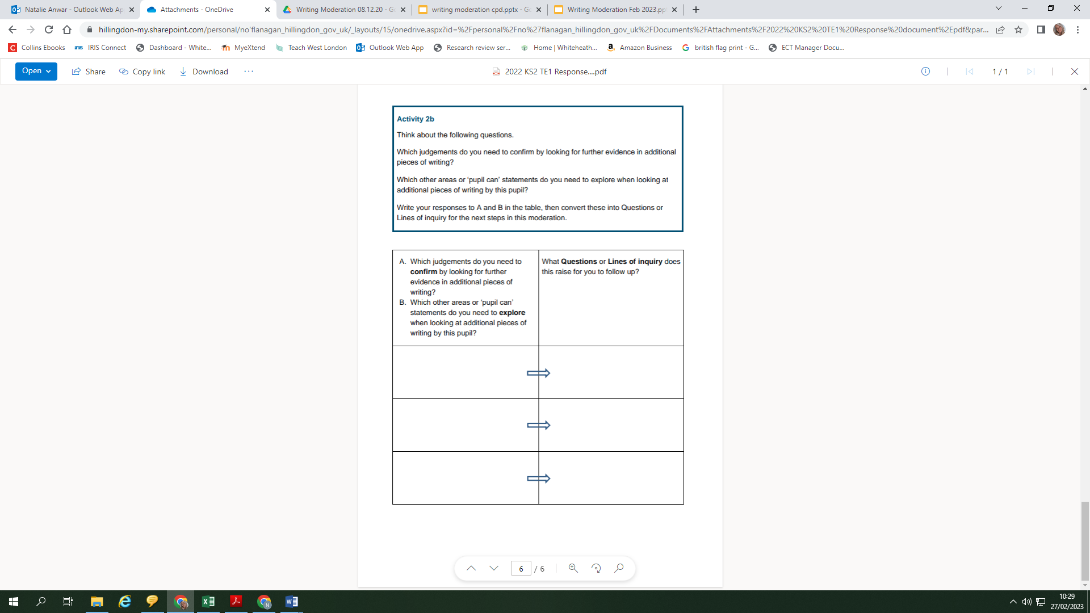

| **The pupil can:** | |
| --- | --- |
| write effectively for a range of purposes and audiences, selecting the appropriate form and drawing independently on what they have read as models for their own writing (e.g. literary language, characterisation,  structure) |
| distinguish between the language of speech and writing3 and choose the  appropriate register |
| exercise an assured and conscious control over levels of formality, particularly through manipulating grammar and vocabulary to achieve this |
| use the range of punctuation taught at key stage 2 correctly (e.g. semi- colons and colons *to mark boundaries between clauses, dashes and*  *hyphens*) and, when necessary, use such punctuation precisely to enhance meaning and avoid ambiguity |

**Line of Inquiry for GDS**

