**Afternoon session - Hillingdon Achievement for All Attendance Conference**

**Monitoring and evaluating data to target interventions**

***Prompt 1:  Based on the ‘data quality characteristics’ shown here, and the issue of data protection regulations, what are the key challenges for your school?  What steps can you take to more fully integrate absence data analysis with your existing MIS capability?***

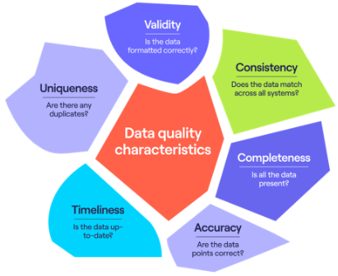

***Prompt 2:  As well as data targets around attendance outcomes, what data targets could your school have around trends in attendance, relative performance to other schools, cohort targets for intersectional groups, or process targets for absence management?***



Trend targets:

Relative performance targets:

Cohort targets:

Process targets:

***Prompt 3:  In-school data shows that absence rates for older female students (Y5 and Y6 if primary, Y10 and Y11 if secondary) with high levels of prior attainment increase in the period leading up to in-school assessments and national tests.  Student and family voice processes have indicated that there are mental health and wellbeing concerns for this group about anxiety around assessment periods.***

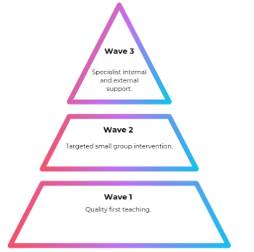

What targeted, small group (Wave 2) provision could you put in place to tackle the causes of these anxieties without removing students from the classroom?  How would subject leads be involved in addressing this issue?

How would you ensure that teachers are equipped to make adaptations to quality first teaching (Wave 1) for the students identified in the group?  In what ways would you capture the impact of the graduated approach?

