How to view your online applications

Below are the instructions for viewing the September 2026 online application forms for children attending your school.
You will firstly need to log into yourLGFL or USO.account. If you not have either of these please contact me at admissions@hillingdon.gov.uk

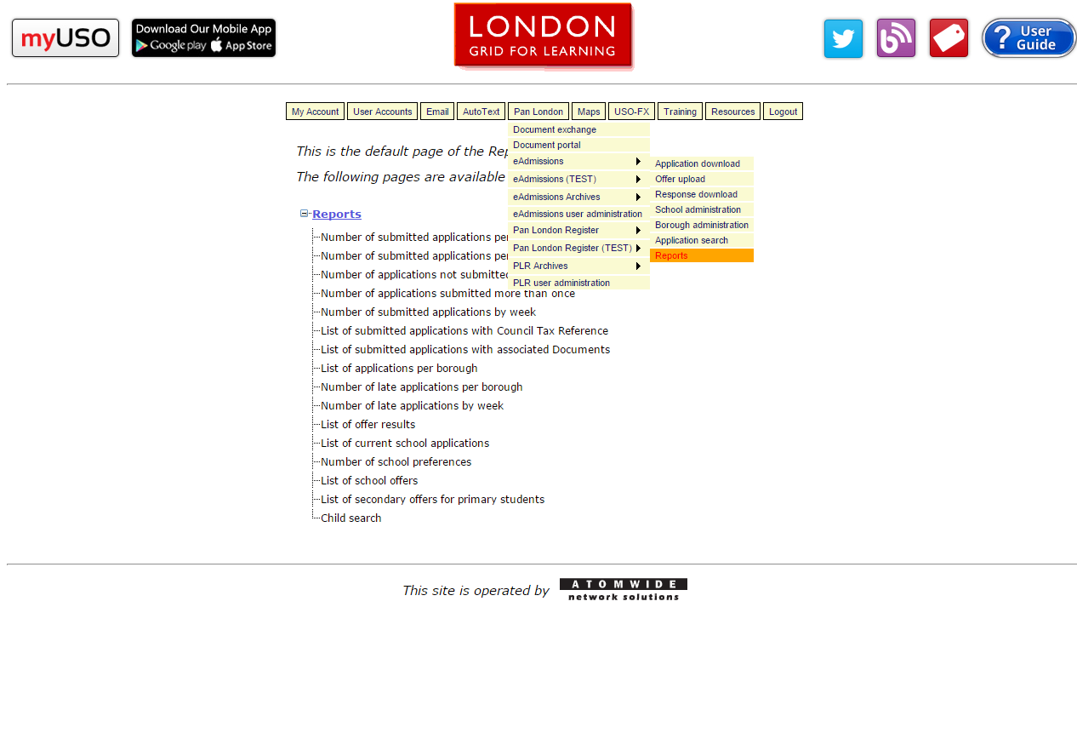
Once you have logged into your account, please select 'Pan London' and then 'Reports'

Please note, if the parent has not selected you as their current nursery, you will not be able to view if they have completed an application.
I will contact you nearer to the closing date to advise you who has applied by paper so you do not chase parents who have already applied.

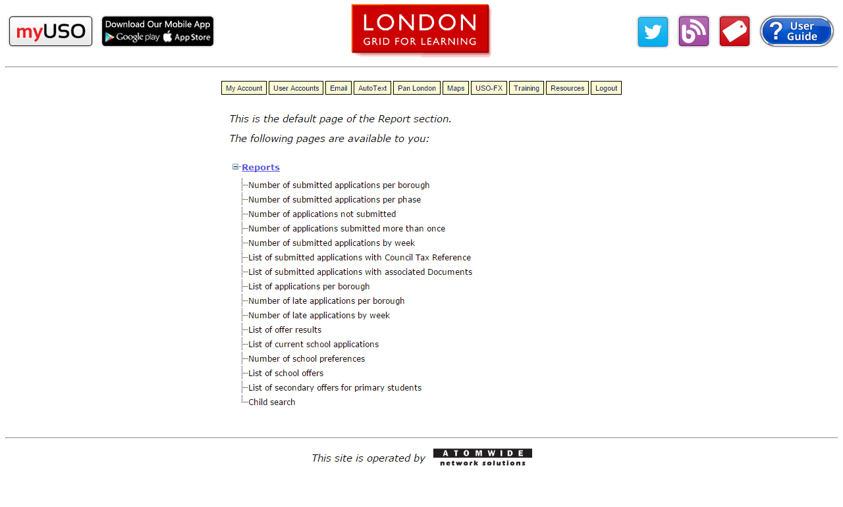
Then you need to select 'List of current school applications' and you will be taken to the page below.

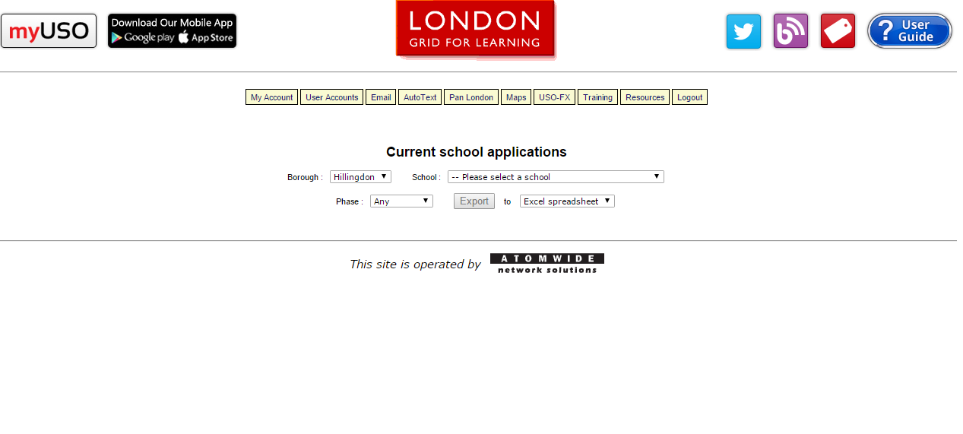
The top two drop downs should automatically be 'Hillingdon' and the name of your school.
Select 'Reception' as the phase and then Export to an Excel spreadsheet if needed.

