Writing and moderation briefing 1 2023
Writing samples

Pupil A- WTS
The Coming of the Iron Man
On the very brink, on a dark night, I stood. I came to the top of the cliff. How far had I walked? Nobody knows. Where had I come from? Nobody knows. How was I made? Nobody knows. I (new to this mysterious world), stood tall on the top of the cliff. I could taste what I though was sand blowing into my mouth, it was disgusting. The wind, that sang though the tree branches, creeped through my rusty fingers, it pressed powerfully against my back. I could see and hear the sea, eating away at the edge of the rocky hard beach. There I stood. Clueless creatures flying above my dustbin-shaped head – soaring and ducking in and out of the cotton candy hazy cloud. A stench. A reek. Below me there was nothingness. Just the noise of the sea. For the last time. I got punched by the wind into the deep blue sea below.

Pupil B- EXS
The Coming of the Iron Man
I (a foreigner in this world) was slowly, rock by rock climbing up a steep hill until I had finally reached the peak. Where had I come from? Nobody knows. How far had I walked? Nobody knows. How was I made? Nobody knows… exept me. As I looked over the edge I saw it: the sea. I had only ever heard rumours about it, but there it was, the enchanting blue wave engolving the rocky yet dusty ground below. I sat staring into the blue abyss as the wind whistled though my dangling feet. Suddenly I saw strange creature flying above me, they were only there for a few seconds before flying back into a tree nearby.
As I stood up, a huge gust of wind forcefully pushed against my collosal iron back and sung through my finger; this happened a few times as I stood listening to the sea. “Hush hush hush,” it whispered. One last time, the wind – that was forcing itself against my immense back – pushed me into the deep gorge below. “Oh no,” I muttered. As I was recklessly tumbling through the dusty air, toward the rocky ground below, I thought to myself, I could never trust the wind again!
CRRRAAAASSSHHH!

Pupil A- WTS
A letter to instruct
Dear sir/Madam
On the third of September, Britian officially declared War with Germany. You are receiving this letter because you have children under 16 in your house hold. Although it is not the best thing for your children, it will keep them safe from any bombs. Children and infants will be safer when evacuated to the country side. Your children will be evacuated on the 6th of January 1940.Your children will need to be provided with: a tooth brush, clothes, toiletries, gas marks, label (address and name) and a ration book. It is optional if you want to bring a teddy or a toy. There will be a squad of 30 on each train and we will ensure that siblings are on the same train. Under Government regulations, children are required to have limited luggage.
Thank you for reading this letter.
Yours sincerely
Bristol County Council

Pupil B- EXS
A letter to instruct
Dear Sir/Madam,
As you will know, Britain officially declared war on Germany on the 3rd of September 1939. You are receiving this letter because it has been identified that you have 1 or more than 1 persons – who are under the age of 16 – in your household; this letter is to inform you of the evacuation scheem. Evacuating your child is of the upmost importance. Evacuation is imperative: it will ensure their safety.
Children will be evacuated from the cities to the countryside. A ‘squad’ of 30 children shall be evacuated at a time for organisation purposes. Siblings will be kept together at all times.All children will need to pack: a spare pair of clothes, their gas mask (which should be around their neck in case of an emergency), a small memory - a stuffed toy or a photo - and a rashon book. If they are supplied with everything, if they are prepared, then it will make the evacuation process easier for everyone.Your unit will be led by Miss Jones. The meeting point is Bristol Tempel Mead station on Tuesday 11th January 1940. Please arrive promptly at 11:00 am.
Yours sincerely
Bristol City Council
Pupil A- WTS
Newspaper report
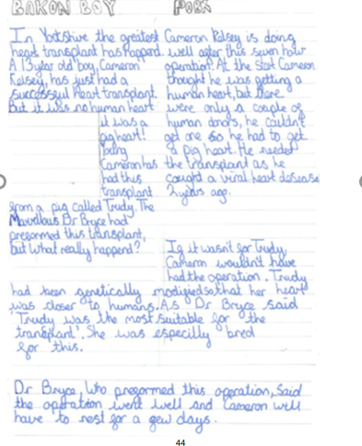
Pupil B- EXS
Newspaper report
