XXXXXX SCHOOL PAYROLL PROCEDURES
(DRAFT FOR USE BY SCHOOLS)

Introduction

(name of school) uses (name of payroll provider) as its payroll provider. Two/three members of staff are set up as the payroll provider's contacts for the school and they are (name and title of school contact) and (name and title of school contact) and (name and title of school contacts). These members of staff are able to contact the payroll provider and have access to online payroll systems.

In case of emergency if all contacts are absent. The payroll system passwords are sealed and kept in the school safe.

(name of payroll provider) contact details are as follows:

(Main contact name and title)
(phone number)
(email address)
Website address for online payroll system is (URL of payroll system if applicable)

Other Registrations

The school will also be registered with outside bodies to process elements of the payroll:

(Examples)

HMRC (to set up being an employer)
Childcare Vouchers e.g. Kiddicare
Additional Voluntary Pension contributions (AVC’s) e.g. Prudential

Details of these registrations are held in (location)

Starter/Leaver and Contract changes

PROCEDURES TO BE LISTED

- How to obtain and complete salary change forms

All starter, leaver and contract changes must be authorised by the Headteacher. It must be possible to provide evidence of this authorisation to auditors if required.

The Headteacher cannot authorise any changes in connection with his/her own salary. These should instead be authorised by the Chair of Governors. The only exception to this is when pay awards are given to all staff.

How to provide information to payroll provider

PROCEDURES TO BE LISTED

- Instructions to logon to payroll system
- Instructions for starters/leavers
- Instructions for change of contracts including grades/increments/over 5 years service (and 10 years for over scale point 40)
- Instructions for overtime
- Instructions for sickness/absence /special/maternity/paternity/other leave
- Instructions for pay awards

Deadlines for the above information to be given to the payroll provider are (list deadlines or give information of where these can be found) but only after authorisation by the Headteacher. It must be possible to provide evidence of this authorisation to auditors if required.

The bursar/finance officer or whoever is the usual member of staff that processes payroll staff contract changes, must not give any instruction to the payroll provider in connection with their own salary. For these (person to do this) must instruct the payroll provider. The only exception to this is when pay awards are given to all staff.

Childcare vouchers

(name of childcare voucher company) is the provider of the school employees' childcare voucher scheme. Contact details are:

(Main contact name and title)
(phone number)
(email address)
Website address for online system is (URL of childcare system if applicable)

PROCEDURES TO BE LISTED

- How to obtain/download any required forms
- How to notify payroll provider

Checking and Approval of Payroll

PROCEDURES TO BE LISTED

- Instructions for receipt /viewing and printing of payroll reports for approval (if Appendix 2 is insufficient)

See Appendix 1 for checking payroll (delete methods not used, please note method 1 is the simplest, if alternative method used provide instructions)

Check individual payments are correct and keep evidence of this.

Liaise with payroll provider to make corrections where errors are found.

Headteacher must sign and date payroll report(s) to give authorisation, before member of staff approves payroll with provider.

PROCEDURES TO BE LISTED

- Instructions for approval of payroll online (see page 11 Appendix 2 for Dataplan procedures)
- Instructions for posting payments on FMS can be found from page 13 Appendix 2

Payslips

(Do these need to be distributed? If so provide instructions)

Document storage

Payroll reports and salary information including overtime and absence returns are filed in (state location). Personnel information is filed in (state location)

All information must be treated as strictly confidential.

APPENDIX 1

SALARY VARIANCE MONITORING
Staffing makes up the majority of a school’s expenditure so this should be a priority area for checking and monitoring. It has always been important to check that salaries are being paid correctly and that any errors are spotted as soon as possible. However, some audit reports have highlighted that salary checking is not taking place in all schools.
Schools may have alternative systems in place already but, if not, this guidance gives three options on how to check payments to individual staff. The most straight forward is Method 1.

METHOD 1: USING SIMS FMS6 SALARY PROJECTION REPORT - COMMITMENTS
Requirements - for this method of checking the staff contracts on Sims Personnel 7 have to be correct to produce accurate commitments. Timing is crucial for this method as the report will only show the month's commitments from the 1st of the month until the salaries are posted. It is not possible to produce a report showing commitments for past months, even if salaries have not been posted.
The report required is generated using the route:
- Focus
- Personnel Links
- Salary projection
- Click on report button
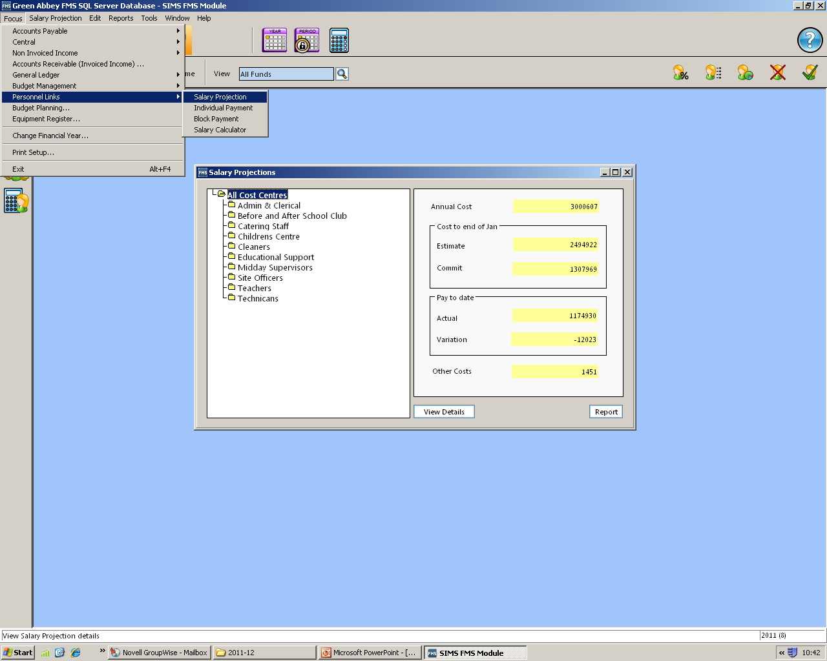
- Click OK

Report button
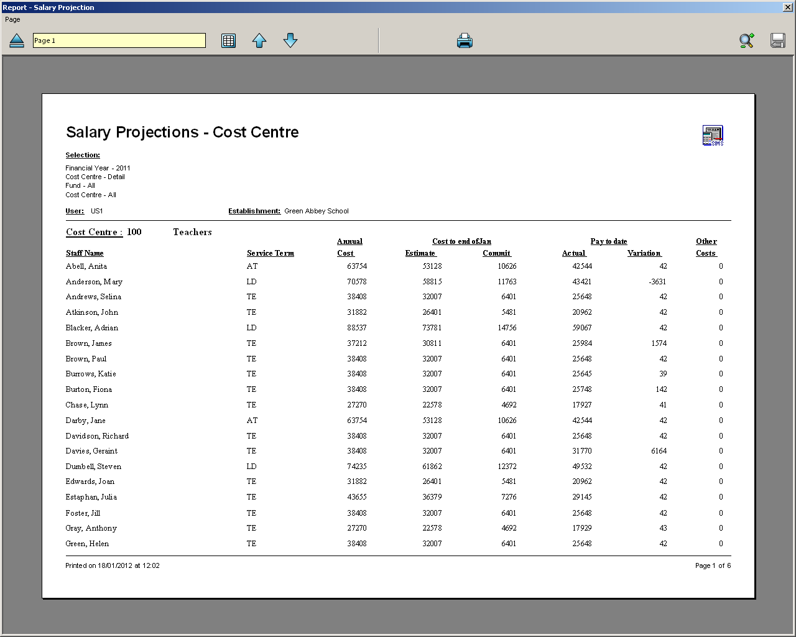
A report listing all staff will generate: What we are interested in is the "Commit" column

This list can be used as a checklist to compare the total cost to the school for individual salaries.
Please note if salaries have not been processed up to and including the previous month, then all outstanding commitments will show not just the month stated.

METHOD 2: USING SIMS FMS6 SALARY PROJECTION REPORT - VARIANCES
Requirements - for this method of checking the staff contracts on Sims Personnel 7 have to be correct to produce accurate commitments. It is best to start this at the beginning of a financial year as the report used gives year to date figures only.
The report required is generated using the route:
- Focus
- Personnel Links
- Salary projection

Click on report button
This screen will appear:
Choose Cost Centre, Service Term or Name for ordering the report.
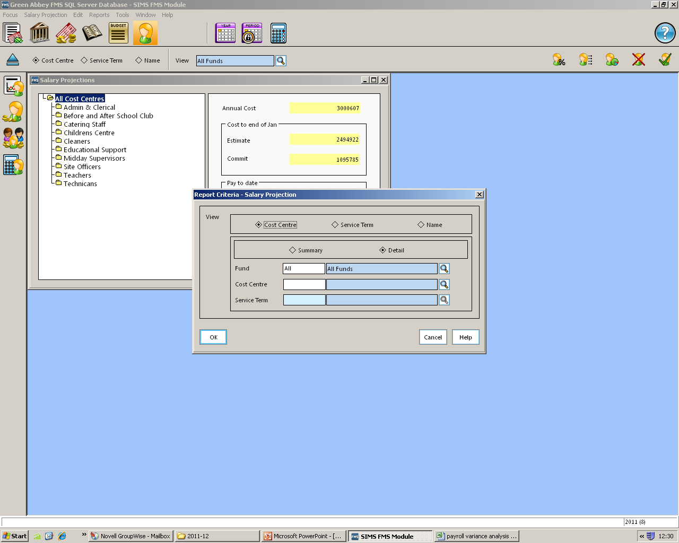

Click OK

A report listing all staff will generate:
What we are interested in is the second to last column – “Variation” under pay to date.

On this Teaching Staff page of the report variations can be seen that are due to items including: £3631 maternity leave, £1574 arrears, £39 GTCs with a rounding (please note GTC payments are no longer required), £142 and £6164 – variances that needs investigating

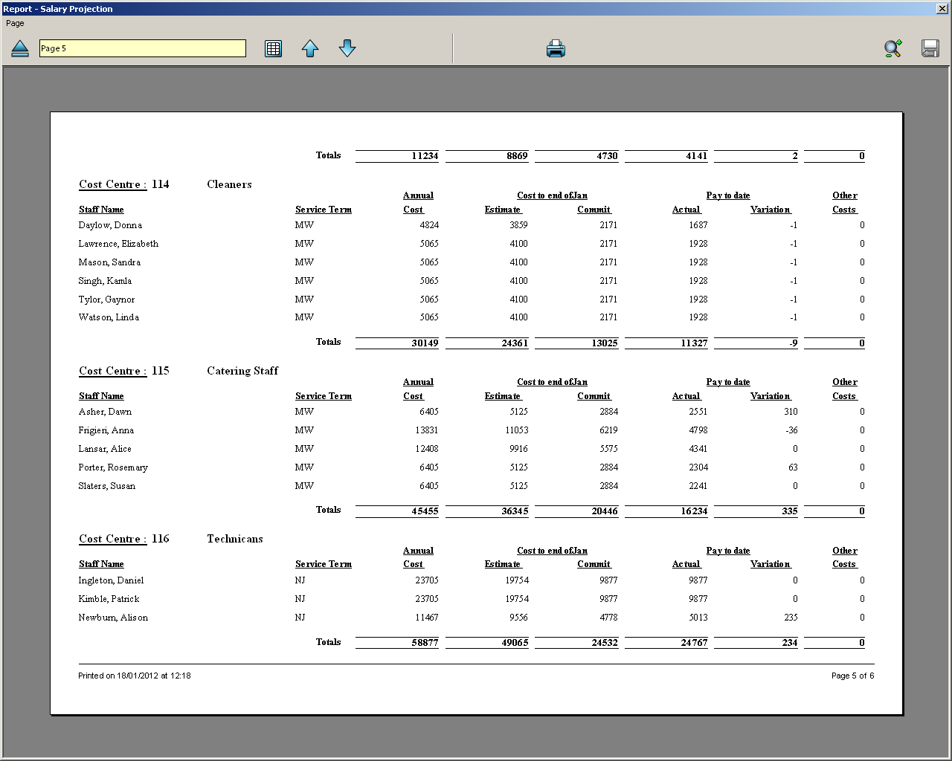
On the Support Staff page above, in the Cleaning Staff cost centre, variations can be seen that are due to items including: £310 overtime, -£36 unpaid leave, £63 overtime. Other cost centres show small rounding amounts.
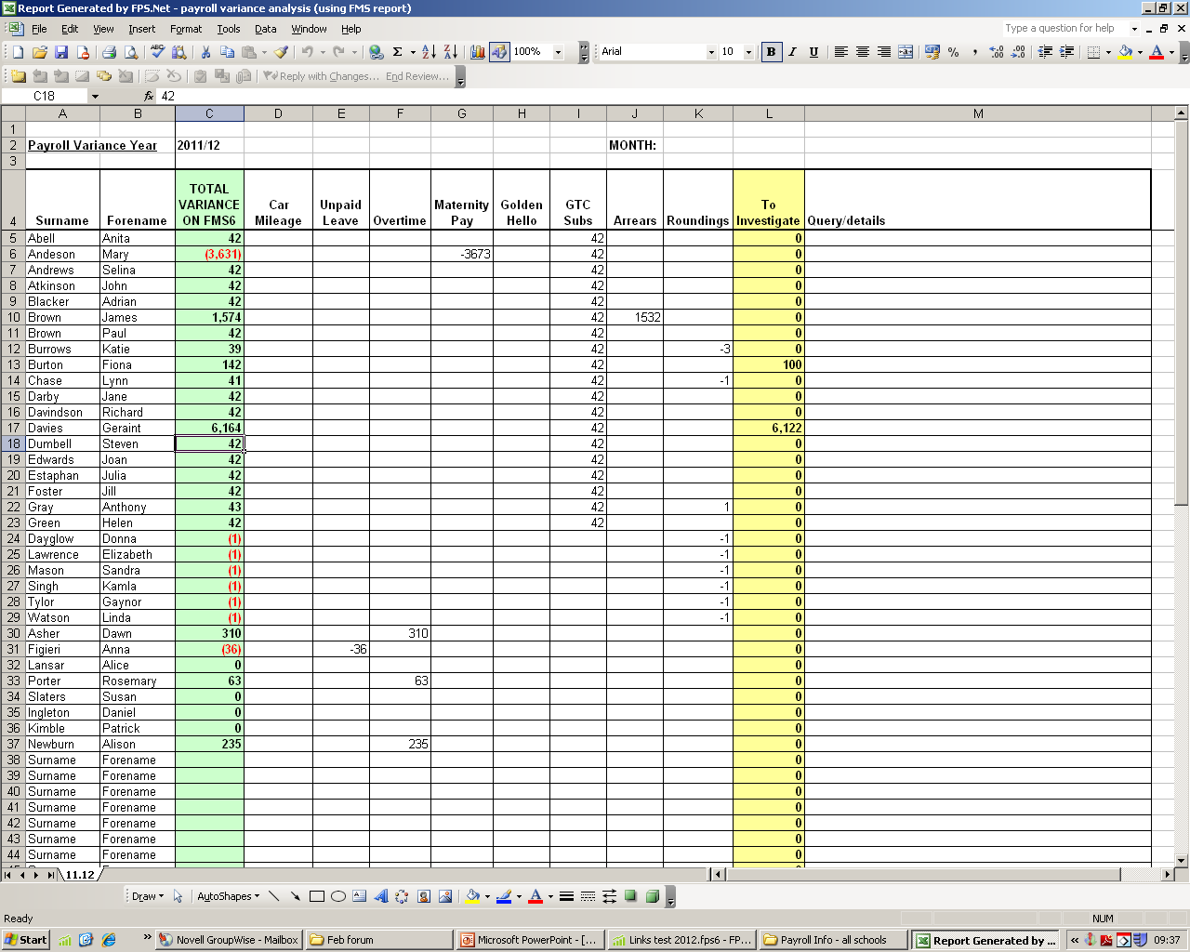
The Payroll Variance Report is an excel spreadsheet that can be saved for each month and updated each subsequent month with the cumulative figures. The variances from the FMS report need to be completed on the green column:
Once the green column is completed enter the amounts that are known in the white columns. Each month needs updating by overtyping of previous months totals. Any unexplained amounts will show in the yellow column which is operated by a formula. It is helpful to use the query/details column to remind of previous findings and this is a clear trail of reasons for additional and one-off payments.
It is recommended that each month’s spreadsheet is printed and kept with salary records to evidence checking.

METHOD 3: USING HCSS BUDGETING SOFTWARE - SALARY MONTHLY PROFILE REPORT
Requirements – a budget scenario with up to date staffing details. The advantage of using this method is that a single month’s commitment can be viewed on the report so this system can be put in place at any time during the year.
For this method the HCSS Budgeting scenario must be kept updated with staff contract changes. Once your budget is set, create a separate scenario. Each month refresh this scenario from SIMS.Net Personnel 7 (if you have the link and Personnel 7 is up to date) or update new staff changes manually (if no links).
On Menu under Reports select:
- Reporting Module
- Pupil/Staff Reports
- Staff Monthly Profile

This screen will appear:
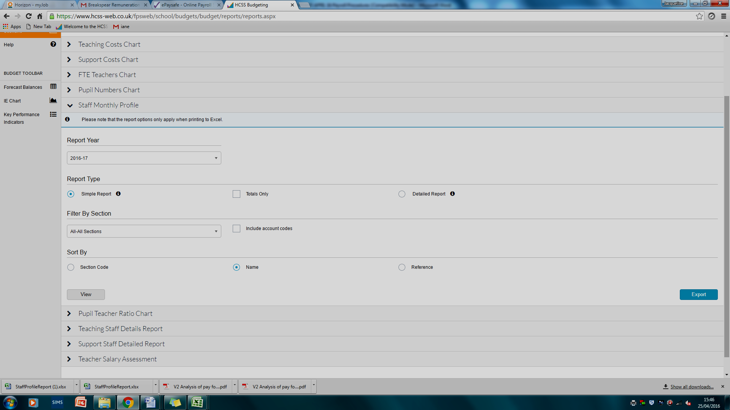

Options are available to choose level of detail, who is included and the ordering of the report. These options only apply to reports printed to Excel.
The options shown – simple report and Name buttons selected will generate this report:
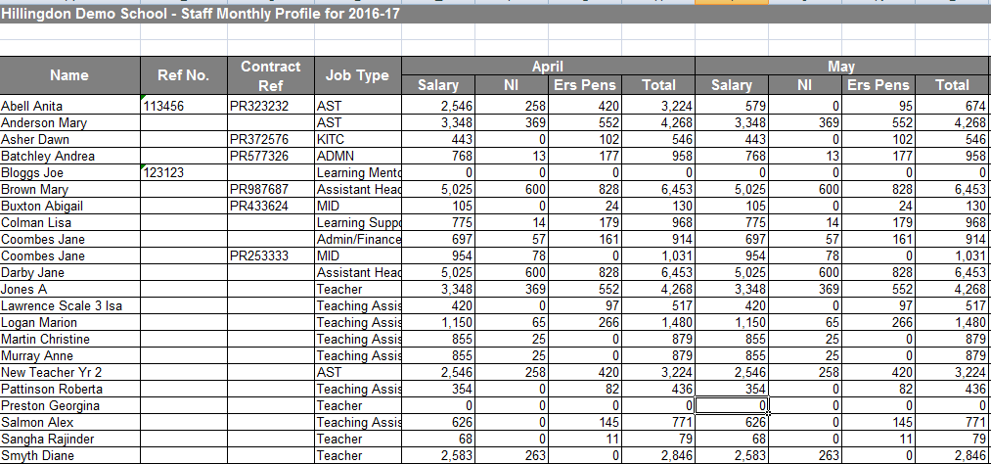

The columns for the months not required can be deleted and this used as a tick list for checking salaries. This report shows the breakdown of employer salary on costs which is useful when investigating variances and comments can be handwritten if there are variances.
A more detailed report with cumulative totals can be generated by selecting the detailed button.
Alternatively actual salaries can be entered onto the spreadsheet and the variance is calculated automatically but this does take time.

APPENDIX 2

GUIDANCE FOR POSTING OF SALARIES ON FMS FROM DATAPLAN REPORTS

This guidance is designed to assist schools in posting salaries and associated elements correctly on SIMS FMS6.

STEP 1 – Approval and checking of payroll

Initially Data Plan will email requesting that the payslips and payroll analysis are approved.

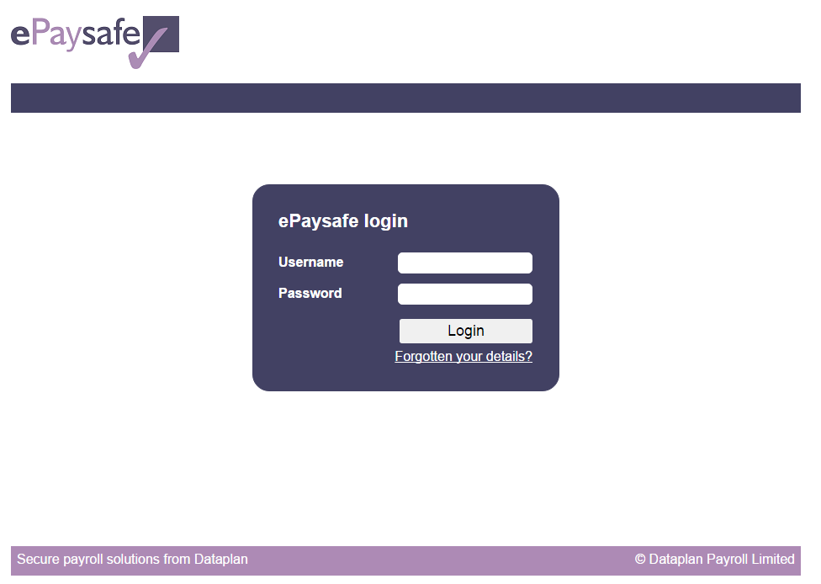
Login to ePaysafe - https://www.epaysafe.co.uk, using your username and password. Then answer the security question that you have already set up.

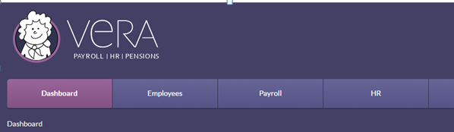

This will bring up the VERA welcome screen. Click on Payroll.
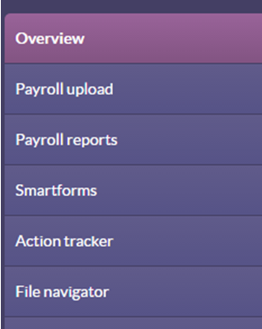

Choose Overview

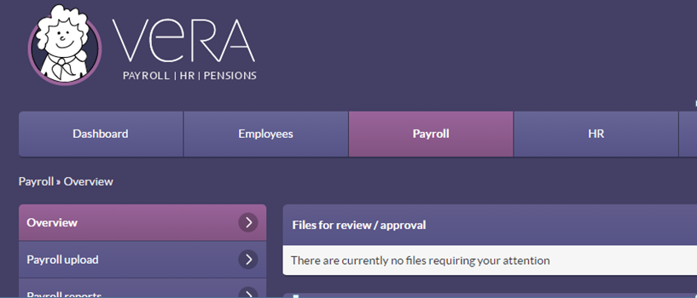
The first section "Files for review/approval" shows those files requiring approval, analysis and payslips for the current month. . These will appear approximately 3-7 days before the pay date. Dataplan will notify the school's designated contacts by email.

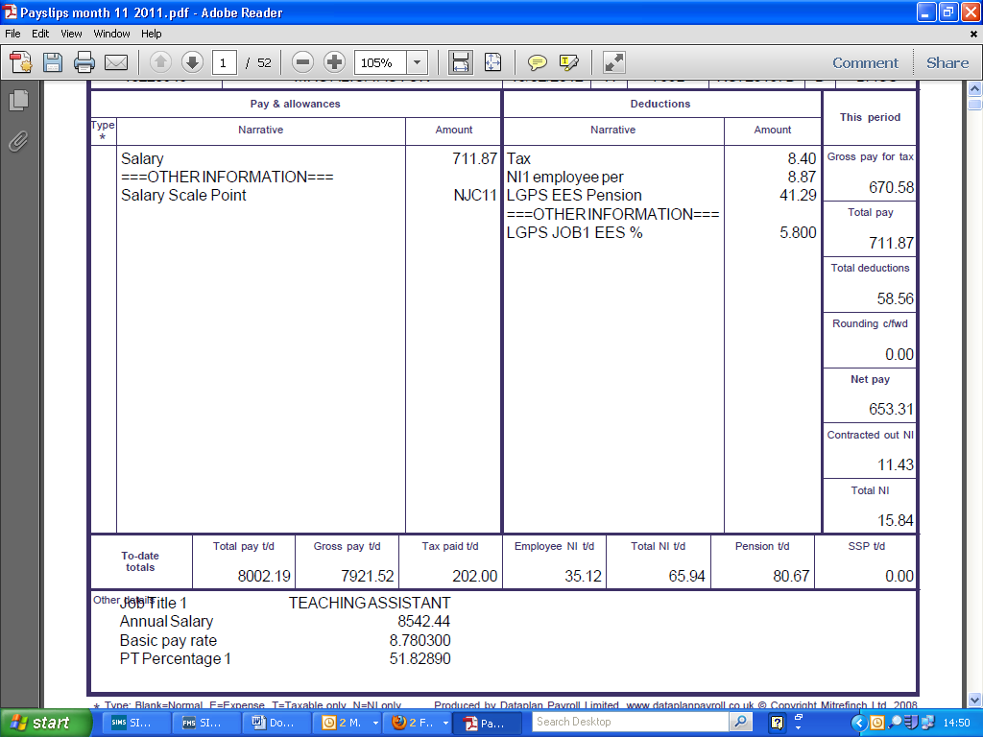
Click on the payslips and the following will open in PDF. You will be able to check each staff member’s payslip. Remember to check additional hours, absence and any other variations to pay have been recorded correctly. In emergencies i.e. if all E-Paysafe users are not available, the payroll provider should be contacted to make alternative arrangements.
If totals are correct and you have checked your individual salaries, (with approval/agreement on variations with HT) you can approve the payslips and analysis.

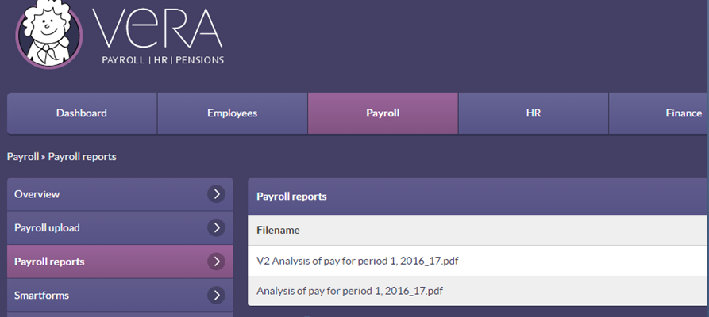
Once approved pay reports can be obtained by selecting Payroll > Payroll reports.

STEP 2 – Completing School Payroll Reconciliation Spreadsheet (Dataplan may complete this for you)

Once salaries have been approved, we recommend that you use the School Payroll Reconciliation spreadsheet to calculate the required salary journals to be posted onto SIMS FMS6.
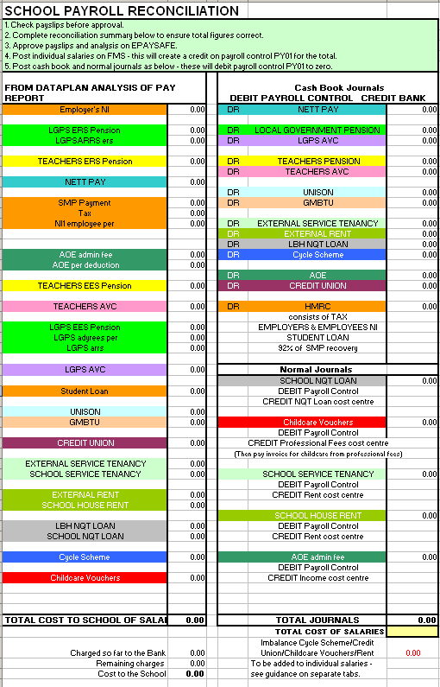
This spreadsheet will also ensure that these journals balance with the total cost of salaries to the school.
Normally Dataplan will complete this reconciliation sheet each month. It can be found on VERA using the route Payroll > File Navigator.
These are Cashbook Journals
These are Normal Journals which will not affect the bank account.
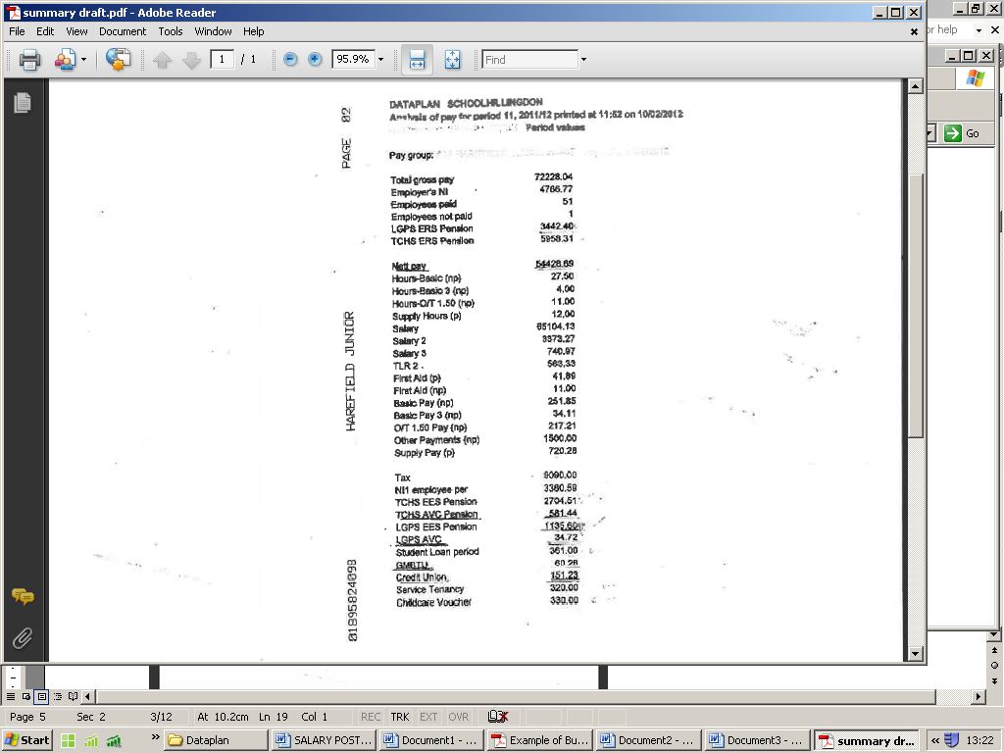
If the School Payroll Reconciliation is not completed for the school, information can be extracted from the payroll report that is sent from Dataplan called “Analysis of Pay” (usually page 1). This information is used to complete the lefthandside of the School Payroll Reconciliation.
Please note: Not all figures are required and some are for information only

Once the information from the Analysis of Pay has been entered on the lefthandside of the School Payroll Reconciliation sheet the amount to be journalled will be automatically calculated on the righthandside of the spreadsheet

Also required is the total cost of salaries to the school. The preferred report to use is the one named “Department Split".
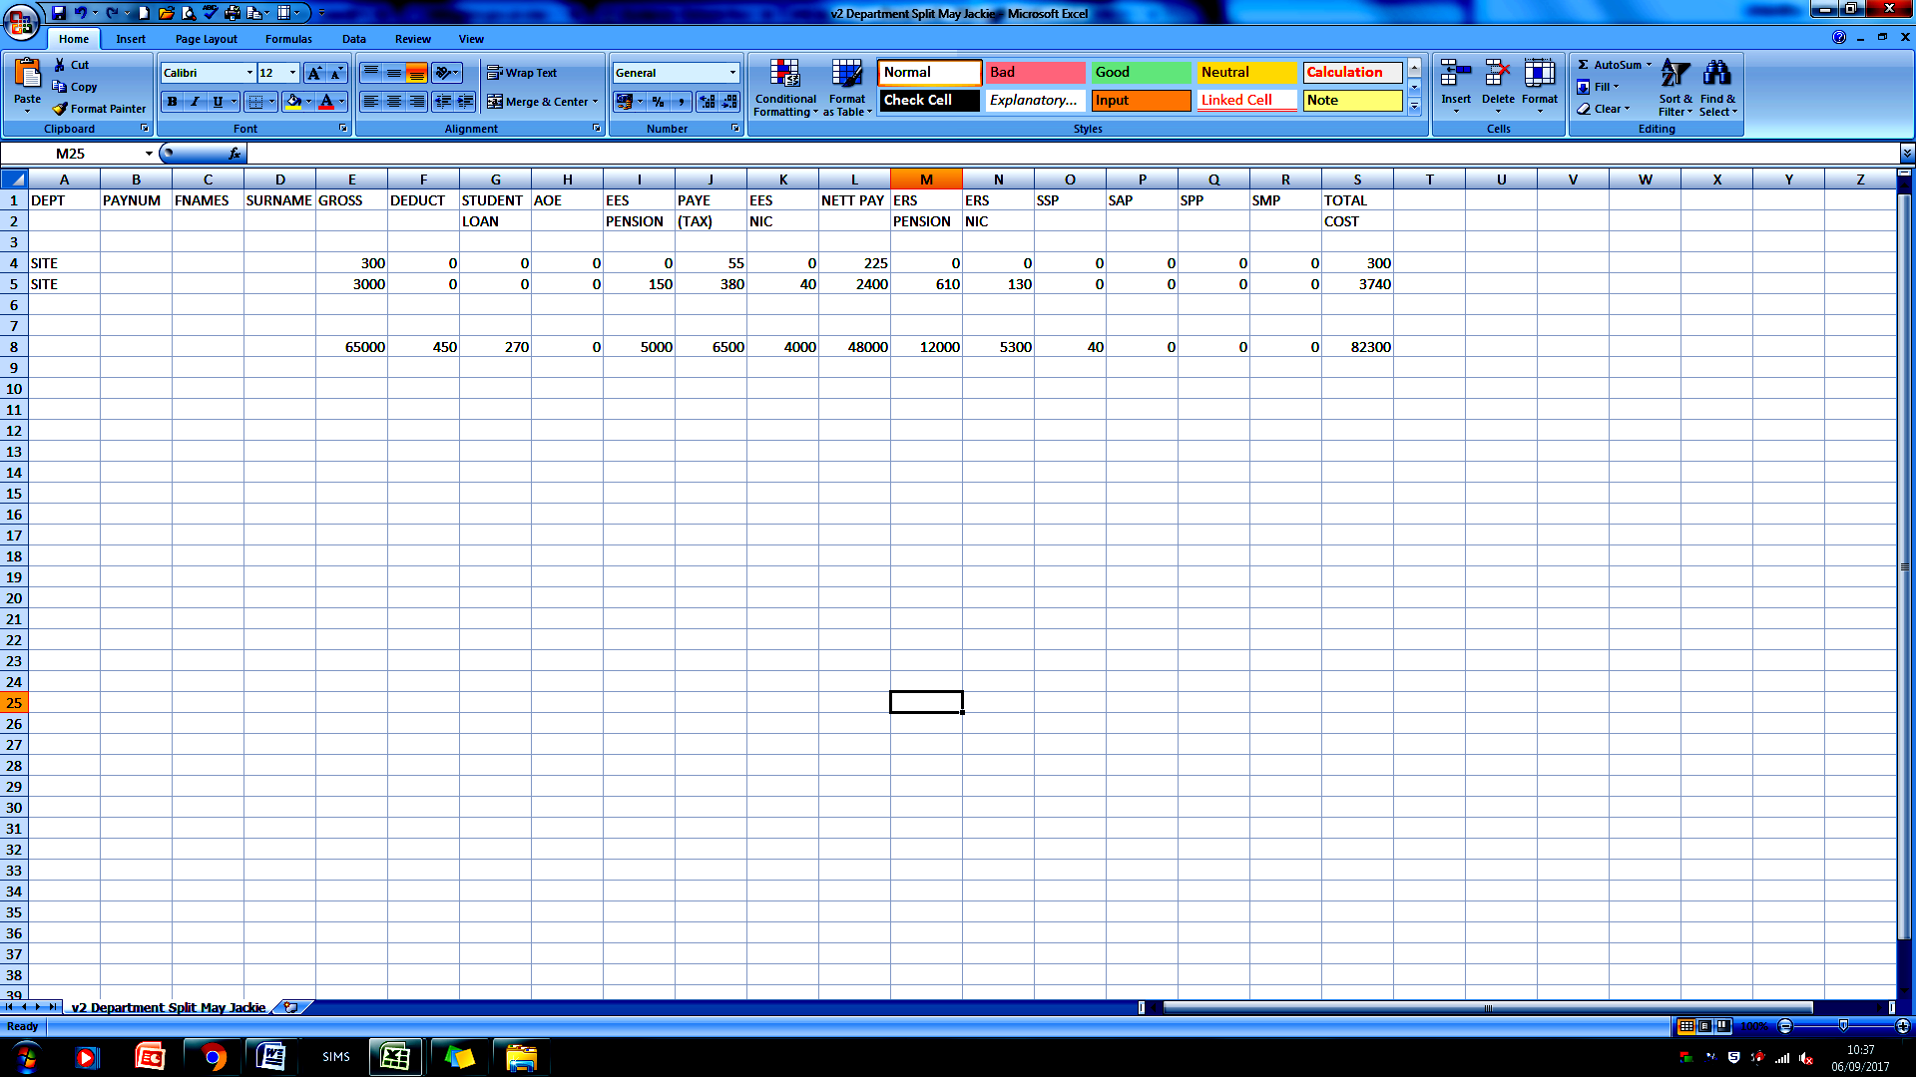
Enter the total cost of salaries from this report into the yellow cell at the bottom right-hand side of the School Payroll Reconciliation spreadsheet.
Total cost of salaries can be found on this report and is shown as the total of the TOTAL COST column

Alternatively total costs can be found on the report named “Build up to Gross Pay”.
Variances will show as red in the cell underneath. If using the "Build Up to Gross Pay" report, certain elements of the payroll will cause an imbalance - these include cycle scheme and childcare vouchers.

STEP 3 – Posting Payroll Journals on SIMS FMS6

Once completed Post the journals listed separately so they show as individual items on your bank ready for reconciliation. Please ensure the journals are posted to the correct month. If wrong months are used it will be difficult to identify errors when balancing FMS.
Method for Cash Book Journals
Post a cash book journal for each of the journals listed. They will show as individual items on the bank to enable each item to be reconciled separately.
On FMS select:
- Focus
- General Ledger
- Manual Journal Processing
- Plus to add a new journal
- Select Cash Book Journal
- Next
- Enter correct period and narrative (e.g. June Teachers Pensions/June Cycle Scheme)
- Next
- Chose Bank Account and enter reference
- Finish

Then add journal line using green plus icon
- Select Ledger code PY01 (Debit to PY01 and Credit to Bank)
- Update and close
- Save
- Post

Method for Normal Journals
- Focus
- General Ledger
- Manual Journal Processing
- Plus to add a new journal
- Select Normal Journal
- Next
- Enter correct period and narrative (e.g. June School House Rent, Childcare Vouchers, AOE etc )
- Next
- Finish

Then add journal lines using green plus icon
- Select appropriate cost centre
- Enter details and Debit/Credit as shown on School Payroll Reconciliation spreadsheet
- Select Payroll Control PY01 and enter Debit/Credit as shown on School Payroll Reconciliation spreadsheet
- Update and close
- Save
- Post

Childcare Vouchers

The Childcare Voucher element should be posted using a normal journal between Payroll Control (debit) and “Other Employee Costs” (credit). Voucher invoices are then paid from the Same “Other Employee Costs” cost centre.

Apprenticeship Levy

The Apprenticeship Levy does not appear on the journal listing provided by Dataplan. This amount can be found on the last page of the Analysis of Pay Report provided by Dataplan. Another Cash Book journal needs to be posted for this as follows:
DEBIT Ledger code A056 Apprenticeship Levy Cost Centre “Other Employee Costs”
CREDIT Bank
This amount will be included in the HMRC payment on the bank statement. Thus, amount on the statement will equal the total of HMRC shown on the journal listing plus the Apprenticeship Levy.

DEBITS ON BANK ACCOUNT
Cash book journals will now be ready for reconciliation. The table below shows typical dates for when payments are taken from the bank.
Nett Pay | Debited 15th | DR PY01 | CR Bank
Teachers Pension | Debited 20th | DR PY01 | CR Bank
Teachers AVC’s | Debited 20th | DR PY01 | CR Bank
LGPS Pension | Debited 20th | DR PY01 | CR Bank
LGPS AVC’s | Debited 20th | DR PY01 | CR Bank
Credit Union | Debited 20th | DR PY01 | CR Bank
GMB Fees | Debited 20th | DR PY01 | CR Bank
HMRC | Debited 19th of following month | DR PY01 | CR Bank

STEP 4 – Posting Individual Salaries on SIMS FMS6

Posting of all individual salaries will create a CREDIT on payroll control (PY01) and a debit on Teaching / Education Staff / Admin / Premises or Other Staff cost centres. Please ensure individual salaries are posted to the correct month.
Use the "Departmental Split" or "Build up to Gross Pay" report supplied by Dataplan. Each member of staff is listed on these reports and their Total Cost as shown on the last column on the right and these amounts are used for posting for all staff. (Please note that on the Build Up to Gross Pay report cycle and childcare voucher schemes amounts are not always included).
Once the Total Costs for each member of staff are known select:
- Focus
- Personnel Links
- Individual Payments
- Plus
- Amend period no if necessary

- Paid from: click 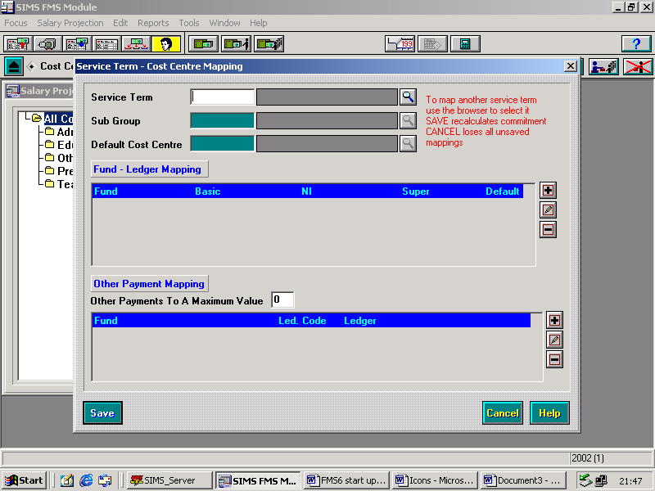

- Select Payroll Control

- Click on to the right of contract details and a list of your staff will appear
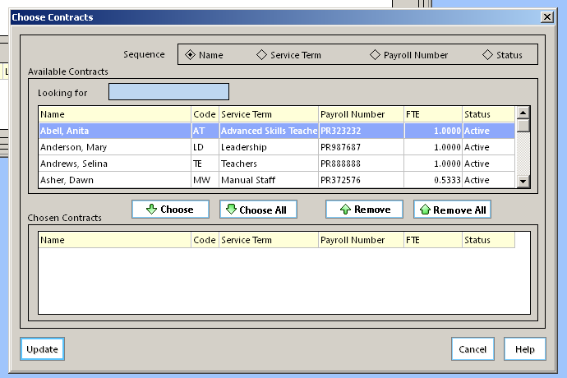

Highlight and chose the first staff member on your payroll breakdown sheet – highlight the remainder one by one as they appear on your breakdown.

- Click update

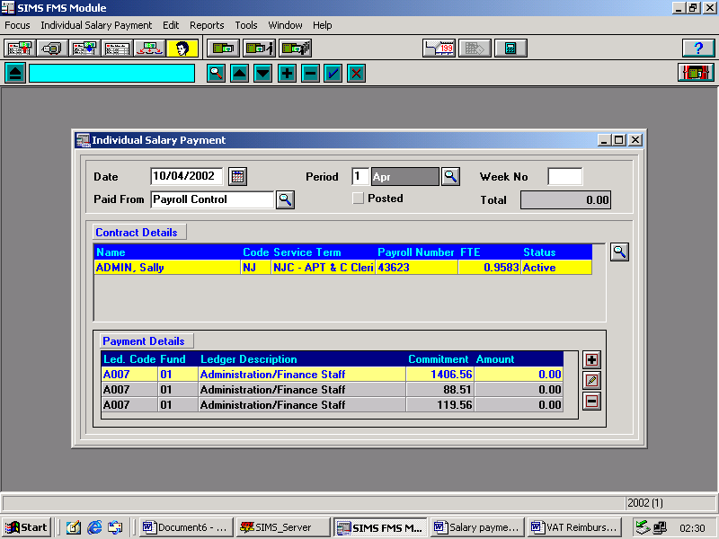
Note: Make sure that the salary is entered on the first line – otherwise the commitment will not clear. Delete the bottom two lines.

- Click to edit the top line, enter amount and 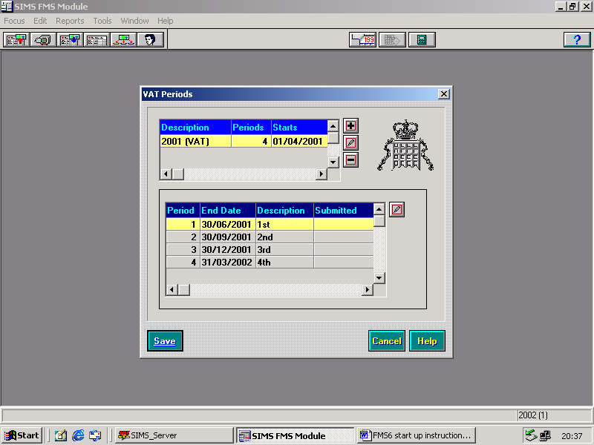
- Highlight and delete the remaining two lines

Highlight the next member of staff from the list above and repeat.
Note: If you wish to add schoolkeeper overtime, click instead of and enter code A033

When all contract salaries have been entered ensure that the total shown agrees to your payroll analysis.
- Save
- Post

Remaining Items - These could be items for anyone without a contract on Sims Personnel 7 for instance supply/casual payments. In these cases a Normal Journal would need to be completed.
Method for Normal Journals
- Focus
- General Ledger
- Manual Journal Processing
- Plus to add a new journal
- Select Normal Journal
- Enter correct period and narrative (e.g. A Smith Supply cover)
- Next
- Finish

Then add journal lines
- Select appropriate cost centre
- Enter details

DEBIT for charges e.g. supply and casual payments
CREDIT if the total posted to the codes is an overall debit
- Select Payroll Control PY01 and enter Debit/Credit as appropriate to balance journal
- Update and close
- Save
- Post

STEP 5 – Checking Payroll Control Balances

Providing you have entered all salary payments and journals as per the reconciliation sheet, the Payroll Control Account should be balanced. To check this:
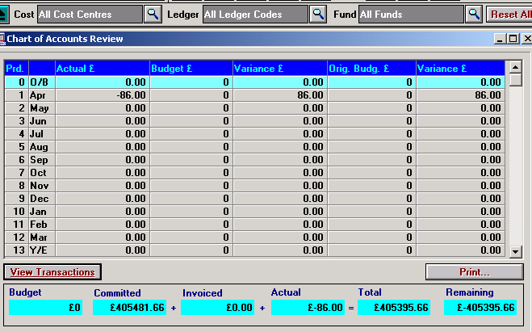
- Focus
- General Ledger
- Chart of Accounts Review

Select All Ledger Codes

Type PY01 and select

The actuals amount at the bottom should say zero

If you are not processing a journal for HMRC until the following month this will remain as a balance on PY01

STEP 6 – Checking Commitments
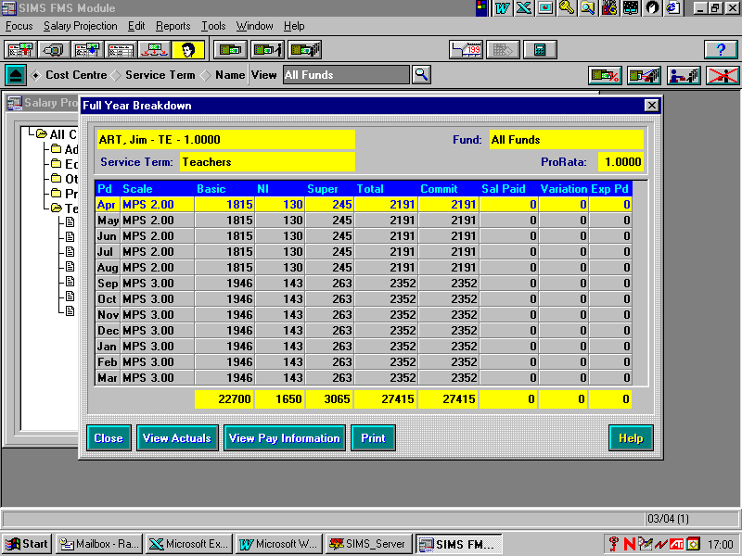
Once salaries have been they should be checked against the commitments raised from Personnel. There are a number of ways to do this as identified on APPENDIX 1.

To see individual variances on screen:

Select:
- Focus
- General Ledger
- Personnel Links
- Salary Projections

Staff are listed within cost centres.

Selecting a cost centre will show list of individual staff.
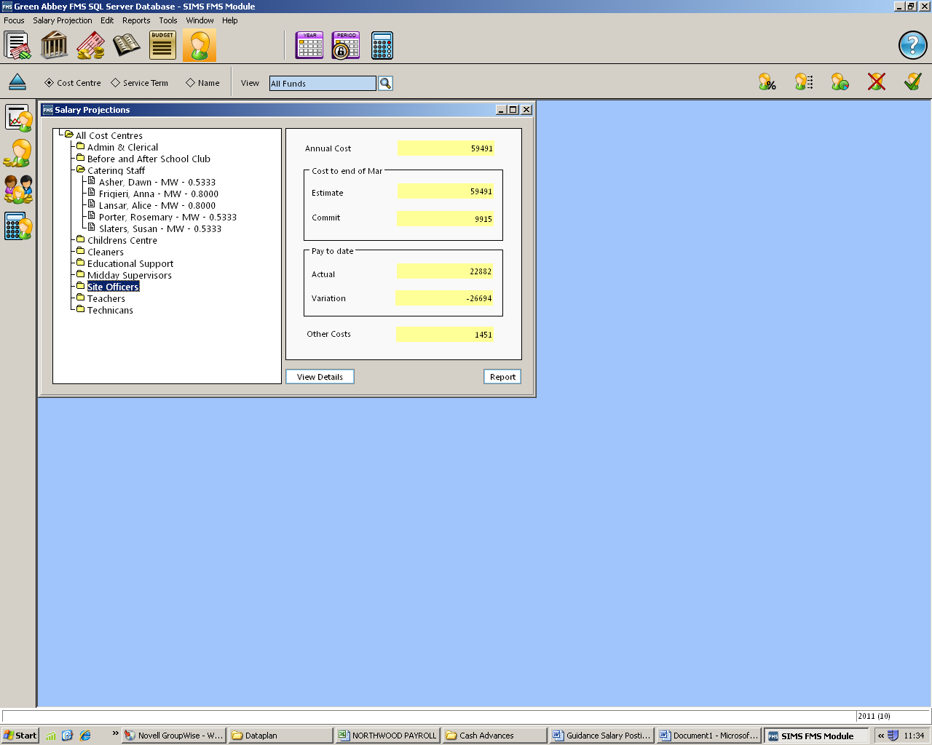
Select to view individual staff.

STEP 7 – Cancelling Commitments

Outstanding commitments for months to date should be checked and deleted if appropriate.
Select:
- Focus
- General Ledger
- Personnel Links
- Salary Projections

If a commitment is remaining for the current, or a previous month for which a payment is not due
Example
An employee started on 1st February but received two months’ salary in March. Once the March salary has been entered, the February commitment should be cleared.
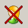
Select to cancel commitment

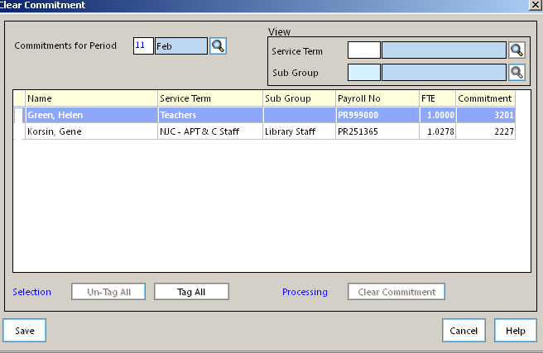
Select Period

Click here to tag commitment to cancel

Click ‘Clear Commitment’

School Finance Team
November 2018

