2020-21

Financial Year End Guidance

For

Hillingdon Schools

Private Funds



Schools Finance Team
April 2021

TABLE OF CONTENTS

Section |  | Page no
1 | Pre Closing Checks | 3
1a | Quick guide – with recommended timetable to aid planning | 4
2 | Introduction | 5
3 | Supporting Documentation | 5
4 | Accounting System Year End Procedures | 5
4.1 | Invoices to be paid | 5
4.2 | Year End System Check Report | 5
4.3 | Petty Cash | 5
4.4 | Bank Reconciliation | 6
4.5 | New Financial Year 2021-22 | 6
4.6 | Delete Obsolete Commitments | 6
4.7 | Produce Aged Creditor Report | 7
4.8 | Produce Aged Debtor Report | 7
4.9 | Produce Commitments report | 7
4.10 | Produce Year End System Check Report | 8
5 | Preliminary Close and Year End Accruals | 8
5.1 | Create 2020-21 Period 13 | 8
5.2 | Accruals | 9
5.3 | Inputting journals | 10
6 | Producing Year End Reports | 11
6.1 | Summary Trial Balance | 11
6.2 | SIMS FMS Reports | 11
7 | Year End Statement return | 11
7.1 | Year End Reconciliation – Section A - Appendices A(1) to A(4) | 12
7.2 | Supporting Documentation | 12
7.3 | Year End Reconciliation – Section B | 13
7.4 | Reconciling Sections A and B | 13
7.5 | Review of Chart of Accounts Review Report | 13
7.6 | Final Close | 13
8 | Any Queries? Who to contact | 14
Please note: this guidance assumes a year end of 31st March please adapt dates to suit the timing of the school's private year end.
Appendices
Appendix A - Year End Returns (includes A(1) to A(4))
Appendix B - SIMS FMS Reconciliation to Year End Statement
Appendix C – Guidance on producing reports for Year End

- Pre Closing Checks

Action | Reference | Tick when completed
Purchase Orders – delete all old commitments or those already paid as Non–Order invoices | 4.6
Bank Reconciliation – Ensure Bank Statement to the end of year is available. | 4.4
Un-Reconciled items – any long outstanding items (over 6 months) for expenditure / income to be investigated and dealt with. | 4.4
Year End System Check Report – run before 1st April to assess possible issues for closing and any unposted items / income. | 4.2 / 4.10
Accruals – start gathering information on what will have to be accrued together with supporting paperwork ready for 31st March. | 5.2

1a Quick Guide – with recommended timetable to aid planning

Recommended Timetable | Action | Year End Guidance Reference | Tick When Completed
Early March | Invoices to be paid | 4.1
Early March | Run Year End System Check Report | 4.2
 | Complete bank reconciliation to 31st March | 4.4
 | Create the new year | 4.5
 | Remove obsolete purchase orders | 4.6
 | Produce Aged Creditor Report | 4.7
 | Produce Aged Debtor Report | 4.8
 | Produce a Purchase Order Report | 4.9
 | Produce Year End System Check Report | 4.10
W/C 31st March | Create 2020-21 Period 13 (preliminary close) | 5.1
 | Identify and enter all year-end accruals on to SIMS FMS using the reversing journal facility | 5.2
 | Copy Bank Statement(s) as at 31st March 2021 | 4.4
 | Produce Income & Expenditure Report Produce Summary Trial Balance(STB) Report | 6.1
 | Produce Final Reports :-
 | ❑ Bank Reconciliation Report | 6.2
 | ❑ Unreconciled Items Listing | 6.2
 | ❑ Income and Expenditure Report | 6.2
 | ❑ Cost Centre Summary | 6.2
 | ❑ Copy of journals | 5.3
 | ❑ STB Report by Ledger Code | 6.1
 | ❑ Ledger Code Balances | 6.2
 | Complete Year End Statement - Appendix A | 7.1

Introduction
This guide takes you through what schools need to action when completing Year End for the Private / Voluntary Fund assuming this is accounted for on SIMS FMS. It needs to accord with financial regulation and may be subject to scrutiny by an independent examiner or auditor. Please follow this guide carefully.

Please make arrangements with your bank to receive the 31st March statement in good time. Alternatively on-line banking can be used to view statement information. By systematically following the Pre Closing Checks most obstacles to achieving a painless closure can be avoided.

It is best practice to close the accounts on an accruals basis. This means that the cost of goods and services are charged within the year in which they were received or provided.

For example: Computers received by March 2021 but not paid for until April 2021 should be recorded as a cost in the 2020-21 financial year, even though the related invoice will be paid in the 2021-22 financial year. Section 5.2 of this guide explains how this is achieved.

Supporting Documentation
Your Year End Statement must accurately reflect your school’s accounting system records. It is therefore essential that year-end items such as accrual adjustments be implemented on your school’s accounting system.

Accounting System Year End Procedures

4.1 Invoices to be paid

If you have outstanding invoices for which a system cheque has not been printed, then complete a cheque run in the normal way before 31st March.

Year End System Check Report

To check the system and assess what further preparation needs to be completed before closing the year, select Reports > Year End > System Checks before 1st April. This is to allow you to post any journals, outstanding Accounts Receivable invoices or credit notes in the correct period and month. Any outstanding Accounts Receivable transactions of this nature must be posted before this date, as failure to do so will result in you being unable to post outstanding invoices and credit notes in the previous year.

Petty Cash

Post any outstanding vouchers relating to the 2020-21 financial year including all staff reimbursements. Remember to include any last minute reimbursements from the bank and to review outstanding unreconciled items above 6 months.

Bank Reconciliation

Please arrange to receive your bank statement (s) giving the closing 31st March 2021 position, for all relevant accounts. It is possible to use online banking to access information although as there is no urgency, then it is likely this will not be required

Complete your bank reconciliation to 31st March closing balance and produce the SIMS FMS bank reconciliation reports before reconciling items in the new financial year.

Check and cancel any old (over 6 months) un-reconciled cheques. These can be cancelled through Focus - Accounts Payable - Cheque Processing - select the cheque number and click on the red cross to cancel. Please ensure that cheques cancelled off the system are also stopped at your bank. A record of all cancelled cheques should be retained for audit purposes.

If you are not intending to re-issue the cheque the invoice should be removed from SIMS FMS too. (Focus - Accounts Payable - Invoices / Credits - select the invoice and click on the red cross on the toolbar to cancel)

Guidance to produce the Bank Reconciliation Report can be found in our Financial Reports Guidance on the Schools Finance Google site.

Where possible invoices for expenditure incurred in 2020-21 should be processed before final closure to reduce the amount of accruals. Invoices dated 1st April or later should be processed in the new financial year for audit purposes. Payment of invoices dated 1st April 2021 or later must not under any circumstances be recorded in the 2020-21 financial year. Finalise the closing process for 2020-21 before recording new payments for the next financial year.

New Financial Year 2021-22

After completing your bank reconciliation you should create the new financial year 2021-22 in SIMS FMS.)
You will need to be in period 12 to do this.

- Tools
- Define Financial Years
- Define / Edit Years
- Select ‘+’
- Add ‘2021-22
- Save
- Select ‘2021-22’
- Select ‘Open Year’
- Save

Delete Obsolete Commitments

Commitments (accounting entries reflecting purchase orders) must not be included in school year end figures.

Schools should verify purchase order commitments and delete any that are no longer appropriate (e.g. those that have been paid or cancelled, by printing an outstanding purchase order report). The rest will be rolled forward into 2021-22 when you create the 2020-21 period 13 (preliminary close).

Produce Aged Creditor Report

At year end it is good practice to ensure that cheques are issued for all invoices on the system. If you have invoices approved in SIMS FMS for which the cheque has yet to be issued the value of these items will be shown on your SIMS FMS system as a creditor control balance. Creditor control balances should be reviewed by analysing your Aged Creditor report which is produced as follows:

- Reports
- Accounts Payable
- Supplier Analysis
- Aged Creditor
- Select Detailed Report
- Select Exclude Zero Balances

If you are satisfied that the balance is a true reflection of invoices processed for which cheques were not issued for 1st April, please include this balance on your Accrued Expenditure form (Section 7.2). Retain the Aged Creditor report as supporting documentation.

Produce Aged Debtor Report

If you have issued invoices through SIMS FMS Accounts Receivable (this would be unusual for Private Funds) for which payment has not been received (or not matched against the invoice raised) than your SIMS FMS system will have a debtor control balance. Debtor control balances should be reviewed by analysing your Aged Debtor report which is produced as follows:

- Focus
- Accounts Receivable
- Report
- Aged Debtor Report

If a balance is present this should be verified. If you are satisfied that the balance is a true reflection of payments due to the school for which payment has not been received by 1st April, please record this balance on your Income Accrual form. Retain the Aged Debtor Report as supporting documentation. Where balances can be confirmed as incorrect because funds have been cleared by another route i.e. Cash Book journal or non-invoiced income, then the balance should be written off – see SIMS FMS6 link on the Schools Finance Leap site. Where the debt is over a year old or its collection is in doubt, schools should make provision in their accounts for a bad debt (see 5.2 page 10).

Produce Commitments report

To evidence orders as at 31st March you must produce a List of Outstanding Purchase Orders report before clearing commitments into 2021-22 (which happens as part of the Preliminary Close).

In 2020-21 select:

- Reports
- Accounts Payable
- Purchase Order Reports
- Purchase Orders
- Select Outstanding Orders and OK

Purchase orders issued (therefore printed and partly invoiced) by 31st March relating to your revenue expenditure should be reviewed so that historic orders or those paid as Non – Order invoices are deleted.

To cancel a Purchase Order click on the red cross - cancel order/clear remaining order commitment icon - in the top right. For an authorised order where individual lines need to be deleted the smaller green cross can be selected on the right. Reprint the report as necessary.

Year End System Check Report

Run this report again (4.2 refers) to ensure FMS is ready for a Preliminary close to be run.

Preliminary Close,

Create 2020-21 Period 13 (Running a Preliminary close)

Purchase Order Commitments (accounting entries reflecting purchase orders) will not be included in school year end figures. They instead will be rolled forward into 2021-22 if still outstanding when the preliminary close routine is run or should be cancelled if no longer outstanding at year end.

To create period 13 you must run a preliminary close. When prompted to transfer all central transactions – select ‘Yes’. You will only be able to run a preliminary close if you have first created the 2021-22 financial year (see 4.5 above). You will need period 13 for your year-end journals. Do not run a preliminary close until you have reconciled SIMS FMS to the 31st March closing bank balance. After a preliminary close you will no longer be able to perform any cash book journals or change any budget allocations in 2020-21. To produce a preliminary close:

- Select Tools
- Select Define Financial Year
- Select Define/Edit Years
- Select 2020-21
- Select Preliminary Close
- Select ‘Transfer all central transactions’ (when Prompted)
- Select ‘Yes’
- Click on continue
- Select Perform close
- Select Save

A number of system checks will take place and the preliminary close only completes if there are no ‘red cross’ errors. If a red cross appears, select report and resolve the problem reported on the printout before attempting the preliminary close once more.
Do not perform the Final Close until you have followed the processes up to section 7.6

Accruals

Expenditure Accruals

Accruals ensure that expenditure is accounted for in the correct financial year by recording an expense against the relevant budget. Invoices for goods and services received before 1st April should wherever possible be paid by 1st April. All invoices paid after 31st March MUST be posted to the 2021-22 financial year.

Where a payment or more is outstanding at 31st March for goods or services received prior to 1st April, record as an accrual on Appendix A (1). Details recorded must include a description of the goods or services received from the supplier,
the value (excluding VAT) and the ledger code to which the accrual is recorded. Examples of accruals include the following:

- Deposit on school journey made in 2020-21 but trip does not take place until 2021-22
- Income received for school journey in 2020-21 but trip is not until 2021-22

It is recommended that an aged creditor report is run to check on outstanding balances.

Don’t forget to include your Creditor Control balance if applicable (Section 4.7).

Income Accruals – Appendix A (3)

Record income items due as at 31st March where the income has neither been received nor an invoice raised through SIMS FMS Accounts Receivable in the 2020-21 financial year. It is unlikely that income accruals would be due for the private fund.

Where invoices have been raised through Accounts Receivable, the Debtor Control balance should be recorded on your Income Accrual form (Section 6.12).

Prepayments – Appendix A (4)

Record any payments posted to the 2020-21 account, which relate to goods or services to be received after 31st March.

For example, if a school has paid £2,500 for summer 2021 trip, this should be recorded as a Prepayment.

Income in Advance – Appendix A (5)

Record the details of any income items received for 2021-22 before 1st April 2021. One example here could be school journey money received from parents.

Bad debt provision

Where a debt is over a year old or its collection is in doubt, schools should make provision in their accounts for a bad debt.

To make a bad debt provision you must first make a prudent assessment as to how much of the invoice issued and recorded on the school’s accounting system is unlikely to be paid. You should then post an Income in Advance journal and clearly report it on your Income in Advance form as ‘Provision for Bad Debt’. Schools should provide bad debt provision for all amounts of more than 1 year old.

Inputting journals

To input your expenditure accruals, income accruals, prepayments and income in advance please first ensure that you are in the 2020-21 financial year, Period 13. Having successfully completed a preliminary close (see above) you will have access to the reversing journal facility.

Go to Focus - General Ledger - Manual Journal, click on ‘+’ – and select ‘Year End Adjustment Reversing’.

Narrative: Year End Item (for clarity, you can enter header as year end expenditure, prepayment or advance income, etc.

- Reversal Year: 2021-22
- Reversal Period: April (period 01)
- One side of the journal will be posted to the ledger code and the other to balance sheet code LIAB or ASST. (Entries will be reversed automatically in period 1 of 2021-22). The codes to use are dependent upon the type of year-end item you are processing as below.
- Expenditure Accrual
  - Debit the ledger code (e.g. Axxx)
  - Credit LS (Liabilities) school code e.g. LIAB

- Income Accrual
  - Credit Income ledger code (e.g. Axxx)
  - Debit AS (Asset) school code e.g. ASST

- Prepayment
  - Credit Expenditure Ledger Code (e.g. Axxx)
  - Debit AS (Asset) school code e.g. ASST

- Income in Advance
  - Debit Income Ledger Code (e.g. Axxx)
  - Credit LS (Liabilities) school code e.g. LIAB

All amounts should exclude VAT.

System creditor and system debtor balances are already included in SIMS FMS and therefore reversing journals must not be done for these balances.

Once all the year end journals are completed, run another preliminary close – see 5.1

Producing Year End Reports
  - Summary Trial Balance Report

- A Summary Trial Balance by ledger code showing all funds and to period 13. (Reports - General Ledger - Trial Balance - Summary Trial Balance - By Ledger Code - Period ‘13’ leave fund blank).

  - SIMS FMS Reports

In order to fill out your Year End Statement you will need to make reference to a number of reports.

- SIMS FMS Bank Reconciliation Report* (one for each bank account)
- SIMS FMS Un-reconciled Items Listing* (one for each bank account)
- SIMS FMS Accruals / Journal copies (with school name annotated on each sheet)
- Cost Centre Summary* (to Period 13) for each Fund used on FMS.
- Ledger Code Transaction Listing (Reports > General Ledger > Transactions > Ledger Code Transactions, Select Type IN and select OK. Repeat above and select Exp,OK). This will capture your Income and Expenditure for the year and should equate to the values in your STB report

* Please refer to the Schools Finance LEAP webpage for guidance on producing these reports.

- Year End Statement Return (Appendix A)

Before you go on to complete the Year End Statement please ensure that you have completed all of Sections 7 and 8 above.

This Statement Return (Appendix A) is in two parts A and B and includes a declaration for the Headteacher to sign once both parts are filled out. The top Section A has links to Appendices A1, A2, A3 &A4, and is partially completed for you and should be completed first followed by Section B at the bottom.

Should Sections A and B of Appendix A/Year End Statement not balance, a variance will be highlighted. Appendix B is the supplementary form to complete to help pinpoint the source of variances.
Please complete all fields highlighted in yellow only, as there are formulae in other cells.

  - Year End Reconciliation – Section A (Appendices A (1) to A (4))

Firstly select your DFE number from the drop down box. This will pre fill a number of boxes with the school name.

Bank Balance as at 31st March as per Bank Statement
Enter the closing bank balance on the 31st March. Take this information from your bank statement(s) (and not SIMS FMS).

Un-reconciled Items
As per your SIMS FMS Bank Reconciliation-Un-reconciled Items Report as at 31st March.

No cheques issued after 31st March should be included in your school’s un-presented (un-reconciled) year-end listings. All cheques issued after 31st March must be recorded on your school’s financial system in the 2021-22 financial year and we recommend these are not processed before the year end procedures are completed.

There should be no income present on your Un-reconciled Items listing other than where income was paid into the bank on or before 31st March but not included in the
31st March bank balances.

Closing Cashbook Position
This is a formula driven field and should match the closing bank ledger balance on SIMS FMS. You can check against the bank balance given on your Summary Trial Balance to see if it does.

Year End Items
The values in here are drawn from the entries made on the following forms (see Appendices A (1) to A (4))
- Expenditure Accruals
- Income Accruals
- Prepayment
- Income in Advance

  - Supporting Documentation

Schools must provide copy documentation (such as invoices) to support all closedown accruals and prepayments. We recommend that each item of supporting evidence is cross referenced to the list on the Appendices.

Petty Cash Accounts
Record your petty cash balance as at the 31st March. All vouchers reimbursed to 31st March should be reflected in SIMS FMS in 2020-21. Vouchers reimbursed after 31st March should be processed in 2021-22.

Total Carry Forward Balance
This is a formula driven field. The carried forward balance is subject to independent examiner or external audit scrutiny.

Year End Reconciliation – Section B

Total Expenditure 2020-21
Enter the expenditure totals from page 1 of your Ledger Code Transaction Listing.

Total Income 2020-21
Enter the income totals from page 1 of your Ledger Code Transaction Listing.

Balance Brought Forward
Check the value from your previous accounting system/year end statement.

Net Closing Balance
These are formula driven fields

Reconciling Sections A and B

Sections A and B should reconcile to each other. If there is an imbalance of more than £5 then the variance will be highlighted.

Schools can narrow down the area of the accounts to which the imbalance relates by completing the yellow cells on the SIMS FMS Summary Trial Balance Reconciliation to Year Statement form. See Appendix B for further guidance.

7.5 Review of Chart of Accounts Review Report

Once the Year end Process has been completed review the balance in the Remaining Budget column and ascertain if a budget needs to be inputted for the following financial year. The Unallocated budget can then be calculated as the remaining budget for the year.

A report can be prepared for the Governors on the use of the funds during the year.

  - Final Close

Once your Headteacher has signed off the Year End Statement and there are no outstanding issues then you can complete the Final Close by following the process from 5.1, this time selecting Final Close instead of Preliminary Close.

The school must arrange for the private account to be audited each year. The auditor will look to ensure that the schools’ accounting systems fully support your year-end returns.

13 Any Queries? Who to Contact
If you have any queries or comments, please do not hesitate to contact the Schools Finance Team at the Civic Centre.

Name / Title | Telephone | Email
Lead Finance Business Partner - Schools Finance  Graham Young | 01895 27 7687 | gyoung@hillingdon.gov.uk
Assistant Finance Business Partner  Rubina Kudhail | 01895 27 7204 | rkudhail@hillingdon.gov.uk
Schools Finance Officers  Greg Watson  Davinder Devgon  TBC | 01895 25 0451  01895 25 0458  01895 27 7665 | gwatson2@hillingdon.gov.uk  ddevgon@hillingdon.gov.uk
Teachers Pensions Assessment Officer  Elaine Hill | 01895 25 0985 | ehill@hillingdon.gov.uk

Address: Schools Finance Team
London Borough of Hillingdon
Civic Centre, 4W/04
High Street
Uxbridge UB8 1UW.

As always, your co-operation is most appreciated and we look forward to another successful year end. Please do not hesitate to call the Schools Finance Team for any assistance necessary to finalise your accounts.

Many thanks.

Graham Young

Appendix C – Guidance on Producing Reports for Year End)

Ledger Code Transaction Listing

(Reference 6.2, SIMS FMS Reports in Year End Guidance)

Go to

- Reports
- General Ledger
- Transactions
- Ledger Code Transactions, select Ledger Type IN and select OK.
- Repeat again this time selecting Ledger Type Ex and select OK

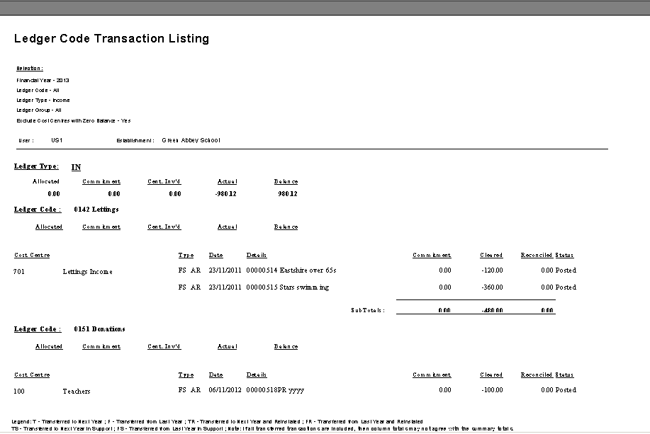
Total income for the year

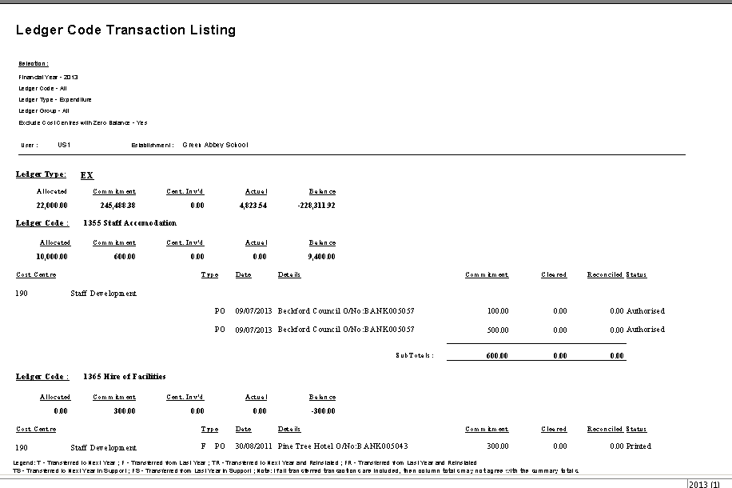
Total expenditure for the year

Appendix D - Review of Cost Centres to determine next years budget

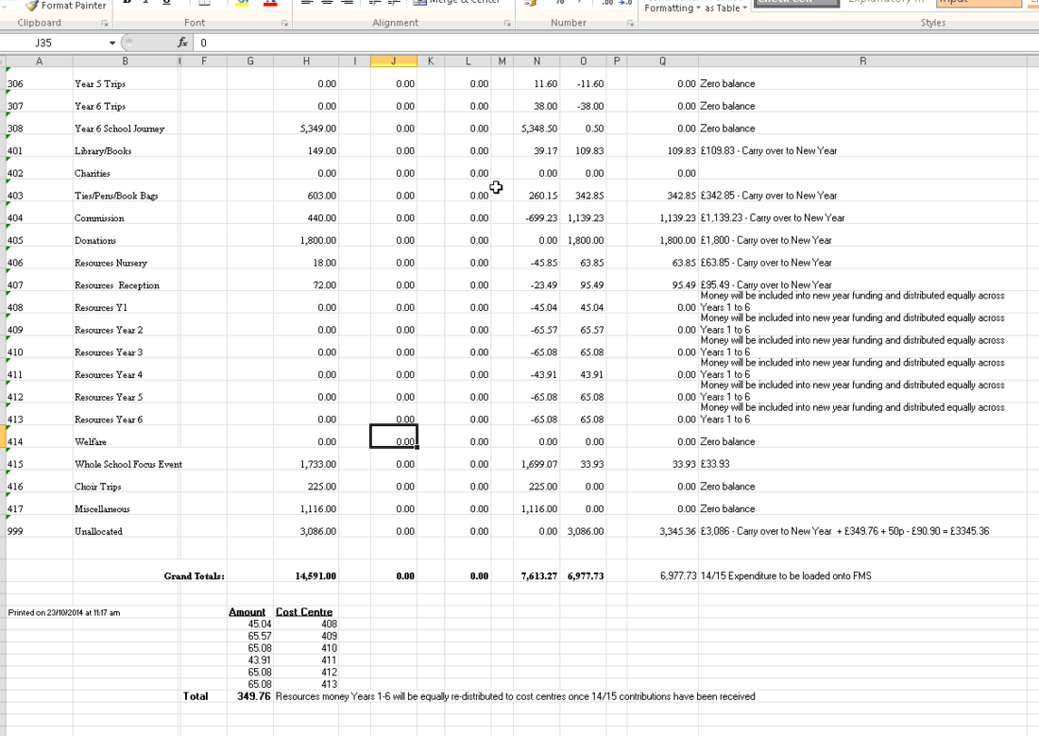
Balance from year end
Planned budget for each cost centre in new financial year
Page intentionally left blank

