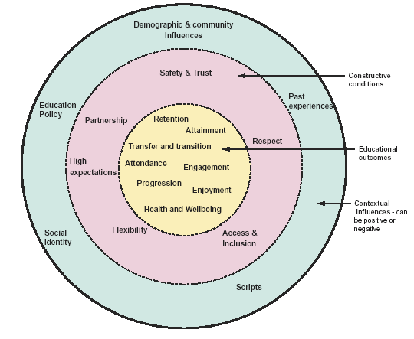
What works for GRT pupils
Safety and Trust:
- School staff demonstrate understanding and awareness
- Collaboration between school and GRT community to build trusting relationships with community members
- Firm but fair behaviour policies accepted by families
- Key individuals in schools act as accessible and approachable points of contact valued
Respect:
- Two-way process between the school families
- School leaders encourage culture of mutual respect in the school, whereby cultural diversity is accepted and celebrated in the school’s systems and values
- Locating responsibility with a senior member of school staff
- Knowledge of, and respect for, Gypsy, Traveller and Roma communities through training and development work including ITT and NQT
Access and inclusion:
- Schools are proactive in assisting parents with the admission process, including practical assistance, e.g. uniforms, transport, form filling
- Distance learning support and re-admission and reintegration of pupils on their return
- The integration of culturally-specific resources and programmes into wider curriculum areas
- The promotion of a ‘school identity’ encouraging all pupils to interact and integrate
- Provision of additional services, resources and facilities, e.g. family learning opportunities
- The employment of community members
Flexibility:
- Flexibility in the curriculum offering individual pathways, skills and opportunities that have direct relevance to their futures
- Work-related curriculum opportunities
- Problem solving approach to behaviour, attendance and homework policies, based on dialogue with parents and understanding of cultures and lifestyles
High expectations:
- Generating and sustaining high expectations and aspirations
- Communication of such expectations to families and communities
- The use of role models from within the communities
- Data analysis and progress tracking to ensure that the most appropriate interventions are made
- Inclusive schools that reach out to parents and families
- Staff with designated responsibilities for GRT pupils who build positive relationships with pupils and families
- Sensitive outreach work and proactive relationship building between secondary schools and communities
- A personalised, flexible and vocational approach to the curriculum as well as opening minds to professional career routes
- Challenging scripts and assumptions.
- Clear communication of high expectations in relation to attainment, attendance and punctuality.
- The use of GRT role models to promote aspiration and achievement
- Psycho-social factors – if GRT pupils are unhappy in school, they are unlikely to feel included, attend or achieve.

Demographic and community influences
Supportive | Obstructive
The local GRT communities may value secondary education highly  Loyalty towards the school may be communicated to other community members | Relatives/other community members may discourage GRT pupils from attending or transferring to secondary school  Parents may be unwilling to consider their children taking part in extra-curricular activities or other enrichment activities such as school visits
Past experiences
Former GRT pupils may have achieved highly in school, providing a good role model  Most/all GRT pupils may have transferred to secondary school in the past and established a pattern | Several GRT pupils may have been excluded from the school, reinforcing stereotyped expectations on all sides  Parents may have had unhappy and negative experiences of school themselves
Scripts
‘Travellers need exams these days –times have changed’  ‘I want them to have the education that I didn’t have’  ‘This school wants all our children to reach their potential’ | ‘Our girls don’t go to high school’  ‘Their parents won’t allow them to go on trips’  ‘There isn’t much point; they drop out and work with their family’
Educational policies
The school may be an all- girls’ school and this may appeal to Traveller parents  Fair and firm disciplinary policy may reassure parents | A selective schooling system in the local area may deter Traveller parents at point of transfer  The secondary curriculum may be perceived as irrelevant to the needs of these pupils
Social Identity
GRT pupils may be less likely to feel like ‘outsiders’ in schools serving diverse populations  The Traveller community may be well established in the local area –community cohesion impacts positively on relationships | The Traveller community may be marginalised by the local community, perhaps segregated geographically and there is inter-community tension.  One Gypsy parent was not going to allow her daughter to transfer to a high school where there were no other Gypsy pupils

‘Improving educational outcomes for Gypsy, Roma and Traveller pupils’, Brian Foster

