**Schools Financial Value Standard (SFVS)**

**2021-22**

The schools financial value standard (SFVS) helps to provide schools with assurance that they are meeting the basic standards necessary to achieve a good level of financial health and resource management.

The [SFVS checklist](https://www.gov.uk/government/publications/schools-financial-value-standard-sfvs?utm_medium=email&utm_campaign=govuk-notifications&utm_source=b4d0e80f-055a-4e5b-9479-0028f9a55e3e&utm_content=weekly) (also known as Schools financial value standard) asks a number of questions of governing bodies in six areas of resource management to provide assurance that the school is managing its resources effectively. This can be used to identify possible areas for change to ensure that resources are being used to support high-quality of teaching and the best education outcomes for pupils.

The checklist was formerly part of a tool that also contained a dashboard. This is now available on the schools financial benchmarking website. Here, schools can select from three types of comparison. Benchmark comparison – normal comparison against similar schools of your choice, Progress comparison - as part of the view my financial insights (VMFI) tool which provides users with insights into the financial position and performance of school comparisons and a Self-assessment dashboard. This shows how a school's data compares to thresholds on a range of statistics that have been identified as indicators for good resource management and outcomes, which will help you to complete your checklist.

**Changes for 2021-22**

1. A word checklist is now completed instead of an Excel spreadsheet, there are two new questions.

1. One is in relation to related party transactions where a new Excel template is completed.



1. The other is in relation to the number of employees (if any) whose gross salary exceeds £100k.

**The DfE Guidance**

[SFVS Guidance](https://www.gov.uk/government/publications/schools-financial-value-standard-sfvs/2019-to-2020-checklist-guidance#part4)

This provides clarification on each question as well good practice and details of further support.

**Additional Resources**



This document provides full details of the Skills Matrix that is referenced in Question 1, for Governors and Question 5, for school staff. It also provides an overview of how a well-informed and balanced budget should be set.

**Self-assessment dashboard**

This is referenced in Question 19. The revised Dashboard gives you Red Amber and Green indicators against the school data and compares against similar schools.

You should select your school by clicking on the [link](https://schools-financial-benchmarking.service.gov.uk/), start a comparison and choose self-assessment dashboard.

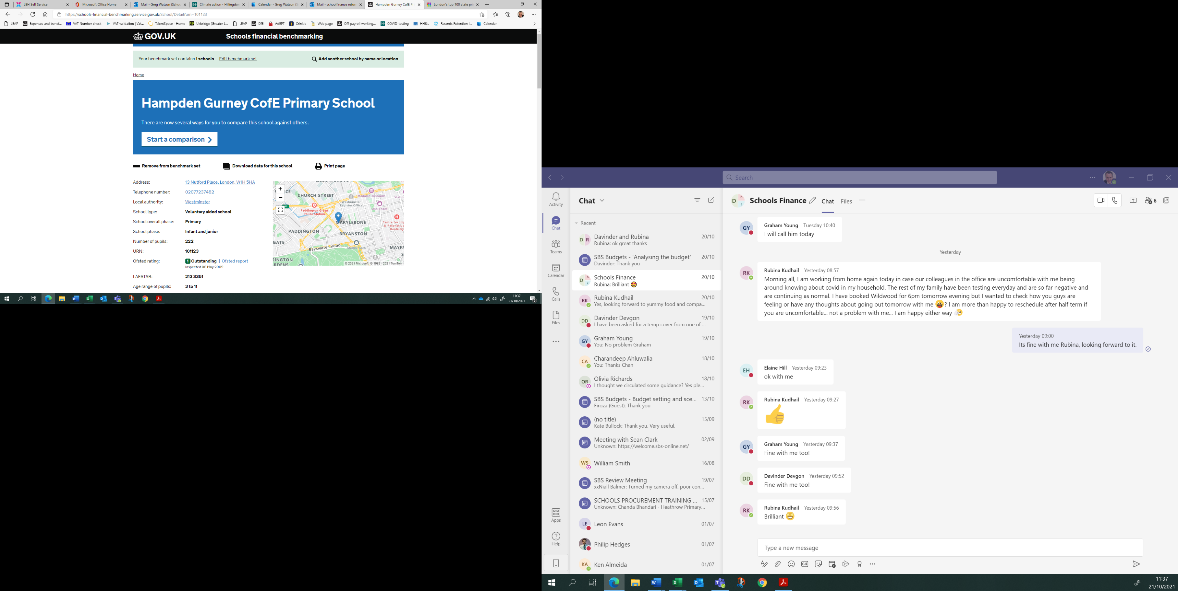

Click on Self-assessment dashboard

Click here

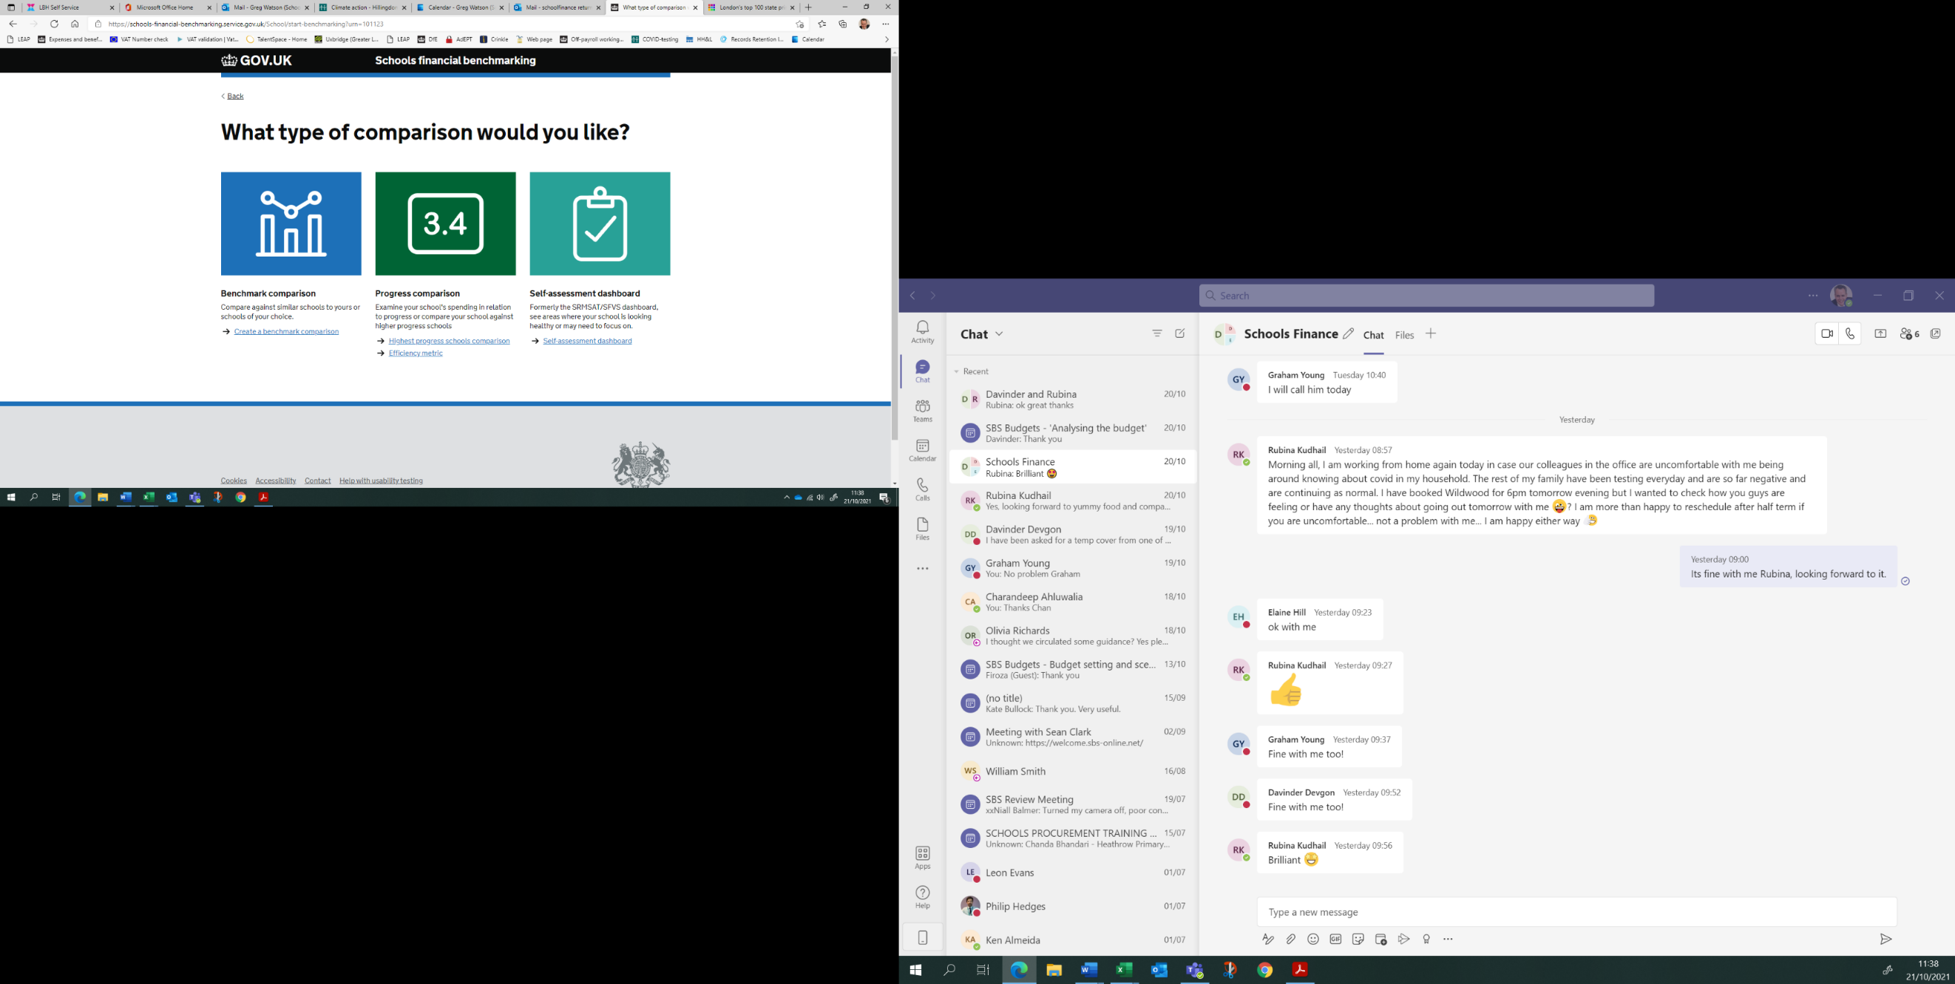

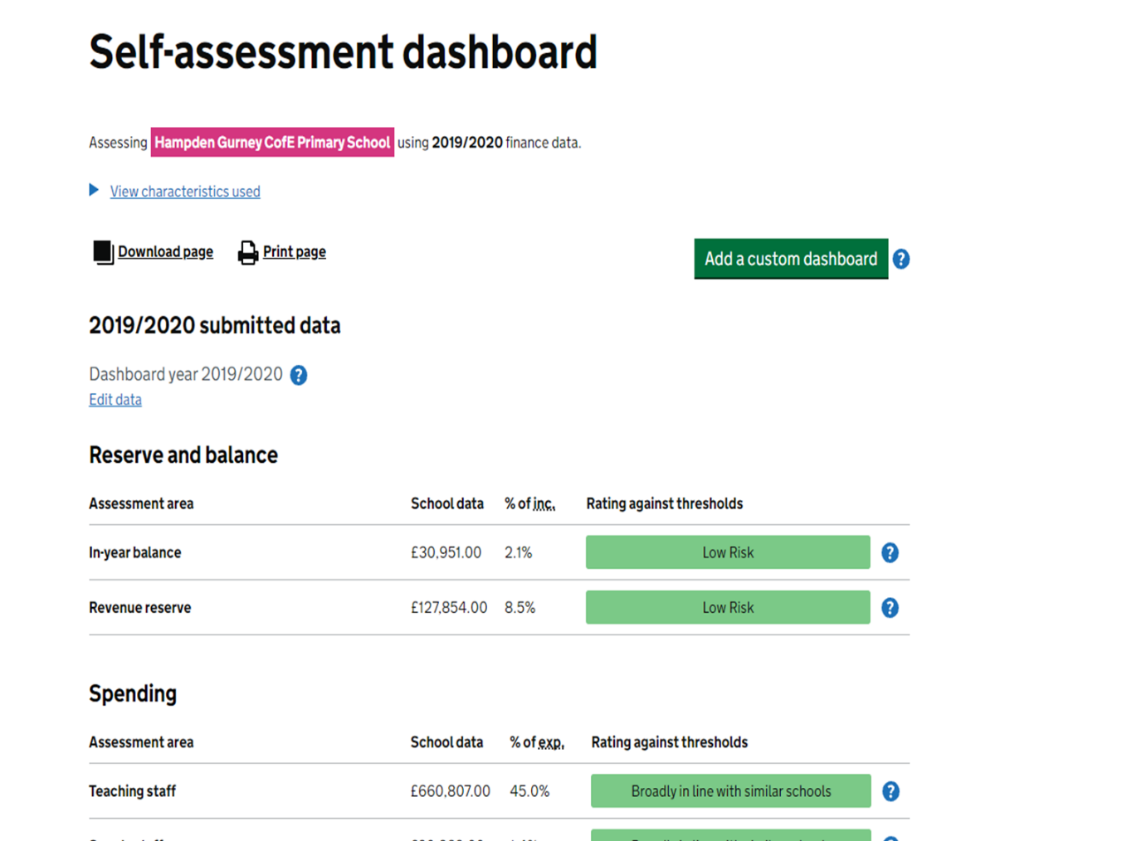

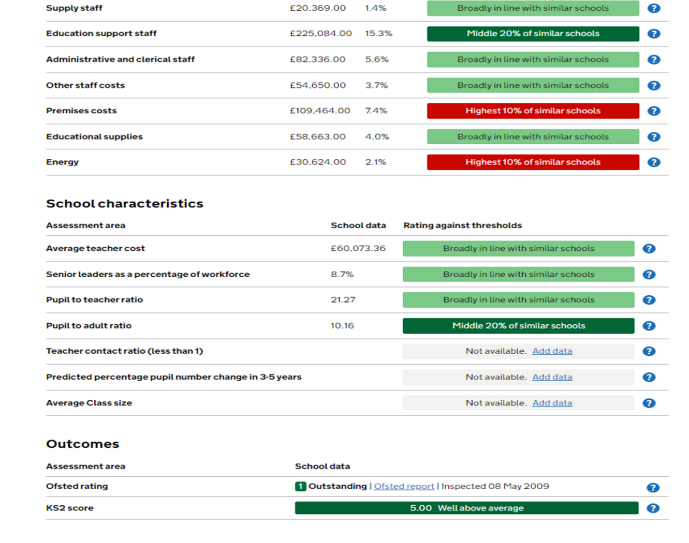

You will then be presented with a summary comparing recent metrics against similar schools which are RAG rated.

**Related part transactions**

We now have Question 26, regarding management of Related Party transactions.

This is generally a contract between the school and a business/person that has close

links with the persons awarding the contract.

The principle is not that related party transactions should never happen, but that

effective procedures should be in place to ensure that open and transparent

procurement procedures are followed, and any potential conflicts of interest are

declared and then adequately and appropriately managed.

An example could be a member of the governing body (or a member of staff, or a close relative of such a person) might have a stake in a catering company that was bidding for a contract to be awarded by the school. The governor must declare this interest as it arises and take no part in the procurement procedure. (The same would apply if a close relative of a governor or member of staff was applying for a job at the school, though that is not to be reported as a related party transaction under SFVS).

The school should have a record of any related party transactions that have been

arrived at through proper procedures and should append this list to the checklist,

using the [template for recording related party transactions](https://www.gov.uk/government/publications/schools-financial-value-standard-sfvs) (see above).

A related party transaction may, in some cases, provide the best deal and the best

value for money for the school. But to avoid any appearance of impropriety, the

school should keep a record of any related party transaction and append it to

[the SFVS Checklist](https://www.gov.uk/government/publications/schools-financial-value-standard-sfvs).

Contracts and agreements that are live in the year that the SFVS is being completed

for need to be reported. These should continue to be reported until the year in which

the contract ceases, at which point they can be removed from the list.

**Deadline**

The checklist should be forwarded to your link officer or [schoolfinancereturns@hillingdon.gov.uk](mailto:schoolfinancereturns@hillingdon.gov.uk) by 31st March 2022, early submissions are welcome.

**Schools Finance Team**

Graham Young 01895 277687

Greg Watson 01895 250451

Davinder Devgon 01895 250458

Charmaine Lawrence 01895 277665

Autumn 2021